I Spy Awesome Buildings Line Master 1
(Assessment Master)
Name: _____________________________

Find and Classify 2-D Shapes in  3-D Objects | Not observed | Sometimes | Consistently
Classifies 2-D shapes based on shared attributes (e.g., number or lengths of sides)
Names 2-D shapes
Classifies 2-D shapes and 3-D solids using geometric properties (e.g., a square has 4 equal sides, a cube has
6 congruent square faces)
Names 2-D shapes and 3-D solids
Identifies 2-D shapes as part of
3-D objects
Investigate and Make 2-D Shapes
Describes and compares 2-D shapes (e.g., triangles, squares, rectangles, circles)
Constructs and compares 2-D shapes with given attributes
Strengths:

Next Steps:

Connecting Home and School Line Master 2–1

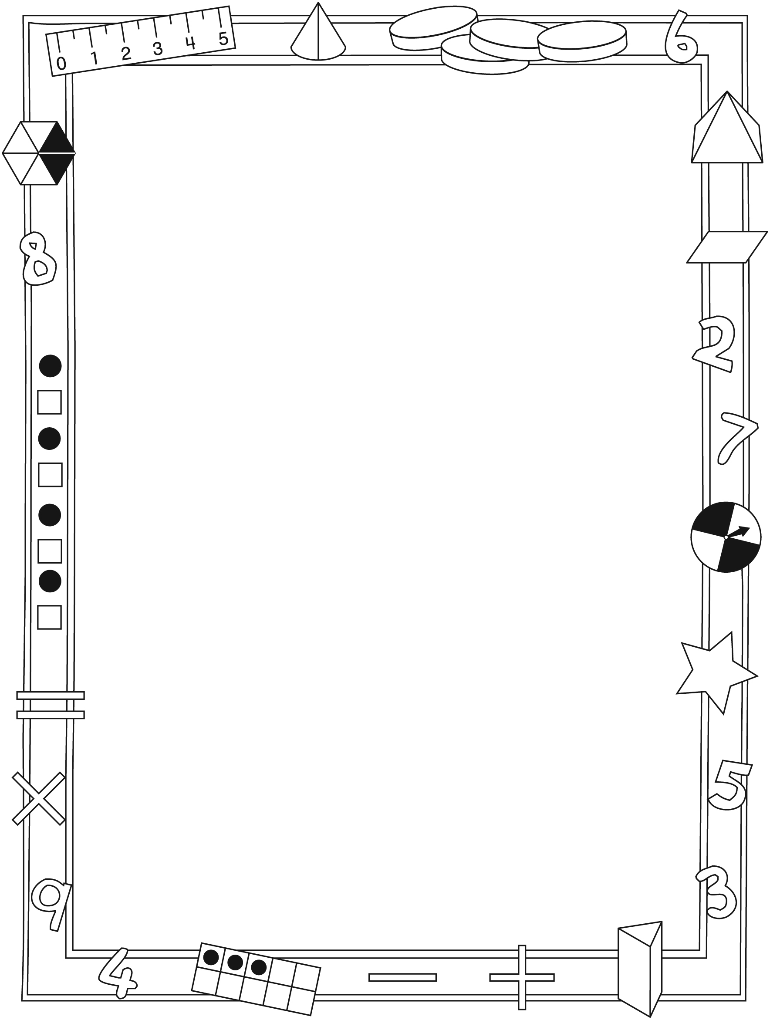

NOTE TO THE TEACHER

You may wish to send families an I Spy Awesome Buildings letter outlining a familiar activity or two they can do at home with their children.

Create a letter using this template and select one or two activities from the suggestions on the next page. Simply delete these instructions and cut and paste the activities you have selected, adapting them to fit your needs.

Connecting Home and School Line Master 2–2

Dear Family:

We have been working on I Spy Awesome Buildings, which engages children in conversations, investigations, and activities that help to develop their understanding of the big math idea that “Shapes and solids can be explored and compared based on attributes.” Particular focus is placed on identifying, describing, and comparing 2-D shapes and 3-D solids. Try this activity at home with your child.
– – – – – – – – – – – – – – – – – – – – – – – – – – – – – – – – – – – – – – – – – –
Reading the Story: As you read the story together, try to make connections to interesting buildings or structures that are around your community or that you’ve visited as a family.
– – – – – – – – – – – – – – – – – – – – – – – – – – – – – – – – – – – – – – – – – –
I Spy 3-D Objects Bump Game: This is a 2-player game. You will need the Math Mat (inside back cover of the book), 1 number cube, and 10 small objects for each player to use as counters (e.g., 2 colours of tiddlywinks or 2 types of dried beans and/or pasta). Attach a label with the name of a 3-D solid to each side of the number cube [i.e., cube, sphere, cylinder, prism (rectangular or triangular), pyramid, and cone].

Decide who goes first. That player rolls the cube and then tries to find an example of that solid in the room or in a picture in the book. If the solid is found, the player records it by placing his/her counter on that solid on the Math Mat. If the player can’t find the solid, he/she loses the turn. The second player then rolls and play continues.

If a player rolls a solid that the other player already has a counter on, and can find a different example of that solid, he/she bumps the counter off that object. If a player rolls a solid that he/she already has a counter on, and can find a second, different example of that solid, that player places a second counter on the Math Mat, which “locks down” the solid. The first person to lock down 3 solids wins.
– – – – – – – – – – – – – – – – – – – – – – – – – – – – – – – – – – – – – – – – – –
Toothpick and Marshmallow Shapes: Using toothpicks for sides or edges and marshmallows for vertices, try to create all the 2-D shapes and 3-D solids found in the book.
– – – – – – – – – – – – – – – – – – – – – – – – – – – – – – – – – – – – – – – – – –
Sincerely,

___________________________

I Spy Awesome Buildings Line Master 3
Math Mat

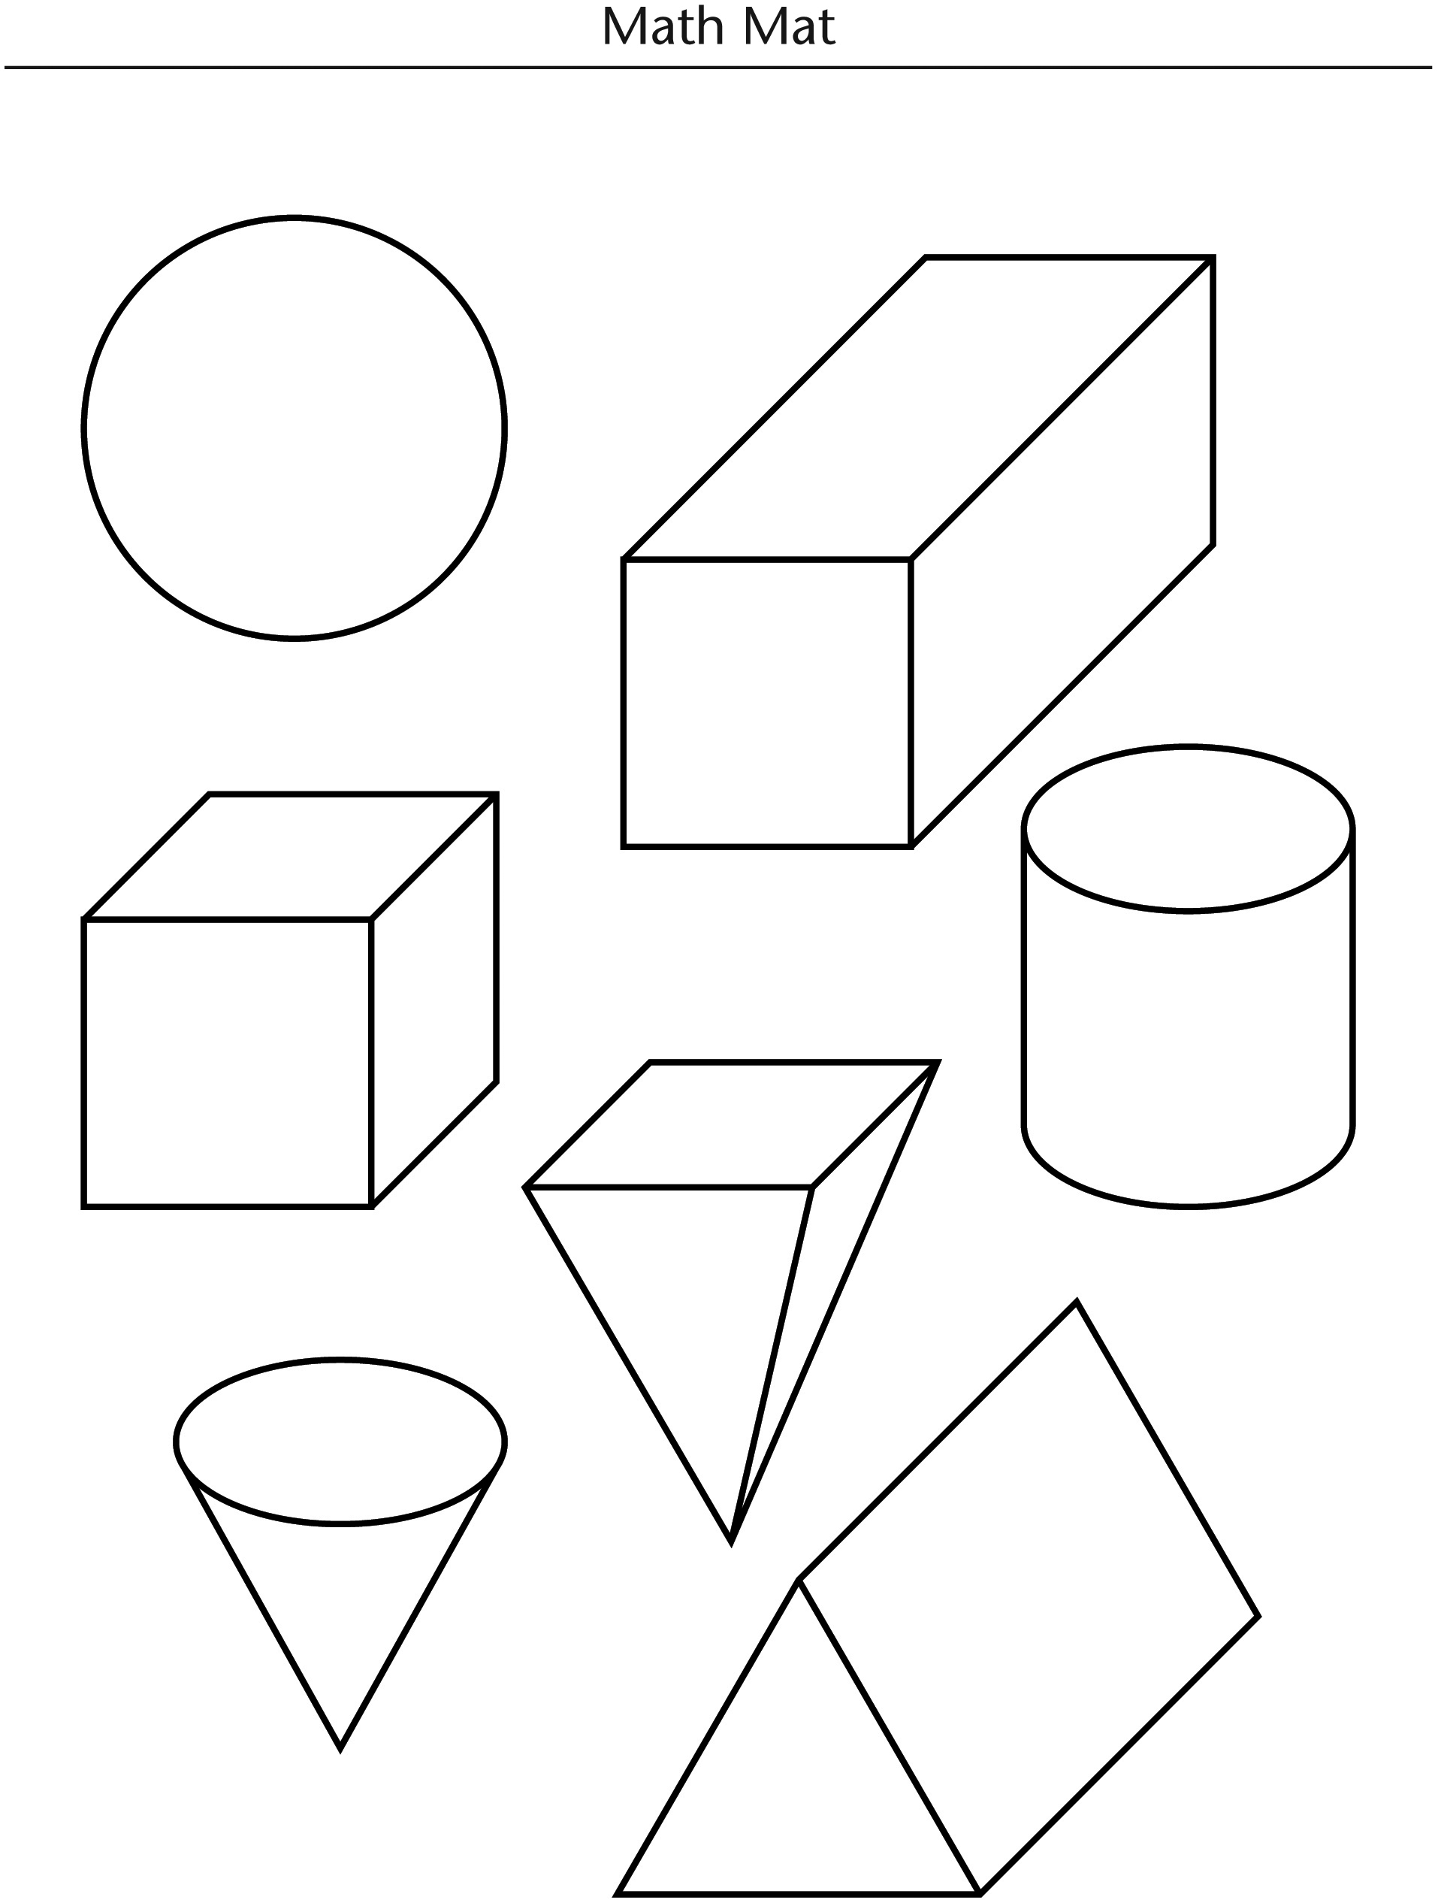

2-D Shape Cards Line Master 4

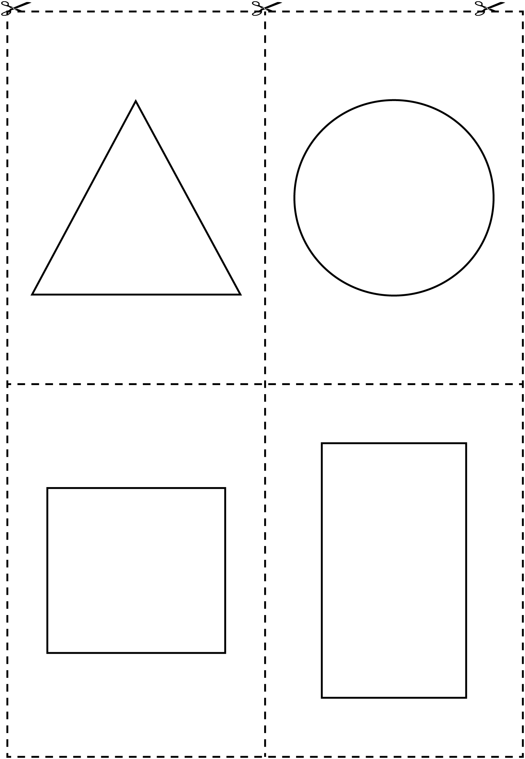

Grid Paper Line Master 5
Name: _____________________________

Dot Paper Line Master 6
Name: _____________________________

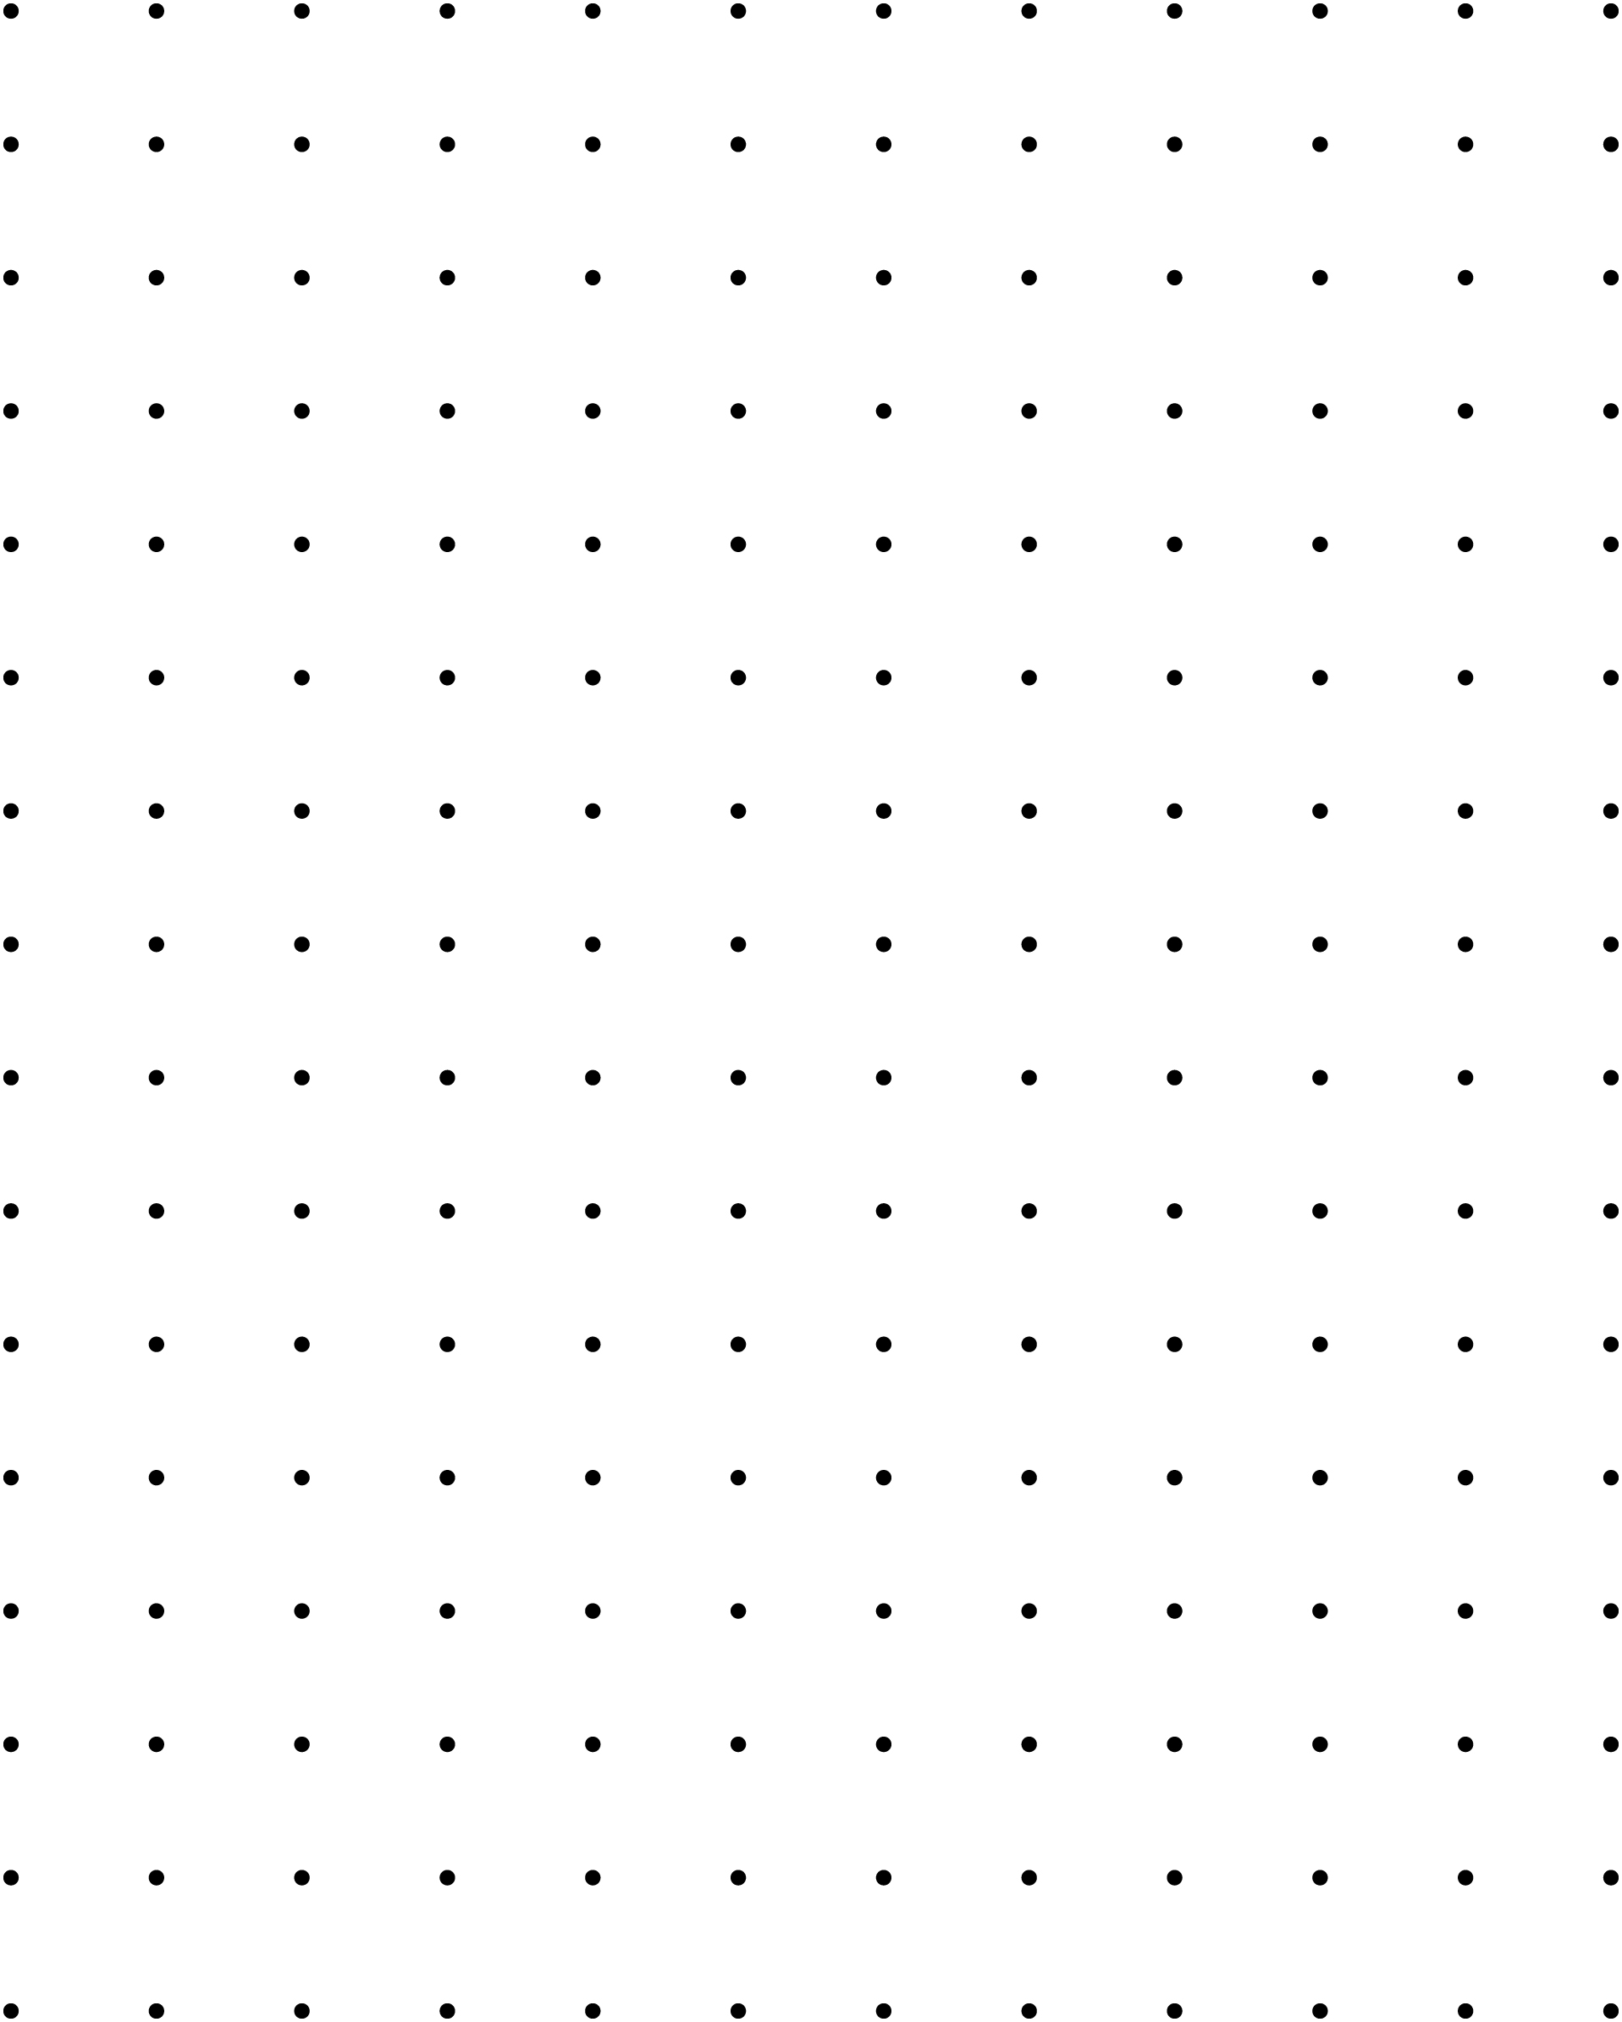

Secret Shapes Line Master 7–1

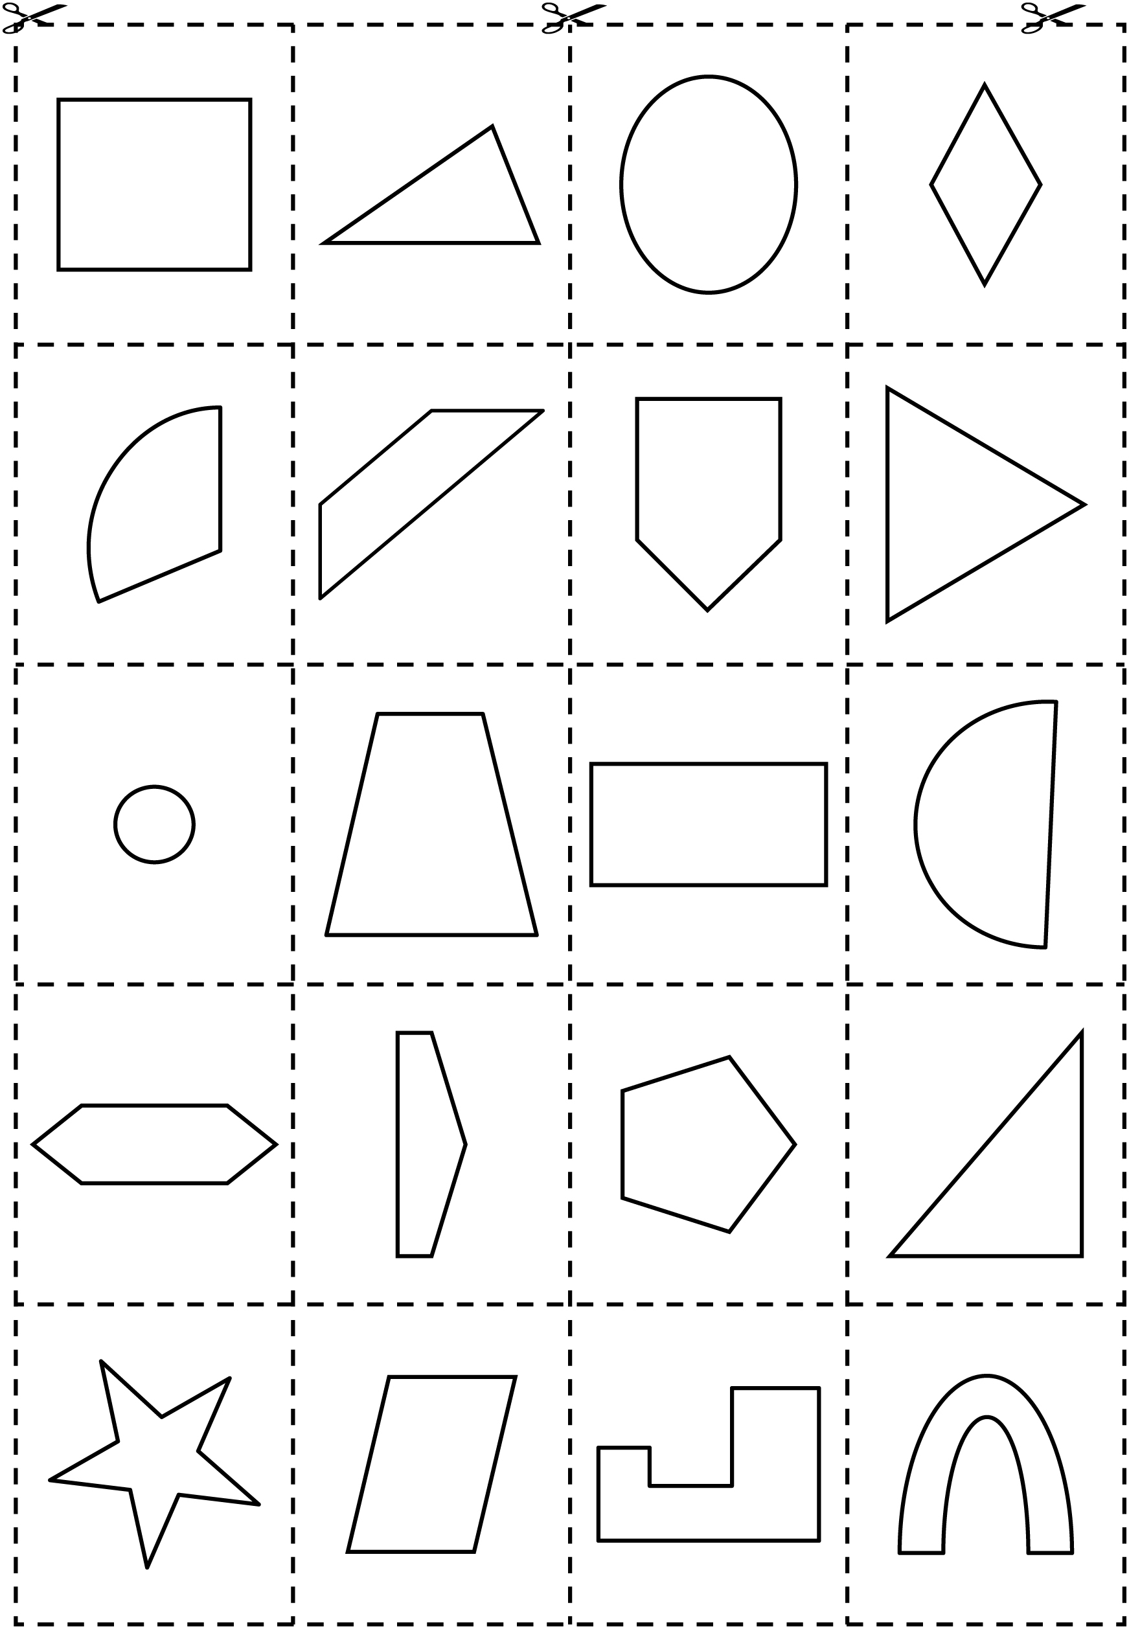

Secret Shapes Line Master 7–2

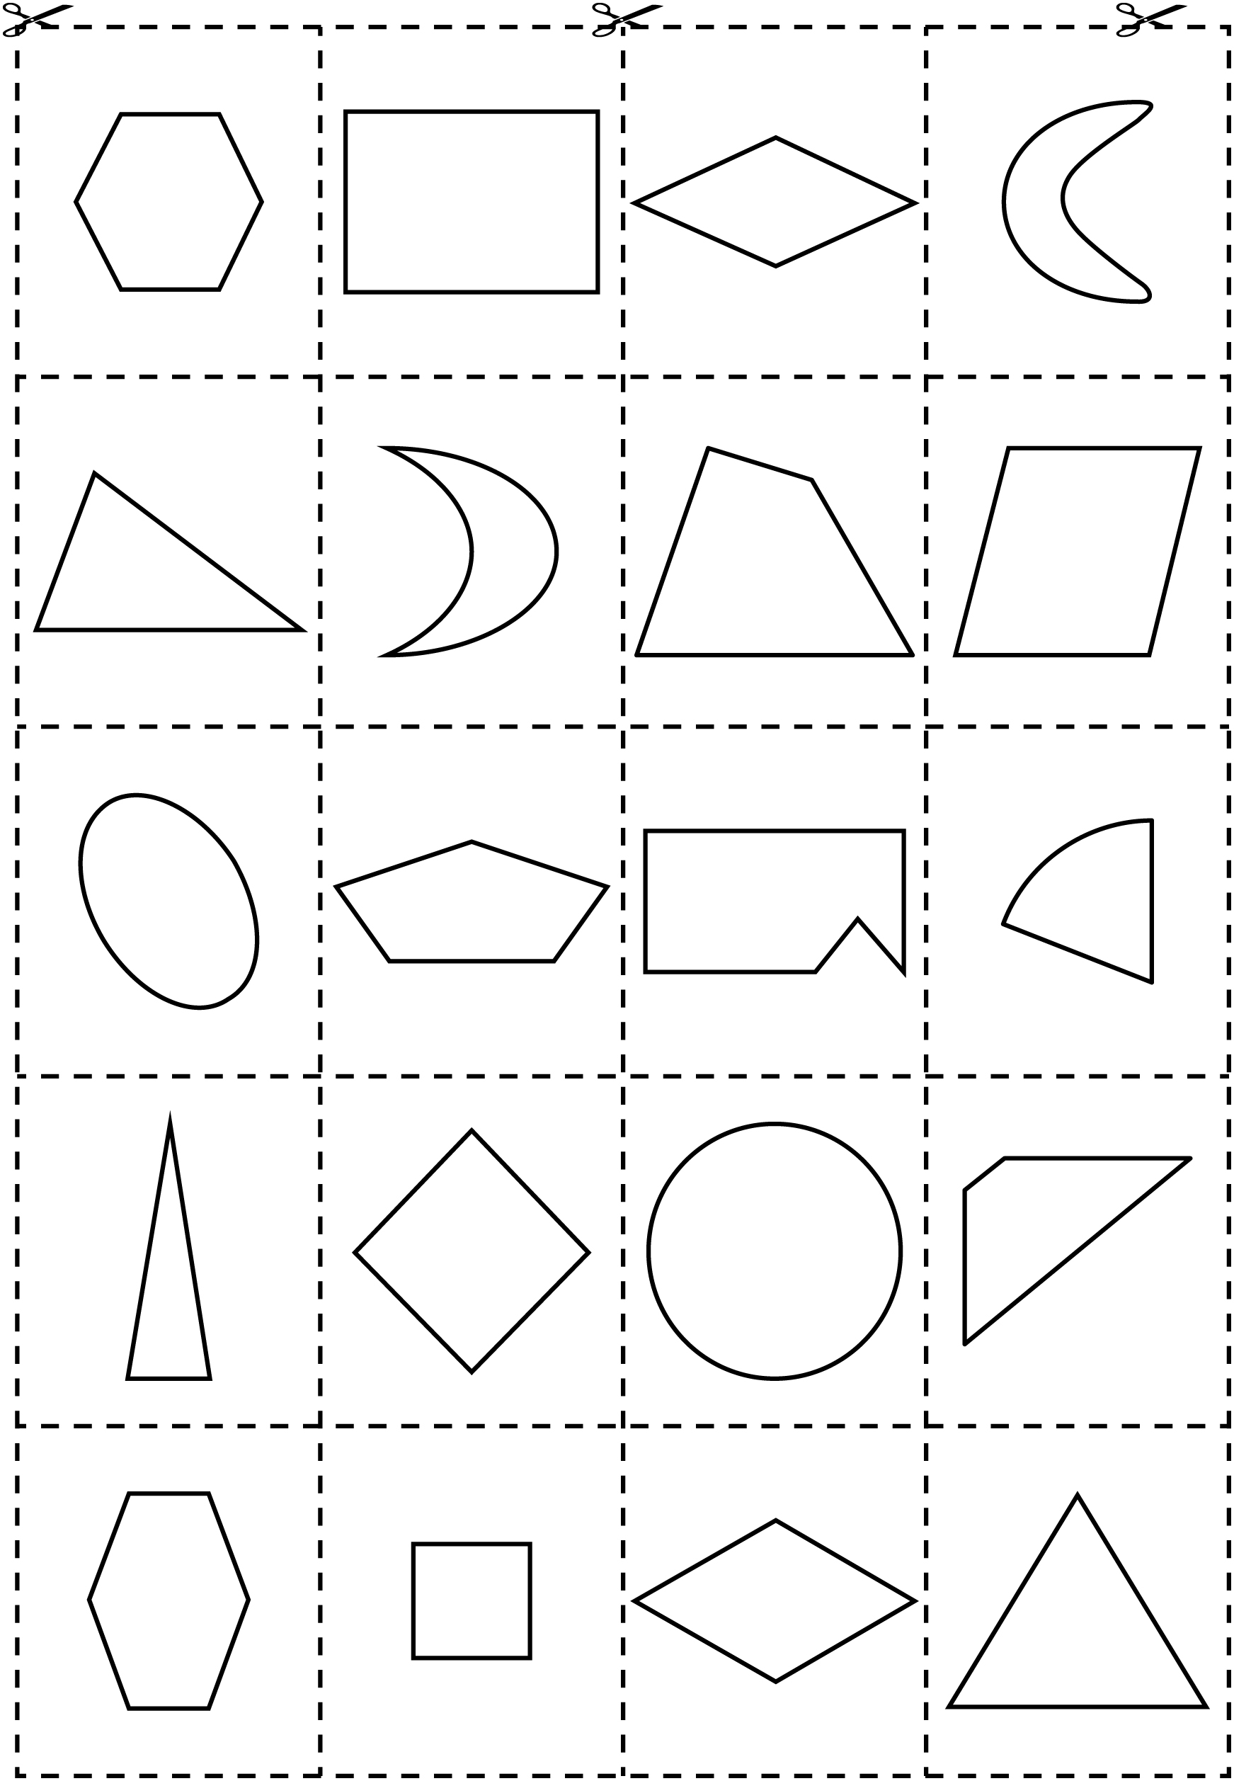

Task Cards Line Master 8–1
Make a shape with  3 sides. | Make a shape with  4 sides.
Make a shape with  3 vertices. | Make a shape with  4 vertices.
Make a square. | Make a triangle.

Task Cards Line Master 8–2
Make a 4-sided shape  that has 2 sides  of different lengths. | Make a triangle with  2 sides of equal length.
Make 2 squares of  different sizes. | Make a shape with more than 4 sides.
Make your own shape.  How many vertices does it have? | Make your own shape.  How many sides does it have?

Solids Spinner Line Master 9

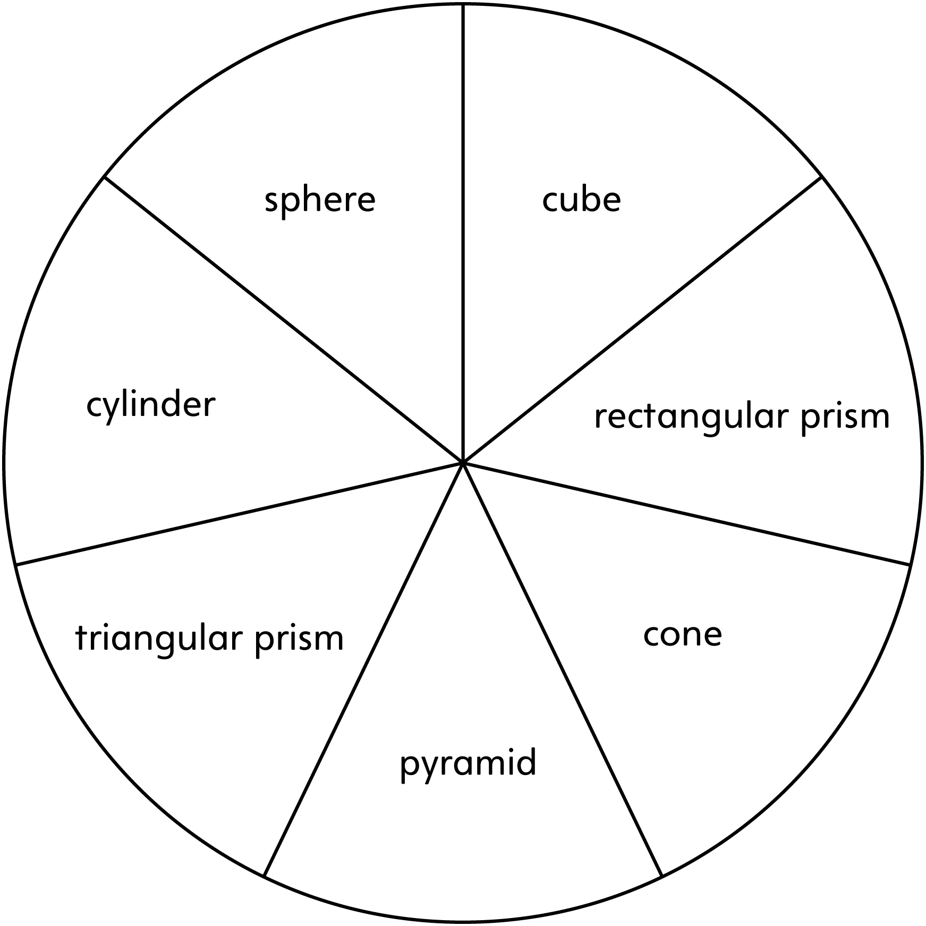

Mini-Book Template Line Master 10–1

My Book of 3-D Solids

Name: ______________________________

Mini-Book Template Line Master 10–2

This 3-D solid is called a _____________________________________ .

It has _________ faces, _________ edges, and _________ vertices.

The 2-D shape or shapes of the faces are called

_________________________________________________________________.

Writing Prompts Line Master 11–1

You are making a book about yourself. Draw a shape for the cover that tells something about you. Write about why you chose that shape. | 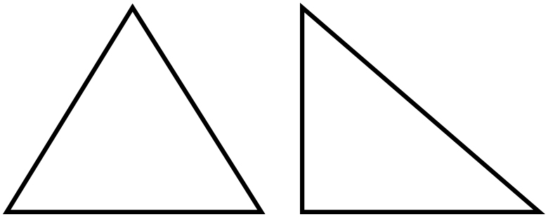  How are these shapes alike?  How are they different?
Choose a type of shape. Describe as many attributes of that shape as you can. | A shape makes you think of a rectangle, but it is not a rectangle. What shape could it be? Why?

Writing Prompts Line Master 11–2

A shape makes you think of a circle, but it is not a circle. What shape could it be? Why? | Use words, numbers, and/or symbols to describe a cube.
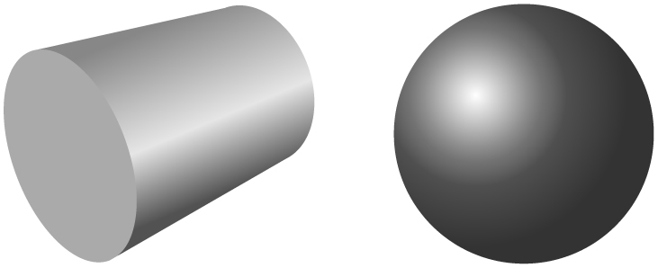  How are these two 3-D solids alike? How are they different? | 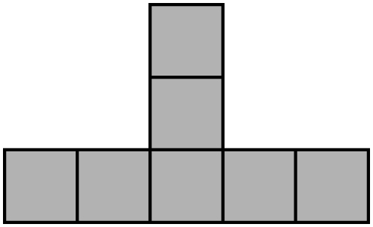  This shows one side of a structure that was built with linking cubes. How many  linking cubes were used to  build this structure? Is there more than one way to build it?  (Hint: Use linking cubes to test your ideas!)

Pattern Block Challenge Line Master 12–1

Create a triangle with these pattern blocks.  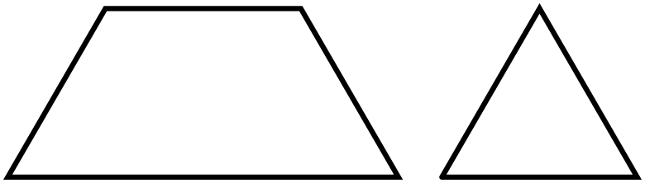 | Create a triangle with these pattern blocks.  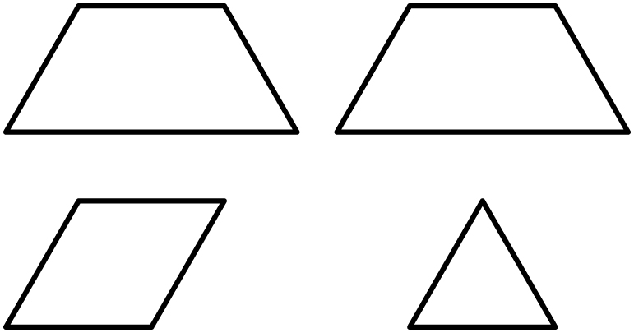
Create a triangle with these pattern blocks.  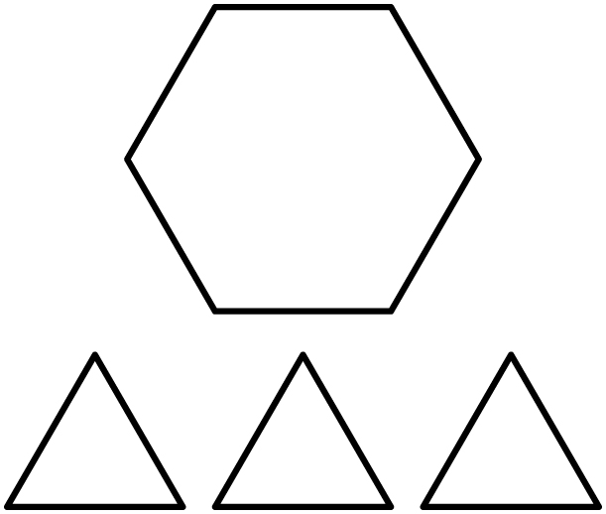 | Create a triangle with these pattern blocks.  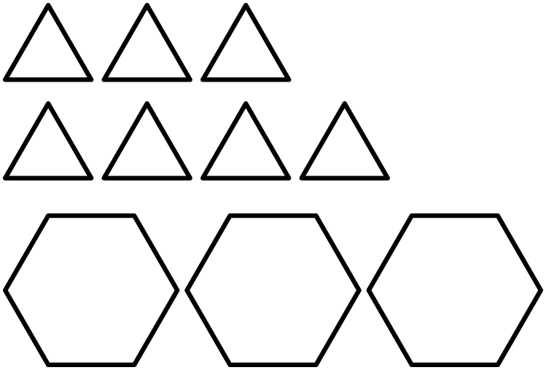

Pattern Block Challenge Line Master 12–2

Create a rectangle with these pattern blocks.  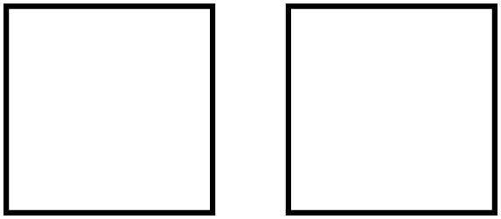 | Create a triangle with these pattern blocks.  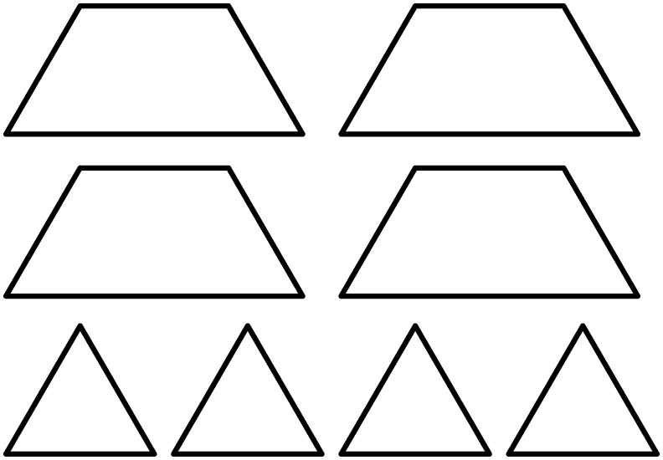
Create a square with these pattern blocks.  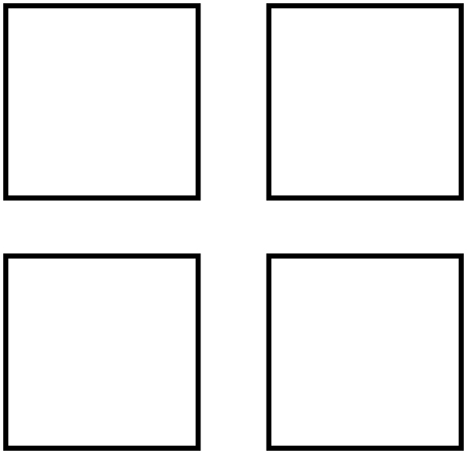 | Create a triangle with these pattern blocks.  