Marsh Watch Line Master 1
(Assessment Master)
Name: _____________________________

Collect, Organize, and Display Data | Not observed | Sometimes | Consistently
Collects data by determining (most) categories in advance
Conducts a survey
Chooses a method to record collected data (e.g., tally marks)
Constructs and labels pictographs and bar graphs
Displays data collected in more than one way and describes the differences
Read and Ask Questions About Graphs
Formulates questions that can be addressed through observation
Interprets displays by noting how many more/less than other categories
Poses and answers questions about data collected and displayed
Strengths:

Next Steps:

Connecting Home and School Line Master 2–1

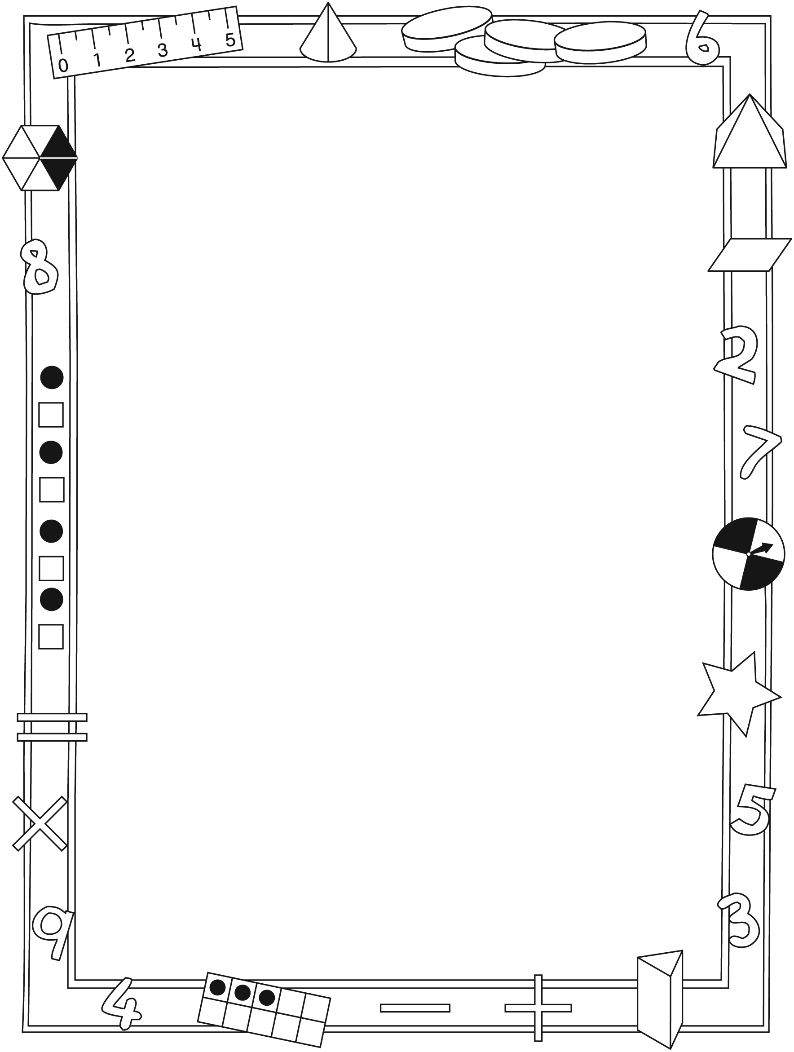

NOTE TO THE TEACHER

You may wish to send families a Marsh Watch letter outlining a familiar activity or two they can do at home with their children.

Create a letter using this template and select one or two activities from the suggestions on the next page. Simply delete these instructions and cut and paste the activities you have selected, adapting them to fit your needs.

Connecting Home and School Line Master 2–2

Dear Family:

We have been working on Marsh Watch, which engages children in conversations, investigations, and activities that help to develop their understanding of the big math idea that “Collecting and displaying data
can help us predict and interpret situations.” Particular focus is placed on conducting surveys, and making and reading pictographs and bar graphs.
Try this activity at home.
– – – – – – – – – – – – – – – – – – – – – – – – – – – – – – – – – – – – – – – – – –
Reading the Story: As you read the story, enjoy the tallying results as Josh completes his surveys and try to predict his final results. Encourage your child to identify important elements of each graph and explain the differences among them.
– – – – – – – – – – – – – – – – – – – – – – – – – – – – – – – – – – – – – – – – – –
Coin Toss: Use a coin to play. With your child, decide who goes first and whether heads or tails wins. In turn, flip the coin and record heads or tails
using tally marks. Pause after 10 or 20 turns each to tally results and determine who is ahead. Keep playing to see who can get the highest number of heads or tails. Your child can also choose to make a graph of the results.
– – – – – – – – – – – – – – – – – – – – – – – – – – – – – – – – – – – – – – – – – –
Family and Friends Survey: With your child, design a survey question to ask your family and friends about a specific topic, such as favourite colour, favourite animal, or favourite sport. Work together to come up with the question and a set of appropriate responses. Record answers using tally marks and then graph the final results as either a pictograph or bar graph.
– – – – – – – – – – – – – – – – – – – – – – – – – – – – – – – – – – – – – – – – – –
Outdoor Observation: With your child, select an outdoor space to observe. Write down the animals (or other living things) that you see during a specific time period and keep track of the numbers using tally marks. Graph the final results as either a pictograph or bar graph. Ask your child what he/she learned about your neighbourhood. How can he/she use that information? Bring the graphs to class to share with the whole group.
– – – – – – – – – – – – – – – – – – – – – – – – – – – – – – – – – – – – – – – – – –
Sincerely,

___________________________

Marsh Watch Math Mat Line Master 3

Animal Survey Line Master 4
Name: _____________________________

Survey Question: __________________________________________________________

__________________________________________________________

Animal | Tally Marks

Pictograph Templates Line Master 5–1
Vertical
Name: _____________________________
Graph Title: _____________________________

Pictograph Templates Line Master 5–2
Vertical, Guides
Name: _____________________________
Graph Title: _____________________________

Pictograph Templates Line Master 5–3
Horizontal
Name: _____________________________
Graph Title: _____________________________

Pictograph Templates Line Master 5–4
Horizontal, Guides
Name: _____________________________
Graph Title: _____________________________

Bar Graph Templates Line Master 6–1
Vertical
Name: _____________________________
Graph Title: _____________________________

Bar Graph Templates Line Master 6–2
Horizontal
Name: _____________________________
Graph Title: _____________________________

Earth Day Survey Line Master 7

Survey Question: __________________________________________________________

__________________________________________________________

Earth Day Idea | Tally Marks

Earth Day Recommendations Line Master 8

– – – – – – – – – – – – – – – – – – – – – – – – – – – – – – – – – – – – – – – – – –
Name: _____________________________
Date: _____________________________

For Earth Day, I think we should _______________________________________________

___________________________________________________________________________________________

___________________________________________________________________________________________

___________________________________________________________________________________________

___________________________________________________________________________________________

___________________________________________________________________________________________
– – – – – – – – – – – – – – – – – – – – – – – – – – – – – – – – – – – – – – – – – –
Name: _____________________________
Date: _____________________________

For Earth Day, I think we should _______________________________________________

___________________________________________________________________________________________

___________________________________________________________________________________________

___________________________________________________________________________________________

___________________________________________________________________________________________

___________________________________________________________________________________________
– – – – – – – – – – – – – – – – – – – – – – – – – – – – – – – – – – – – – – – – – –

Survey Template Line Master 9
Name: _____________________________
Survey Question: __________________________________________________________

__________________________________________________________

Coin Toss Line Master 10
– – – – – – – – – – – – – – – – – – – – – – – – – – – – – – – – – – – – – – – – – –
Player 1: _____________________________

Heads
Tails

Player 2: _____________________________

Heads
Tails
– – – – – – – – – – – – – – – – – – – – – – – – – – – – – – – – – – – – – – – – – –
Player 1: _____________________________

Colour 1
___________
Colour 2
___________

Player 2: _____________________________

Colour 1
___________
Colour 2
___________
– – – – – – – – – – – – – – – – – – – – – – – – – – – – – – – – – – – – – – – – – –

My Recommendations Line Master 11
– – – – – – – – – – – – – – – – – – – – – – – – – – – – – – – – – – – – – – – – – –
Name: _____________________________
Date: _____________________________

My question is: ______________________________________________________________________

___________________________________________________________________________________________

I think we should: __________________________________________________________________

___________________________________________________________________________________________

___________________________________________________________________________________________

___________________________________________________________________________________________
– – – – – – – – – – – – – – – – – – – – – – – – – – – – – – – – – – – – – – – – – –
Name: _____________________________
Date: _____________________________

My question is: ______________________________________________________________________

___________________________________________________________________________________________

I think we should: __________________________________________________________________

___________________________________________________________________________________________

___________________________________________________________________________________________

___________________________________________________________________________________________
– – – – – – – – – – – – – – – – – – – – – – – – – – – – – – – – – – – – – – – – – –

Graphing Problems Line Master 12–1
– – – – – – – – – – – – – – – – – – – – – – – – – – – – – – – – – – – – – – – – – –
Suppose you asked your classmates what their favourite colour was:

Red = |||| | Orange = |||
Blue = |||| |||| | Yellow = ||

Which colour was the most popular? Which colour was the least popular? Explain how you know.

– – – – – – – – – – – – – – – – – – – – – – – – – – – – – – – – – – – – – – – – – –
Suppose you asked your classmates what their favourite colour was:
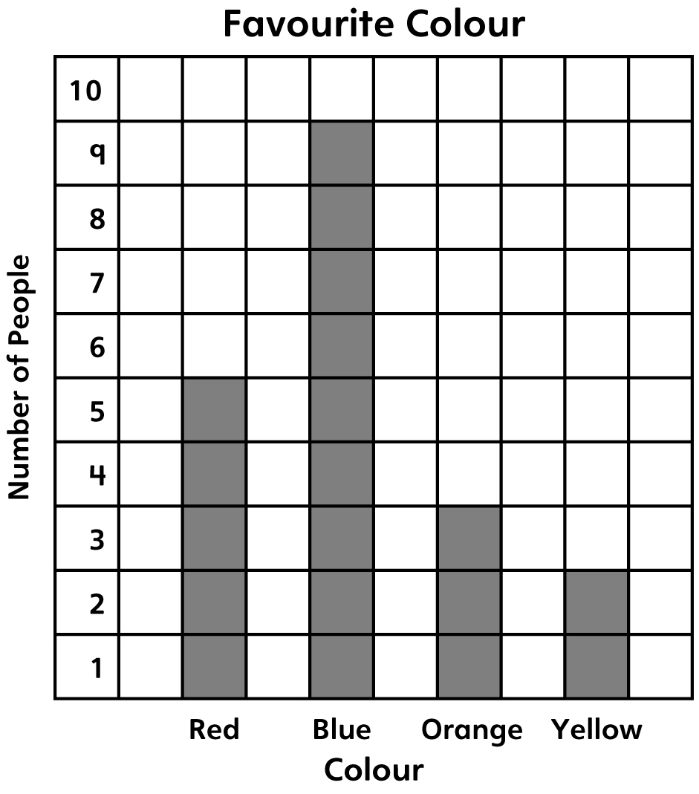

How many people chose yellow? How many more people chose blue?

– – – – – – – – – – – – – – – – – – – – – – – – – – – – – – – – – – – – – – – – – –

Graphing Problems Line Master 12–2
– – – – – – – – – – – – – – – – – – – – – – – – – – – – – – – – – – – – – – – – – –
Suppose you asked your classmates what their favourite season was:

Spring = |||| | | Autumn = ||||
Summer = |||| ||| | Winter = ||

Which season was the most popular? Which season was the least popular? Explain how you know.

Use the data in the tally chart to create a bar graph of your classmate’s favourite season.

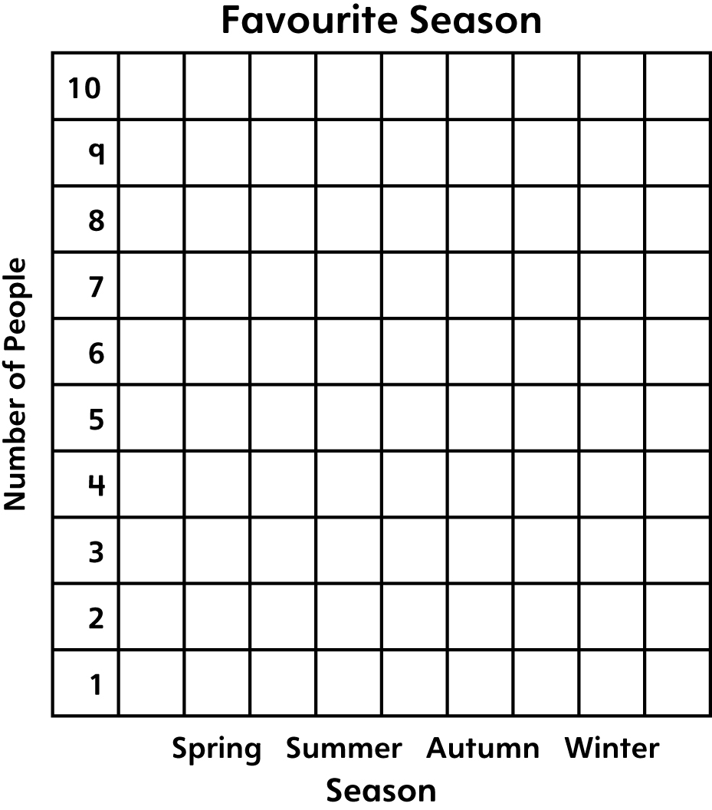

– – – – – – – – – – – – – – – – – – – – – – – – – – – – – – – – – – – – – – – – – –

Graphing Problems Line Master 12–3
– – – – – – – – – – – – – – – – – – – – – – – – – – – – – – – – – – – – – – – – – –
Josh observed the marsh again.
His observations are shown in this chart:

Turtle Marsh Animal Groups Count
Amphibians | |||| |||
Mammals | |||
Reptiles | |||| ||
Birds | |||| ||||
Fish | |||| |||| ||

How many more fish than mammals did Josh see on this visit?

Use words, numbers, and/or drawings to explain how you got
your answer.

– – – – – – – – – – – – – – – – – – – – – – – – – – – – – – – – – – – – – – – – – –

