**Robo** **Line Master 1** (Assessment Master)

**Name:** _____________________________

|  |  |  |  |
| --- | --- | --- | --- |
| **Describe the Location of Objects** | **Not observed** | **Sometimes** | **Consistently** |
| Provides instructions to locate an object in the environment |  |  |  |
| Visualizes and creates 2-D representations (e.g., top/front/side views) of 3-D objects |  |  |  |
| **Explore and Describe the Movement of Objects** |  |  |  |
| Uses positional language (e.g., through, around, between, across, along, up, down, over) to describe the movement of objects |  |  |  |
| Uses a map to describe the path by which an object moves from one location to another |  |  |  |
| Uses words and/or gestures to show directions |  |  |  |

**Strengths:**

**Next Steps:**

**Connecting Home and School Line Master 2–1**

**NOTE TO THE TEACHER**

You may wish to send families a ***Robo*** letter outlining a familiar activity or two they can do at home with their children.

Create a letter using this template and select one or two activities from the suggestions on the next page. Simply **delete these instructions and cut and paste the activities you have selected**, adapting them to fit your needs.

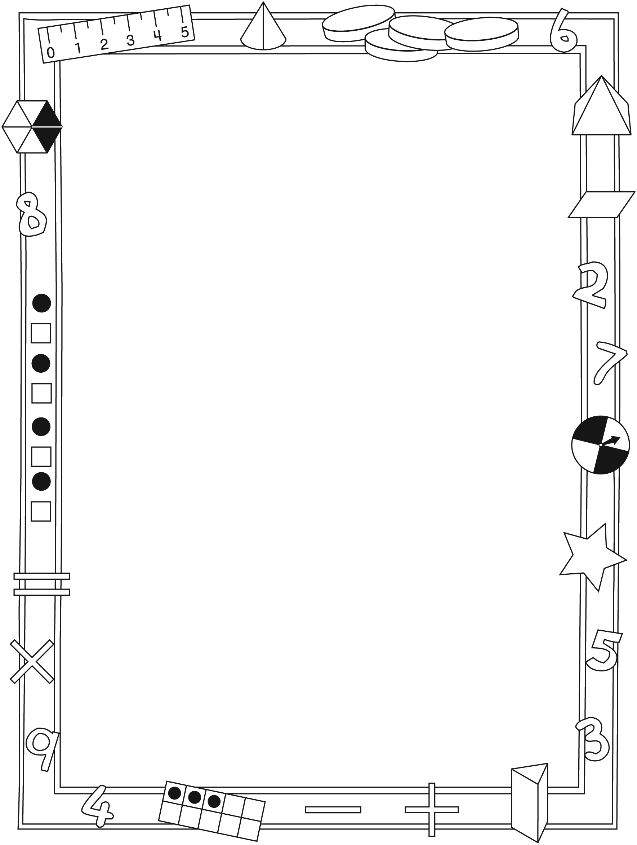

**Connecting Home and School Line Master 2–2**

Dear Family:

We have been working on ***Robo***, which engages children in conversations, investigations, and activities that help to develop their understanding of the big math idea that “Objects can be located in space and looked at from different perspectives.” Particular focus is placed on describing the location of objects and exploring and describing the movement of objects. Try this activity at home with your child.

✂ – – – – – – – – – – – – – – – – – – – – – – – – – – – – – – – – – – – – – – – – – –

**Reading the Story:** As you read the story, talk about how some robots move and how they need the instructions of their human owners to tell them which way to go to complete a task. After you read, you might use the mat on the inside back cover to re-create some of the different situations from the story.

✂ – – – – – – – – – – – – – – – – – – – – – – – – – – – – – – – – – – – – – – – – – –

**Robo Navigator:** Use the mat on the inside back cover as a game board and a small object to represent Robo. Take turns choosing a starting point and a destination for Robo (e.g., kitchen, family room), and then saying the directions to get there. The other player moves the object (robot) according to the instructions. This activity can be extended to include places in the home. For example, what instructions would Robo follow to get from your kitchen to your child’s bedroom?

✂ – – – – – – – – – – – – – – – – – – – – – – – – – – – – – – – – – – – – – – – – – –

**Directional Hide and Seek:** One person hides a small object such as a toy and provides step-by-step instructions to lead the other person to it (e.g., go forward   
4 steps; turn right; go forward 5 steps; reach down to the floor and pick up the box of crayons).

✂ – – – – – – – – – – – – – – – – – – – – – – – – – – – – – – – – – – – – – – – – – –

**Neighbourhood Maps:** Together, draw a simple map of your neighbourhood. Take turns imagining you have hidden an object somewhere in the neighbourhood. The person who is guessing asks questions using direction words, such as *right, left, up,* and *down,* to find the location.

✂ – – – – – – – – – – – – – – – – – – – – – – – – – – – – – – – – – – – – – – – – – –

Sincerely,

___________________________

***Robo* Math Mat Line Master 3**

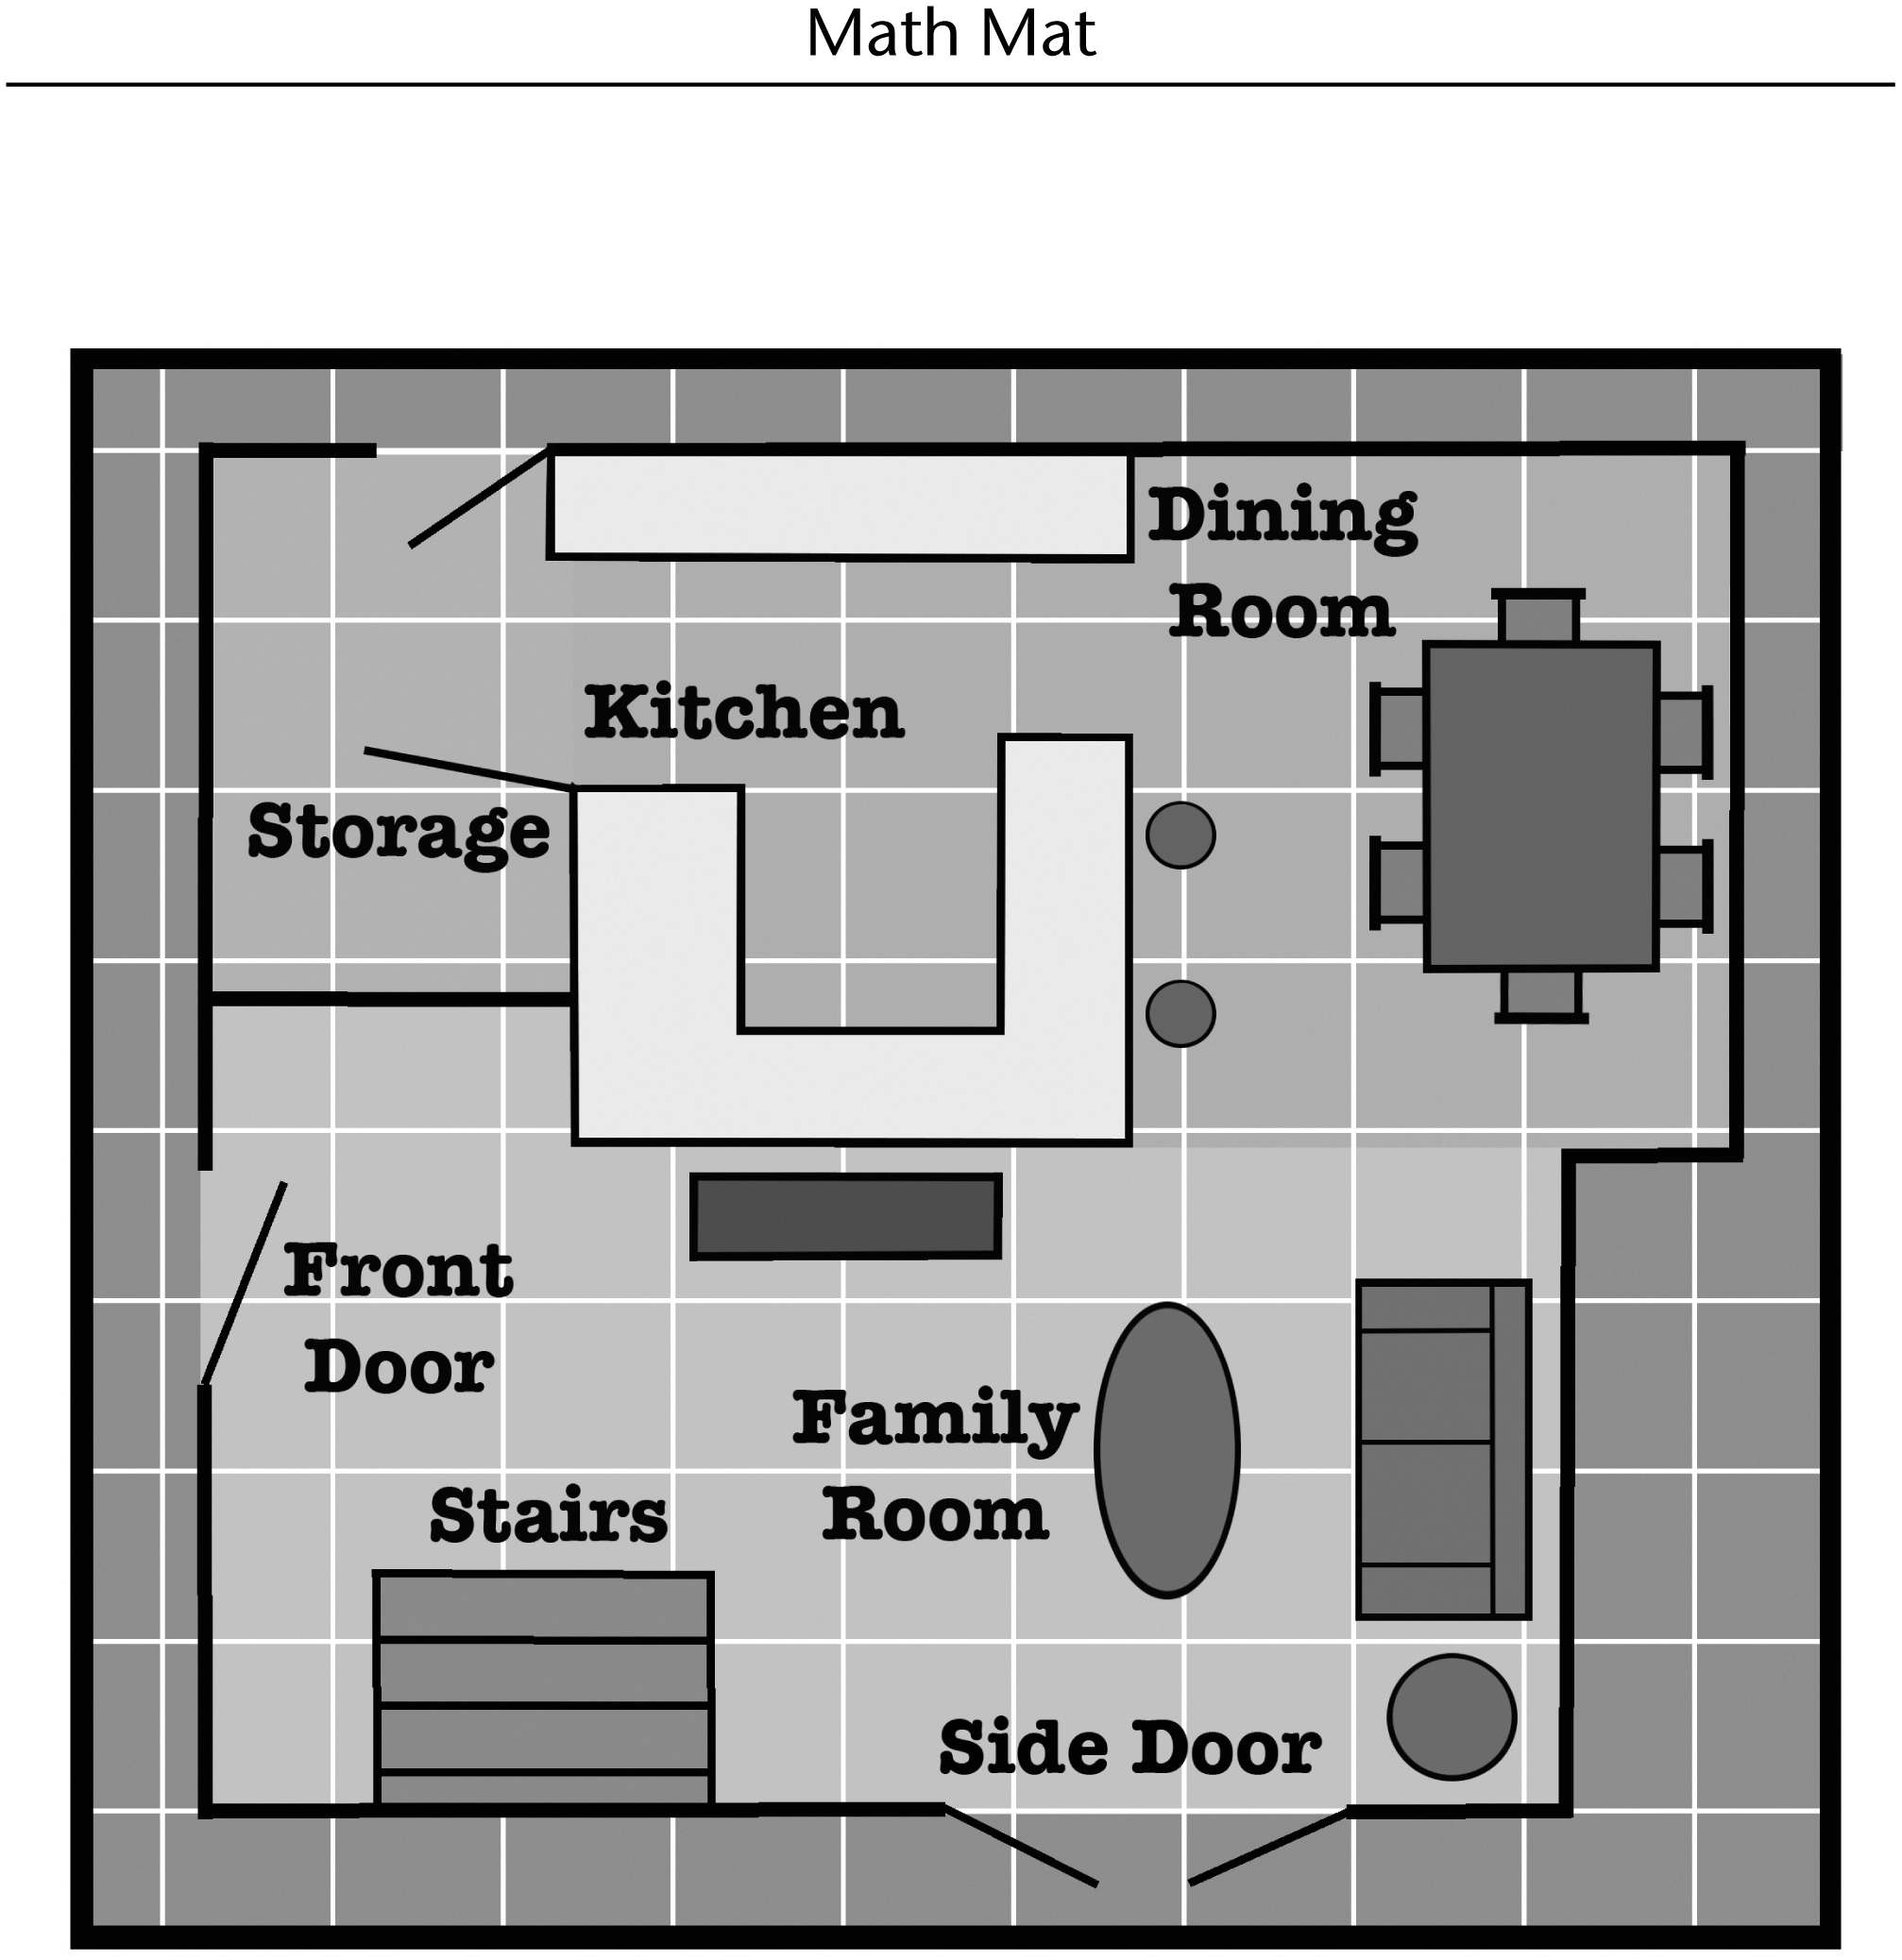

**Game Path Line Master 4–1**

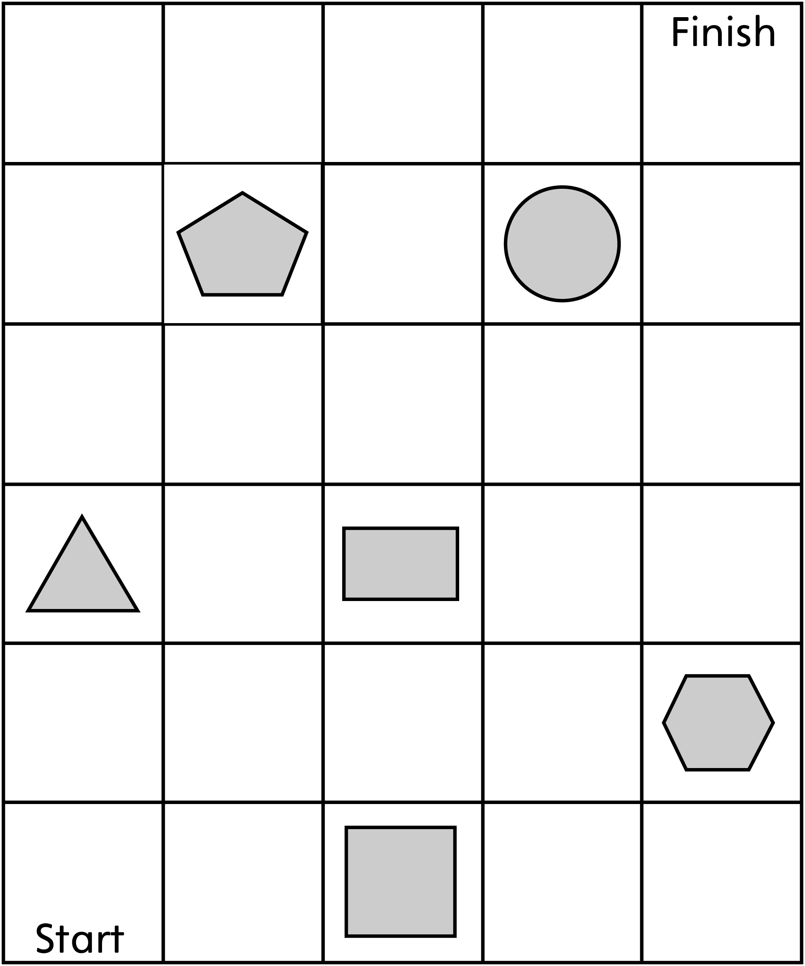

**Game Path Line Master 4–2**

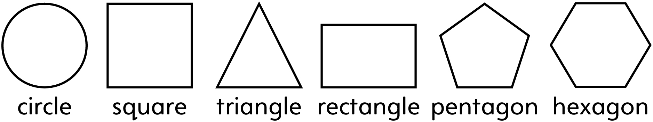

**Describe your path. Write shape names to complete the sentences.**

My path goes to the **right** of the ____________________________.

My path goes to the **left** of the ______________________________.

My path goes **over** the _______________________________________.

My path goes **under** the _____________________________________.

My path goes **between** the __________________________________

and the ______________________________________.

**Can you think of any more ways to describe your path? You might use words, numbers, or drawings. Write your answer below.**

**Barrier Game Line Master 5**

|  |  |  |  |  |
| --- | --- | --- | --- | --- |
|  |  |  |  |  |
|  |  |  |  |  |
|  |  |  |  |  |
|  |  |  |  |  |
|  |  |  |  |  |
|  |  |  |  |  |
|  |  |  |  |  |

**Direction Game Board Line Master 6**

**Name:** _____________________________

|  |  |  |  |  |  |
| --- | --- | --- | --- | --- | --- |
|  |  |  |  |  | **Finish** |
|  |  |  |  |  |  |
|  |  |  |  |  |  |
|  |  |  |  |  |  |
|  |  |  |  |  |  |
| **Start** |  |  |  |  |  |

**Direction Cards Line Master 7**

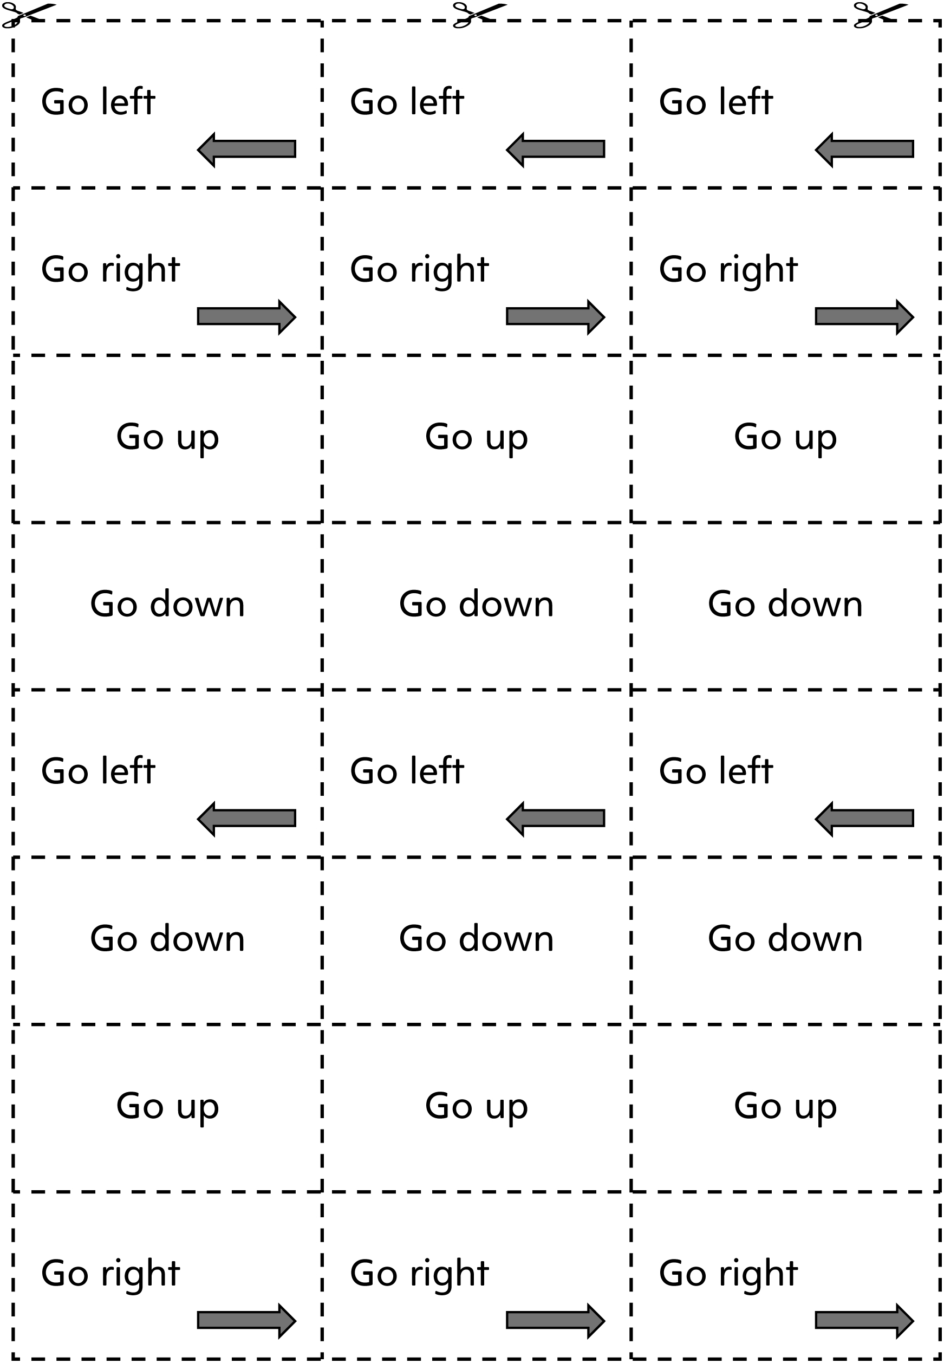

**I Spy Line Master 8**

|  |  |
| --- | --- |
| **Player 1** | **Player 2** |
| Questions asked:  Guesses made:  Was one of my guesses correct? **Yes No** | Questions asked:  Guesses made:  Was one of my guesses correct? **Yes No** |
| Questions asked:  Guesses made:  Was one of my guesses correct? **Yes No** | Questions asked:  Guesses made:  Was one of my guesses correct? **Yes No** |
| Questions asked:  Guesses made:  Was one of my guesses correct? **Yes No** | Questions asked:  Guesses made:  Was one of my guesses correct? **Yes No** |
| Questions asked:  Guesses made:  Was one of my guesses correct? **Yes No** | Questions asked:  Guesses made:  Was one of my guesses correct? **Yes No** |

**Pattern Paths Line Master 9–1**

Place the Pattern Blocks on the grid so that

is above the

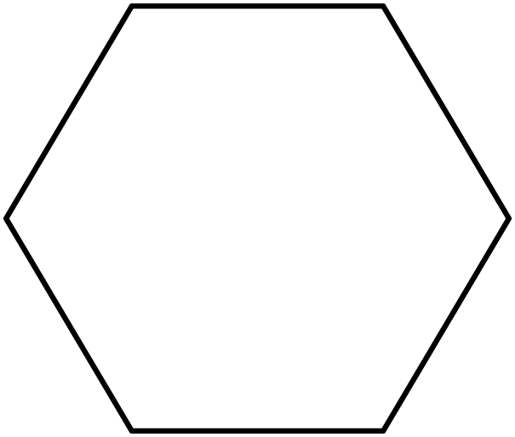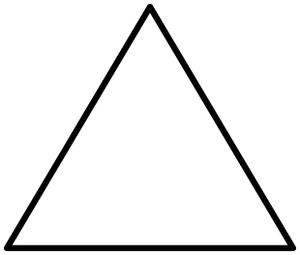

is to the left of the



is below the

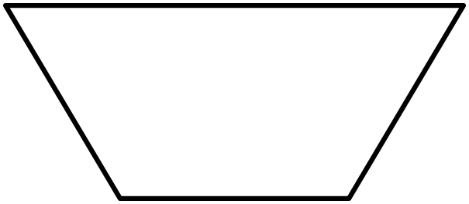

**Pattern Paths Line Master 9–2**

|  |  |  |
| --- | --- | --- |
|  |  |  |
|  |  |  |
|  |  |  |
|  |  |  |

**Where Is Robo? Line Master 10**

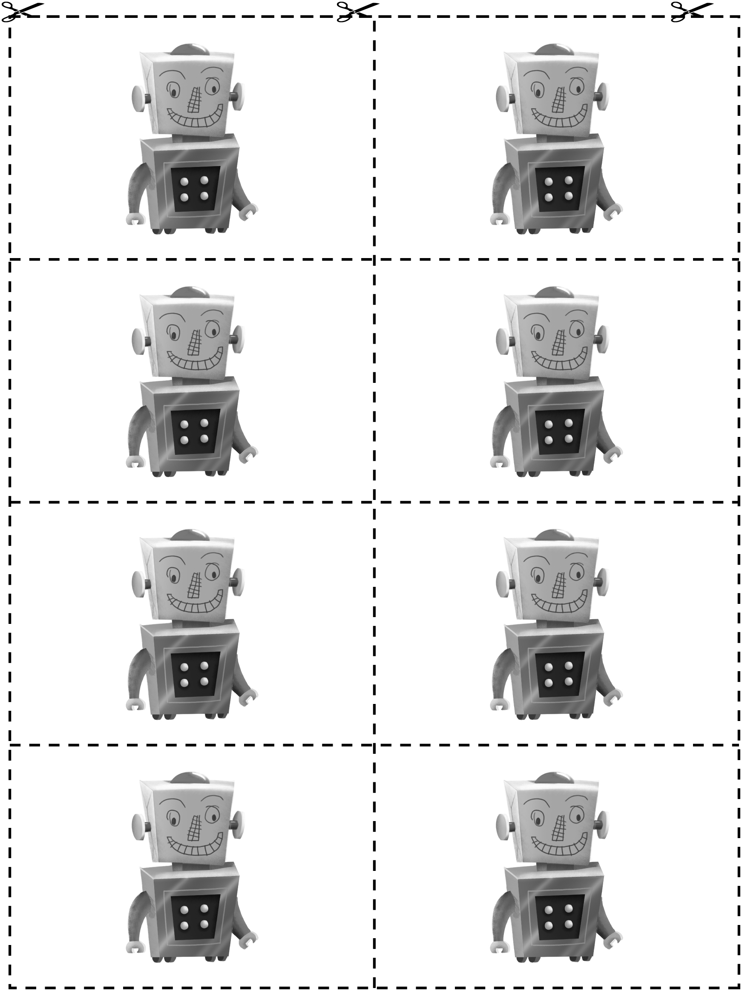

**Where Is It? Line Master 11**



|  |  |
| --- | --- |
| Where Is It? |  |
|  |  |

**Where To? Problems Line Master 12–1**

✂ – – – – – – – – – – – – – – – – – – – – – – – – – – – – – – – – – – – – – – – – – –

Draw a path that begins at **“Start”** and moves to **“Finish**.” Then describe your path.

**Path 1**

|  |  |  |  |  |
| --- | --- | --- | --- | --- |
|  |  |  |  | **Finish** |
|  |  |  |  |  |
|  |  |  |  |  |
|  |  |  |  |  |
| **Start** |  |  |  |  |

✂ – – – – – – – – – – – – – – – – – – – – – – – – – – – – – – – – – – – – – – – – – –

Draw a path that begins at **“Start”** and moves to **“Finish**.” Then describe your path.

**Path 2**

|  |  |  |  |  |
| --- | --- | --- | --- | --- |
|  |  |  |  | **Finish** |
|  |  |  |  |  |
|  |  |  |  |  |
|  |  |  |  |  |
| **Start** |  |  |  |  |

✂ – – – – – – – – – – – – – – – – – – – – – – – – – – – – – – – – – – – – – – – – – –

**Where To? Problems Line Master 12–2**

✂ – – – – – – – – – – – – – – – – – – – – – – – – – – – – – – – – – – – – – – – – – –

Draw a path that begins at **“Start”** and moves to **“Finish**.” Then describe your path.

**Path 3**

|  |  |  |  |  |
| --- | --- | --- | --- | --- |
|  |  |  |  | **Finish** |
|  |  |  |  |  |
|  |  |  |  |  |
|  |  |  |  |  |
| **Start** |  |  |  |  |

✂ – – – – – – – – – – – – – – – – – – – – – – – – – – – – – – – – – – – – – – – – – –

Draw a path that begins at **“Start”** and moves to **“Finish**.” Then describe your path.

**Path 4**

|  |  |  |  |  |
| --- | --- | --- | --- | --- |
|  |  |  |  | **Finish** |
|  |  |  |  |  |
|  |  |  |  |  |
|  |  |  |  |  |
| **Start** |  |  |  |  |

✂ – – – – – – – – – – – – – – – – – – – – – – – – – – – – – – – – – – – – – – – – – –