Sharing Our Stories Line Master 1
(Assessment Master)
Name: _____________________________

Explore lines of symmetry in  2-D shapes | Not observed | Sometimes | Consistently
Can explain what it means for a shape or design to be symmetrical
Distinguishes between symmetrical and asymmetrical shapes
Can identify the line(s) of symmetry on a 2-D shape
Can construct a symmetrical design
Can complete a symmetrical design
Explore 2-D shapes
Identifies and describes various shapes according to geometric properties
Recognizes and identifies 2-D shapes embedded in 3-D objects
Connects 2-D shapes to 3-D solids
Strengths:

Next Steps:

Connecting Home and School Line Master 2–1

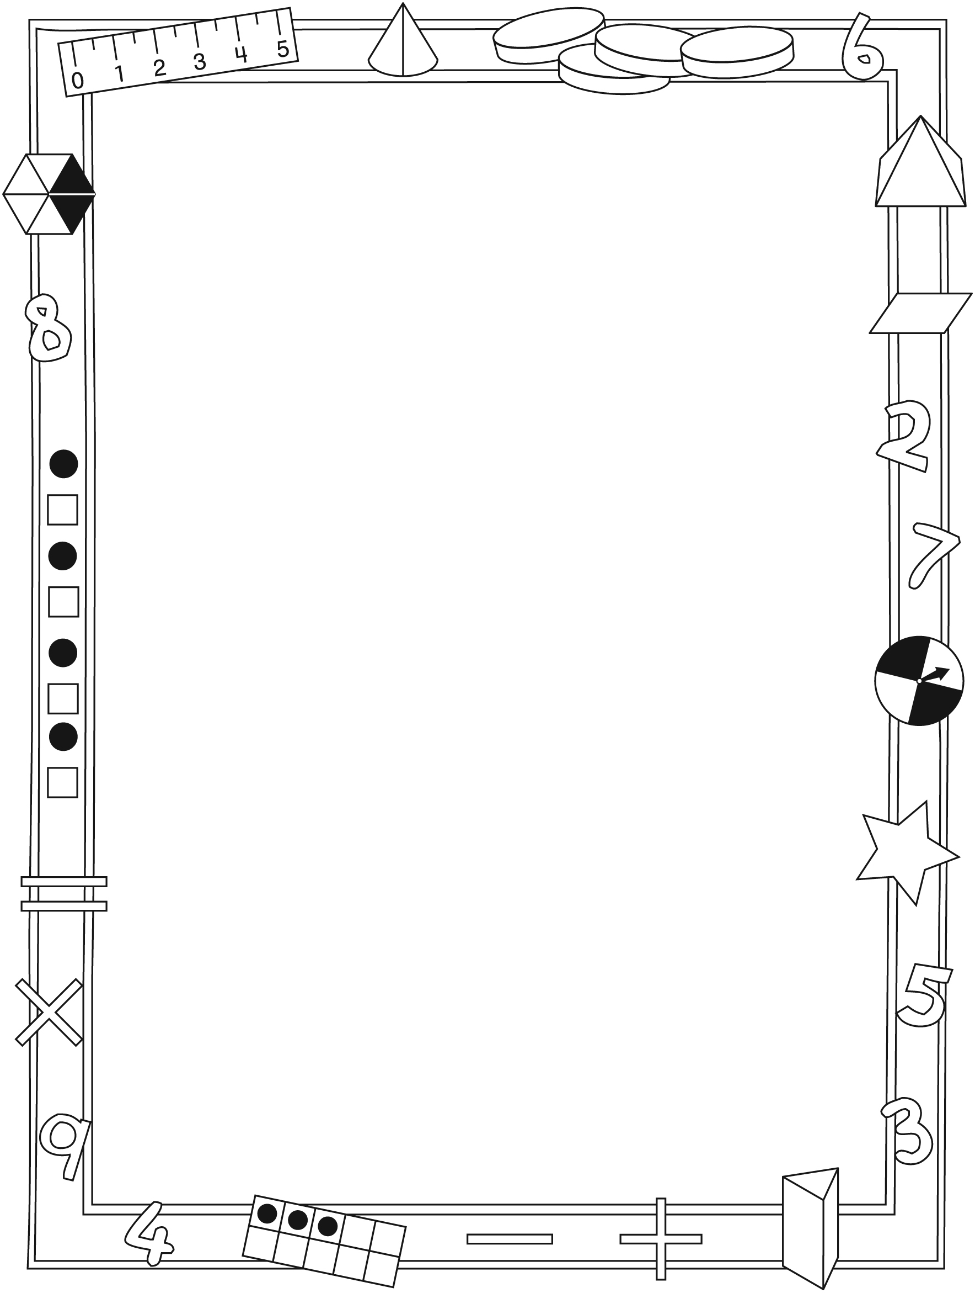

NOTE TO THE TEACHER

You may wish to send families a Sharing Our Stories letter outlining a familiar activity or two they can do at home with their children.

Create a letter using this template and select one or two activities from the suggestions on the next page. Simply delete these instructions and cut and paste the activities you have selected, adapting them to fit your needs.

Connecting Home and School Line Master 2–2

Dear Family:

We have been reading Sharing Our Stories, which engages children in conversations, investigations, and activities to help develop understanding
of the big math idea that “Shapes and solids can be transformed in many ways.” We have been exploring 2-D shapes and lines of symmetry on shapes. Try this activity at home with your child.
– – – – – – – – – – – – – – – – – – – – – – – – – – – – – – – – – – – – – – – – – –
Reading the Story: As you read the story, encourage your child to identify and describe the 2-D shapes she/he see. Invite him/her to count the number of sides and vertices (corners) each shape has and to determine if the shape is symmetrical. Discuss what it means for a shape to be symmetrical and look
for examples of symmetry throughout the book.
– – – – – – – – – – – – – – – – – – – – – – – – – – – – – – – – – – – – – – – – – –
Shape Treasure Hunt: Encourage your child to look for shapes around your home and on the way to school, and to record what she/he finds using words and drawings. Challenge your child to find 2-D shapes on 3-D solids and record them as well (e.g., the rectangular side of a toaster, the square on the bottom of a milk carton). Invite your child to bring his/her findings to school and share them with the class.
– – – – – – – – – – – – – – – – – – – – – – – – – – – – – – – – – – – – – – – – – –
Symmetrical Designs: Invite your child to create a symmetrical design. Provide her/him with a blank sheet of paper or grid paper and draw a line down the middle (either horizontally or vertically). Remind your child that both sides/halves of the paper have to match (same shapes, same colours, same design).
– – – – – – – – – – – – – – – – – – – – – – – – – – – – – – – – – – – – – – – – – –
Shape I Spy: Invite your child to identify 2-D shapes through a game of I Spy.
For example, if your child sees a triangle, he/she might say, “I spy a shape with 3 sides.” Encourage him/her to give increasingly detailed clues that include lines of symmetry (e.g., “I spy a shape with 4 vertices (corners) and 2 lines of symmetry”).
– – – – – – – – – – – – – – – – – – – – – – – – – – – – – – – – – – – – – – – – – –
Sincerely,

___________________________

Sharing Our Stories Line Master 3
Math Mat

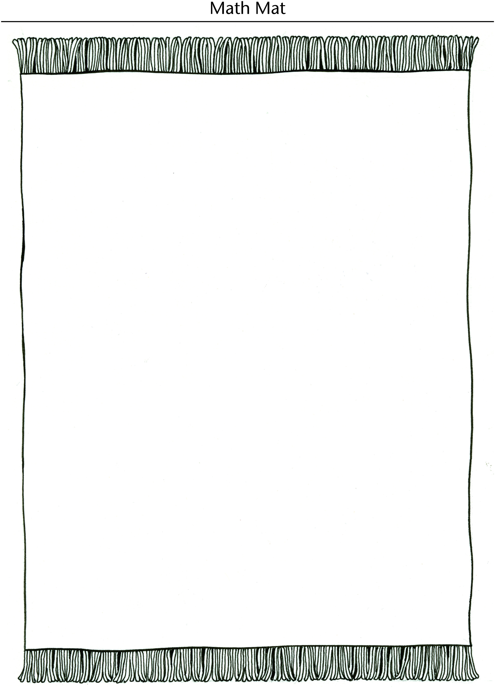

Symmetrical and Line Master 4–1
Asymmetrical Shapes

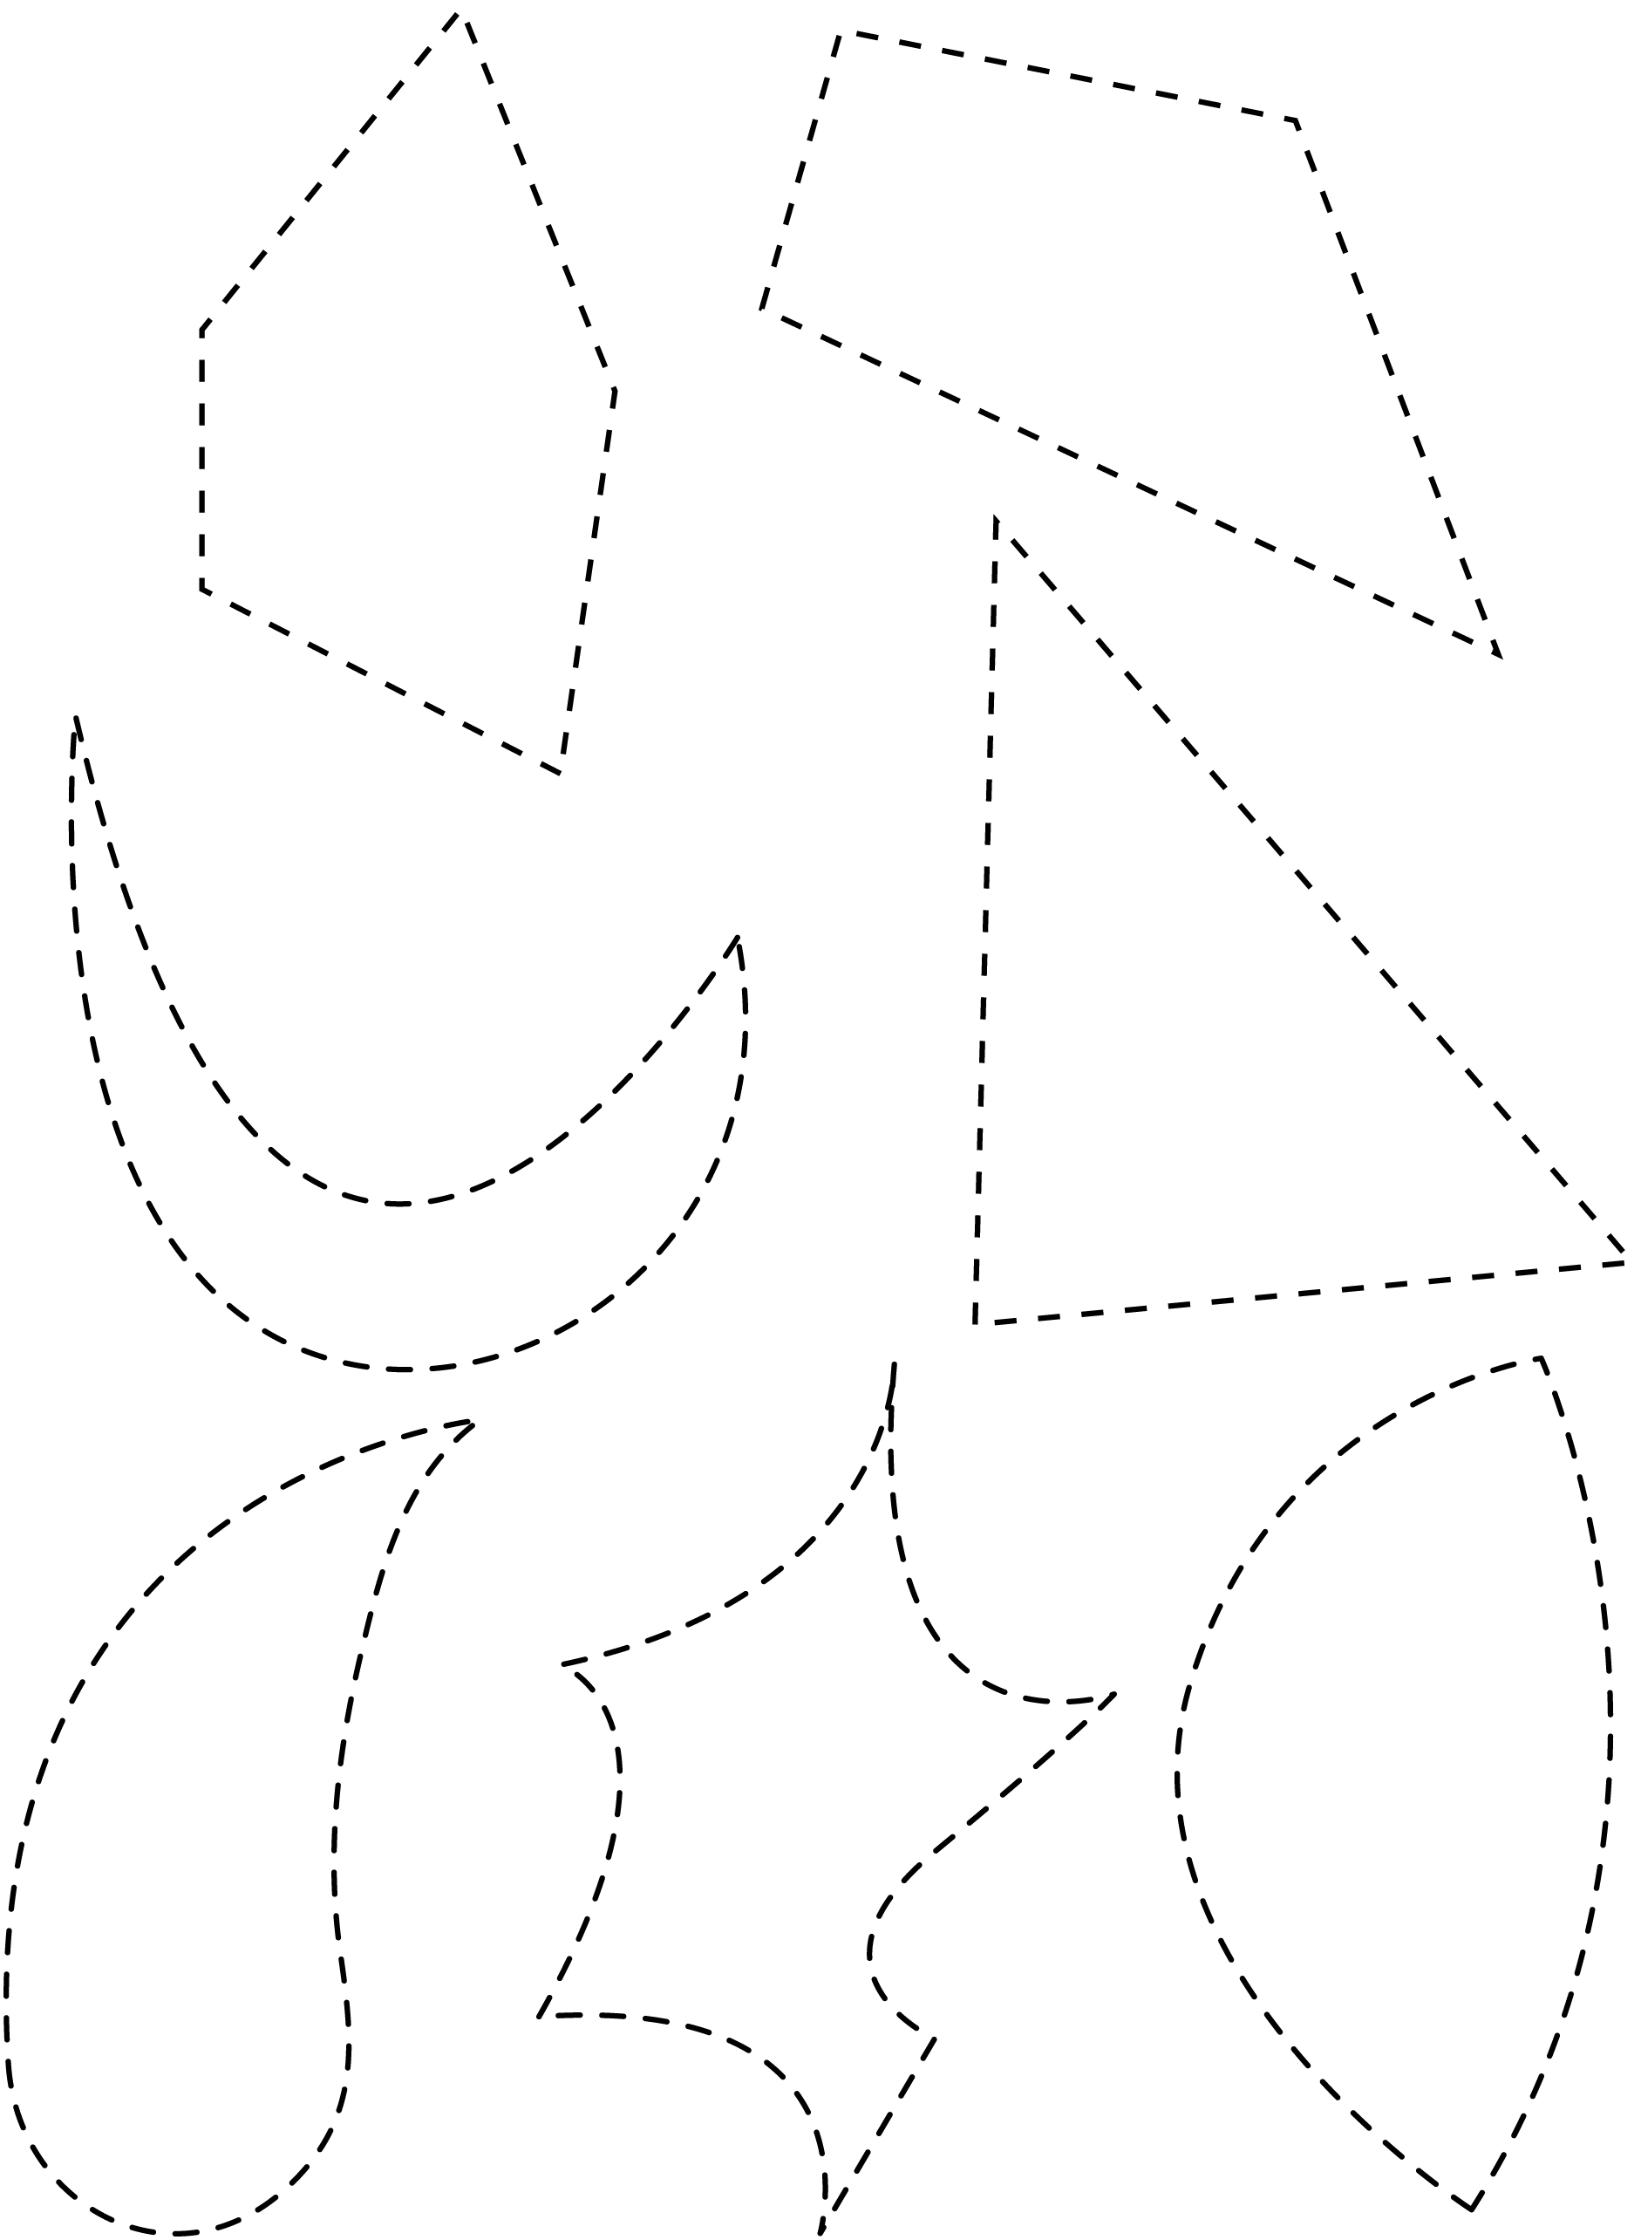

Symmetrical and Line Master 4–2
Asymmetrical Shapes

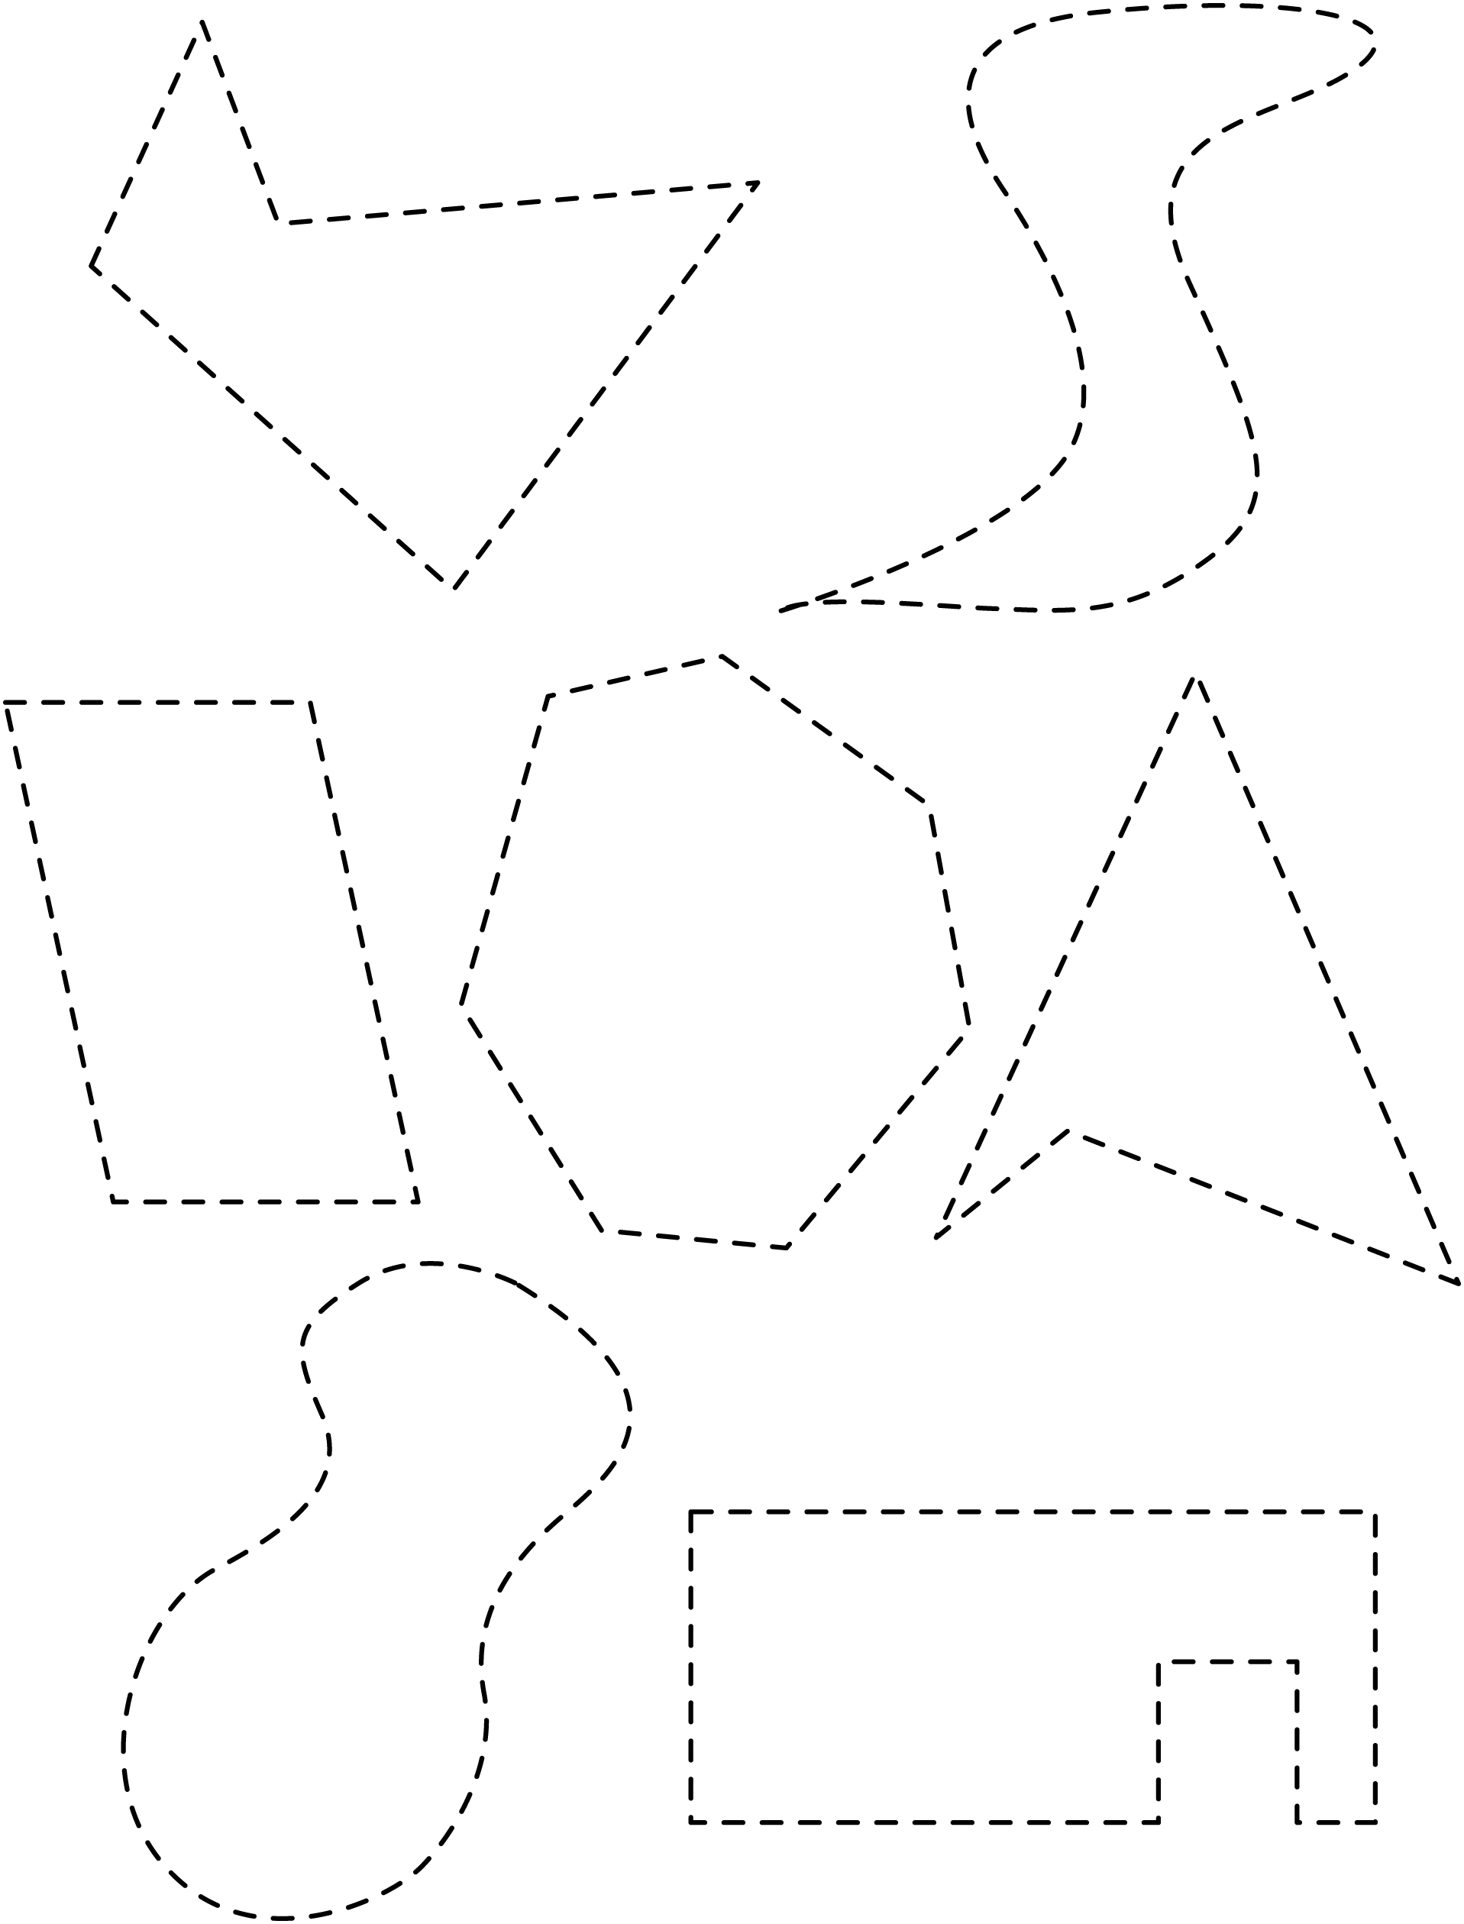

Symmetrical and Line Master 4–3
Asymmetrical Shapes

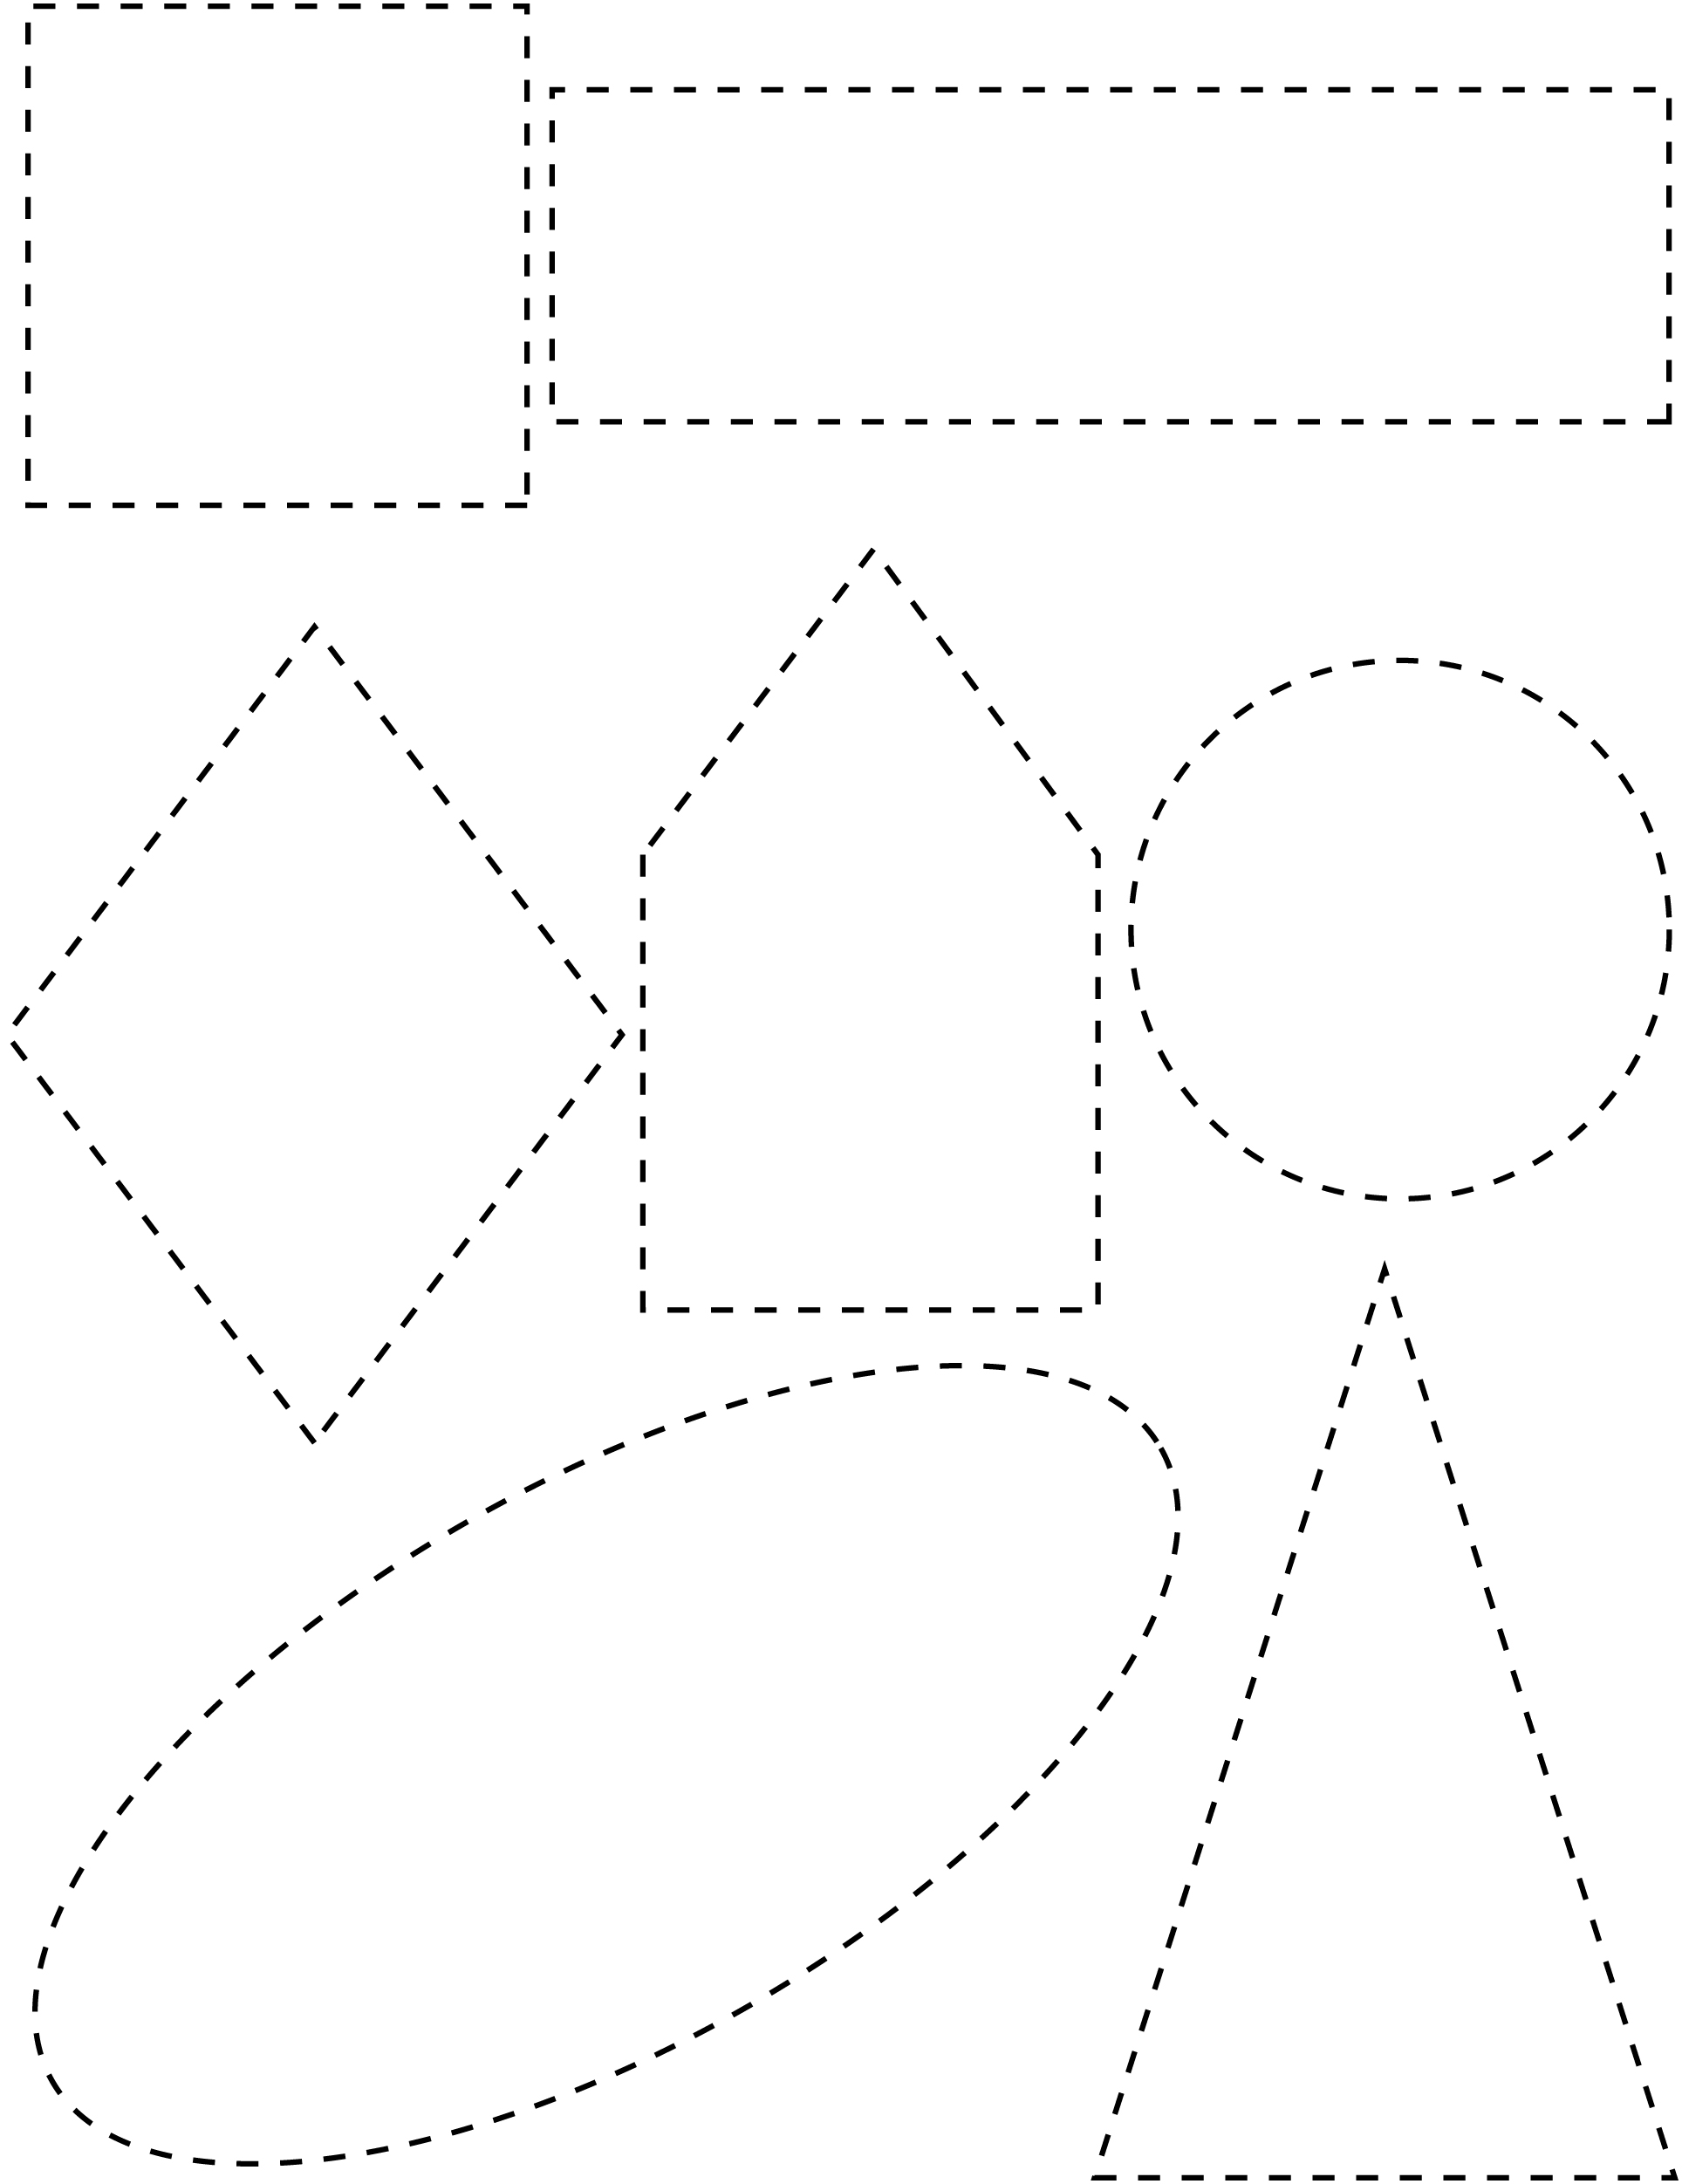

Symmetrical and Line Master 4–4
Asymmetrical Shapes

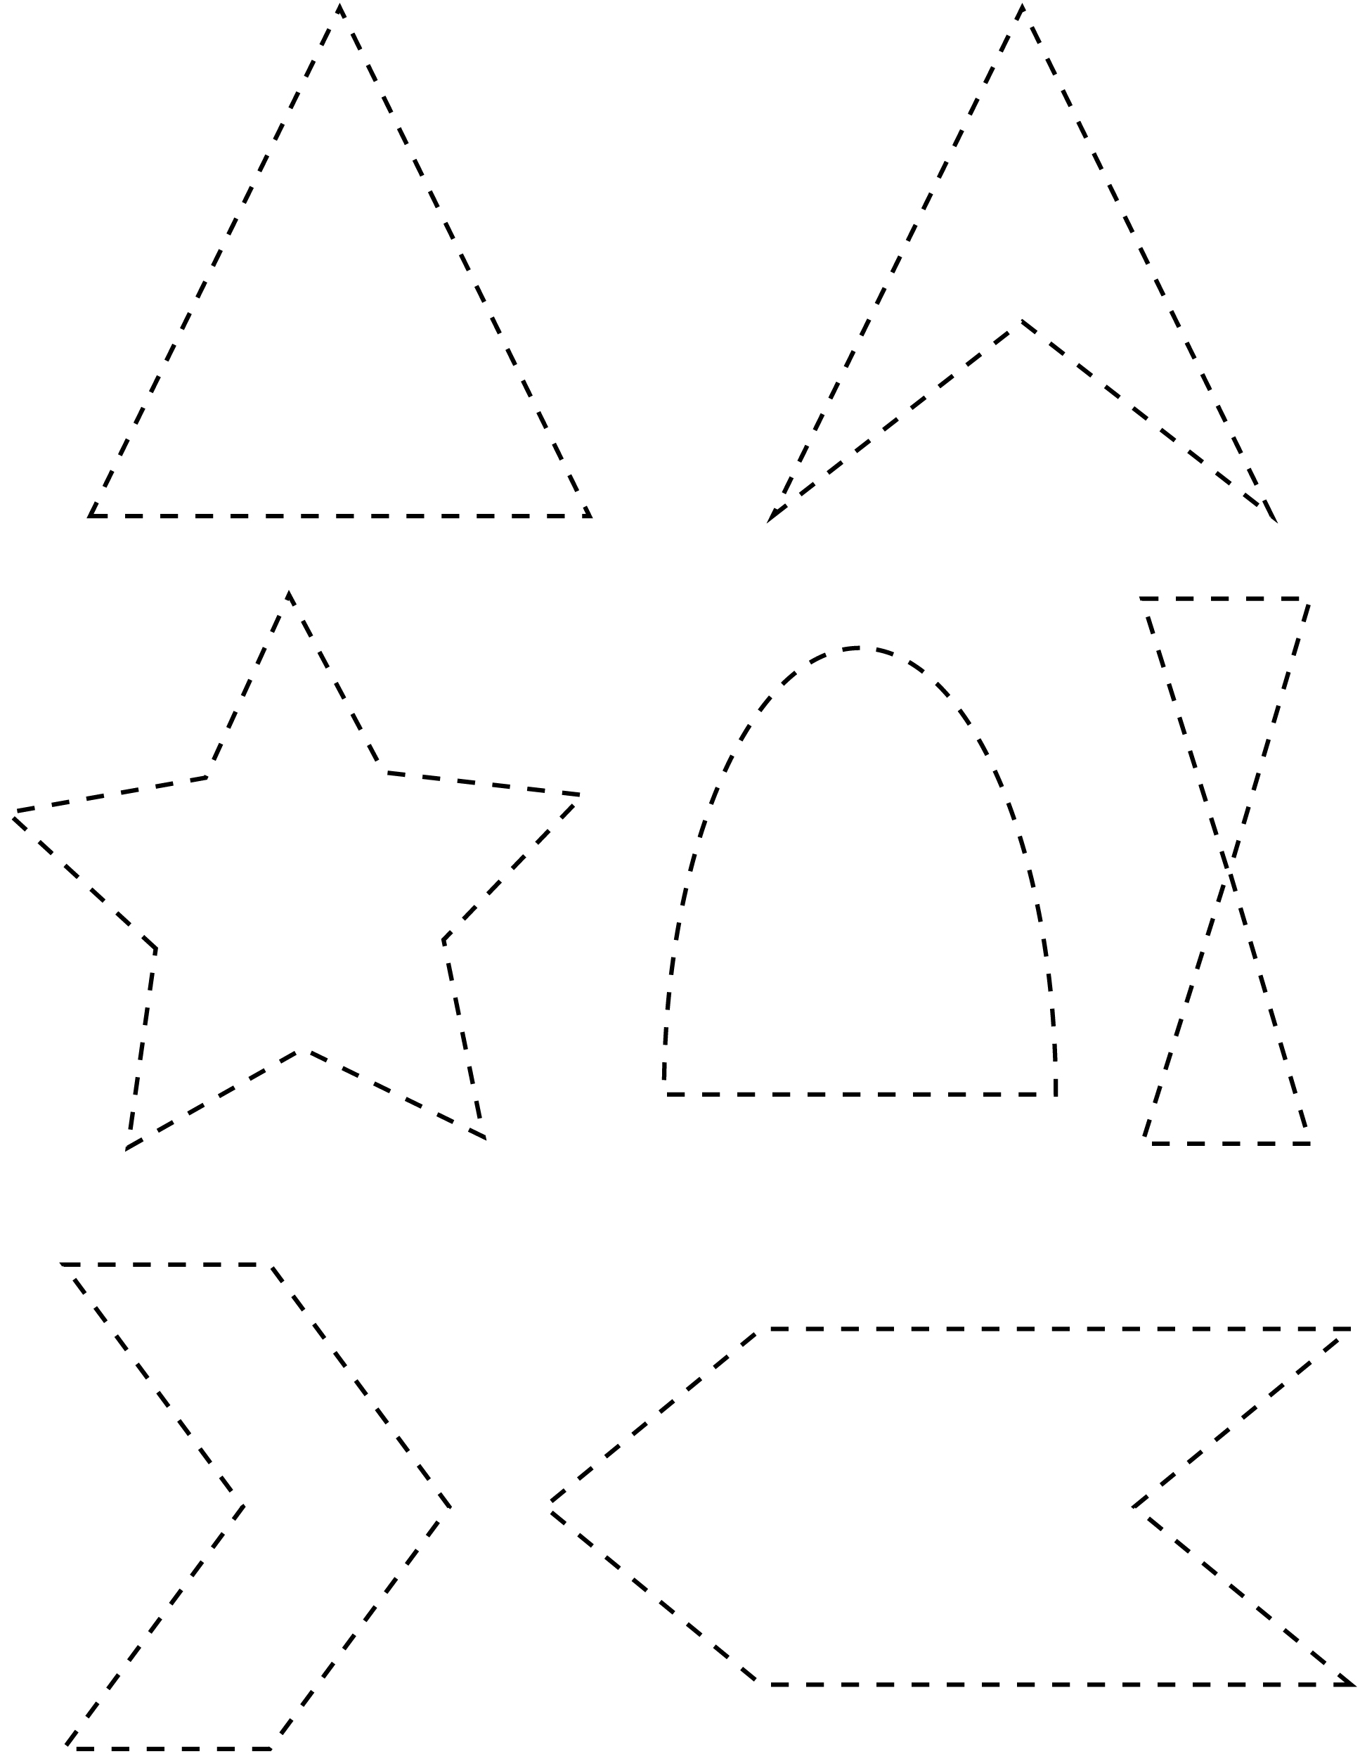

Symmetrical and Line Master 4–5
Asymmetrical Shapes

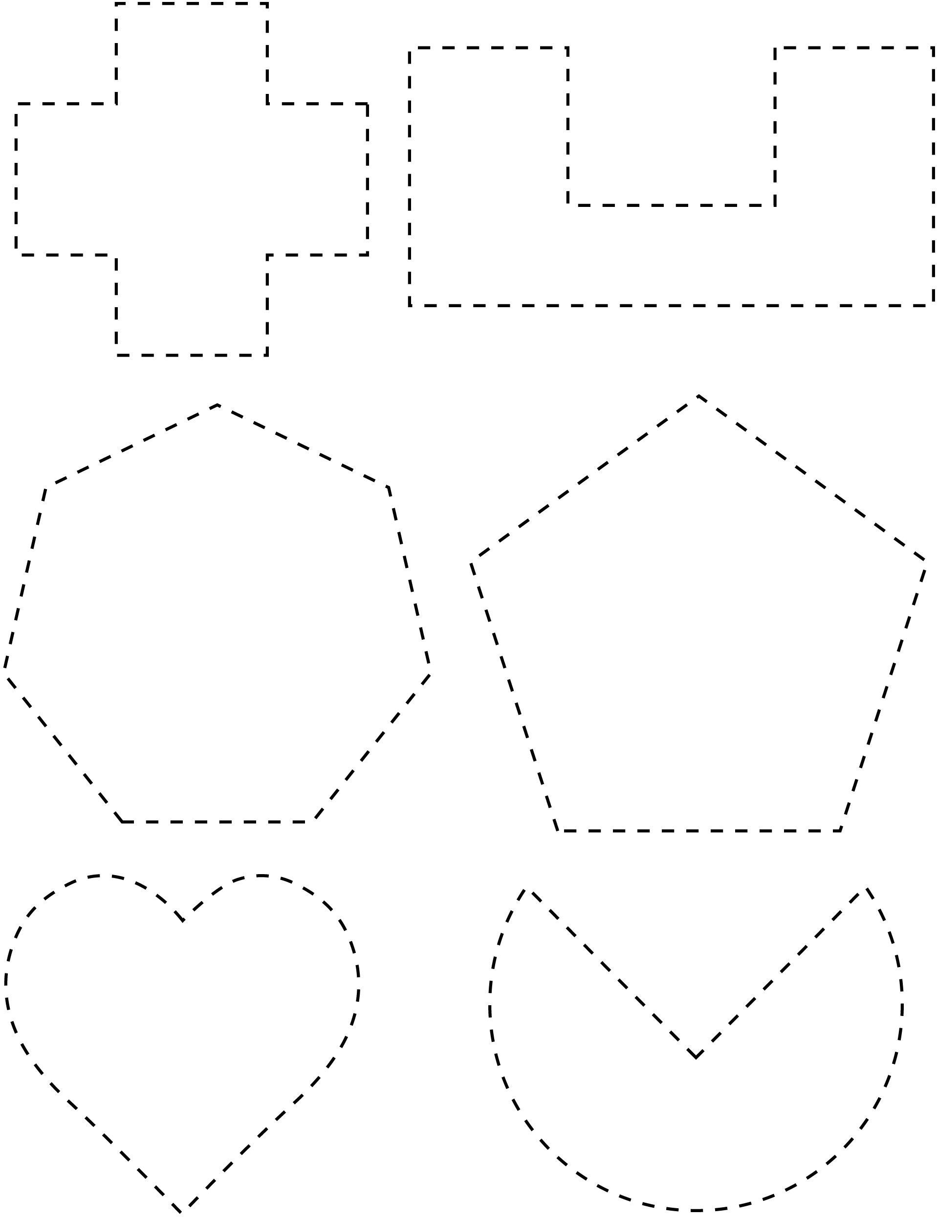

Symmetry Grid Line Master 5–1
Name: _____________________________

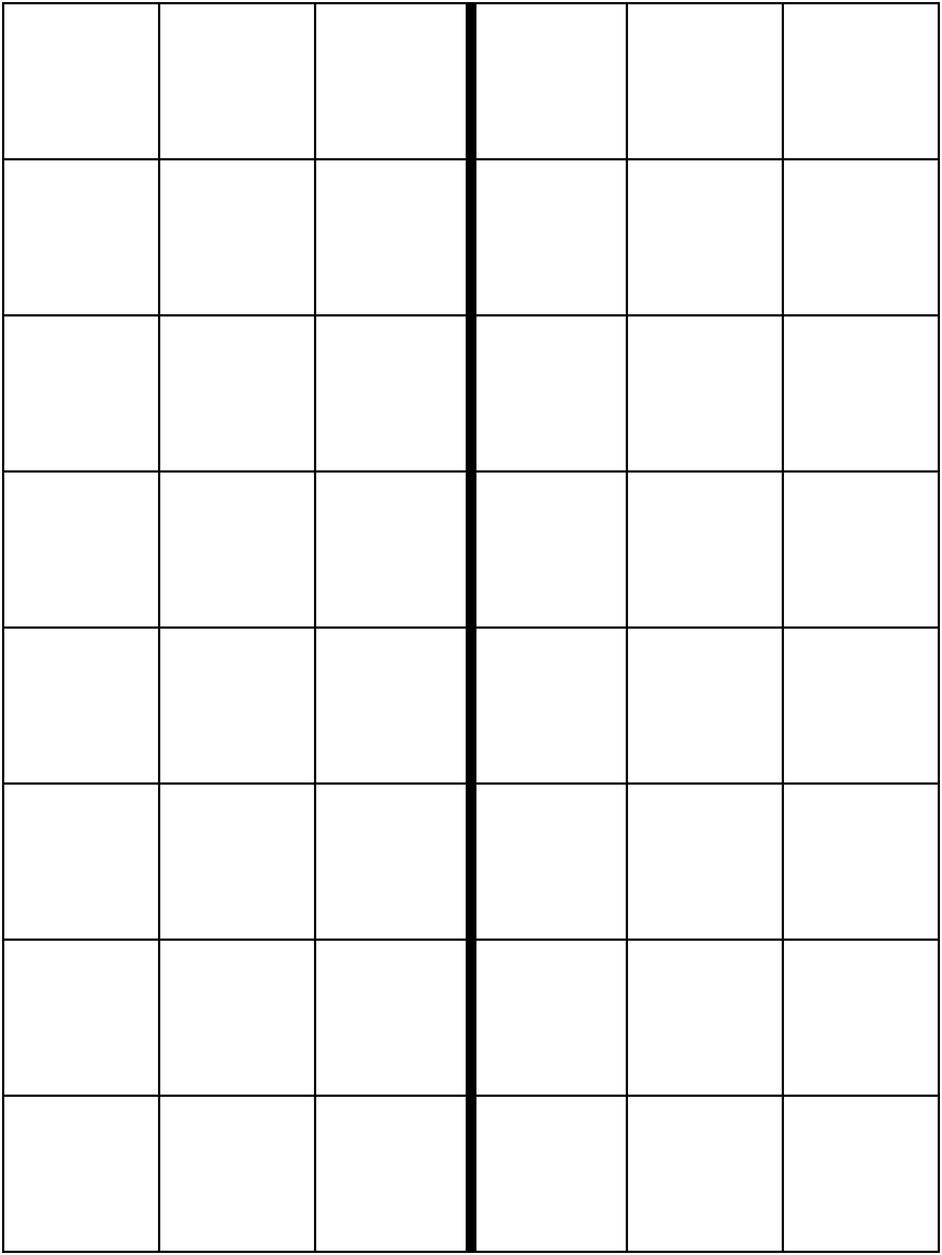

Symmetry Grid Line Master 5–2
Name: _____________________________

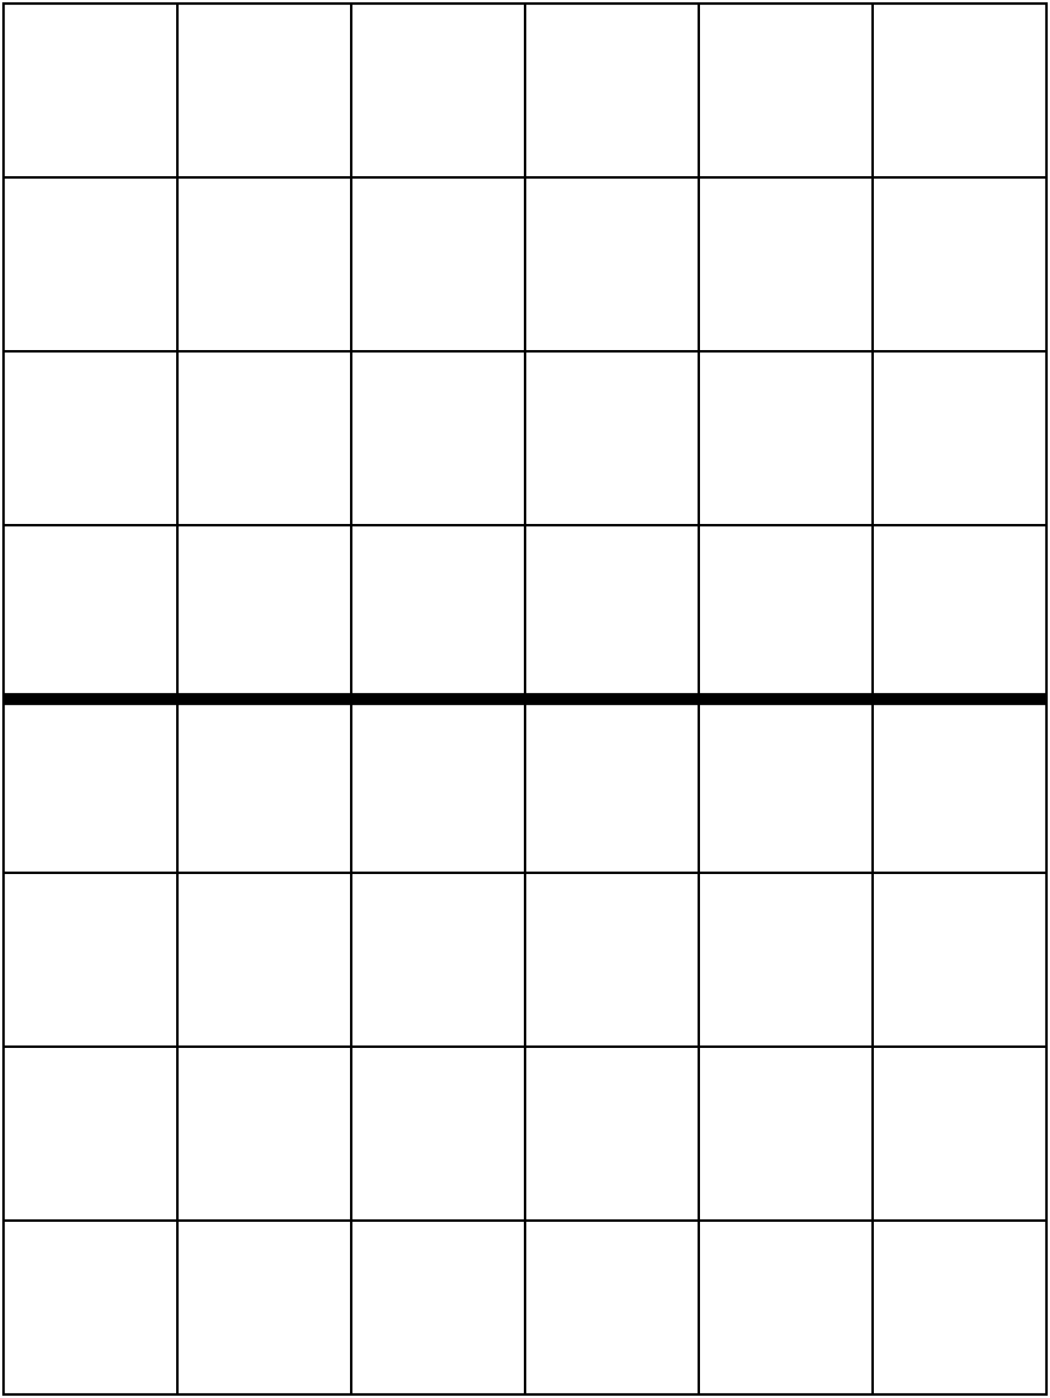

Symmetry Grid Line Master 5–3
Name: _____________________________

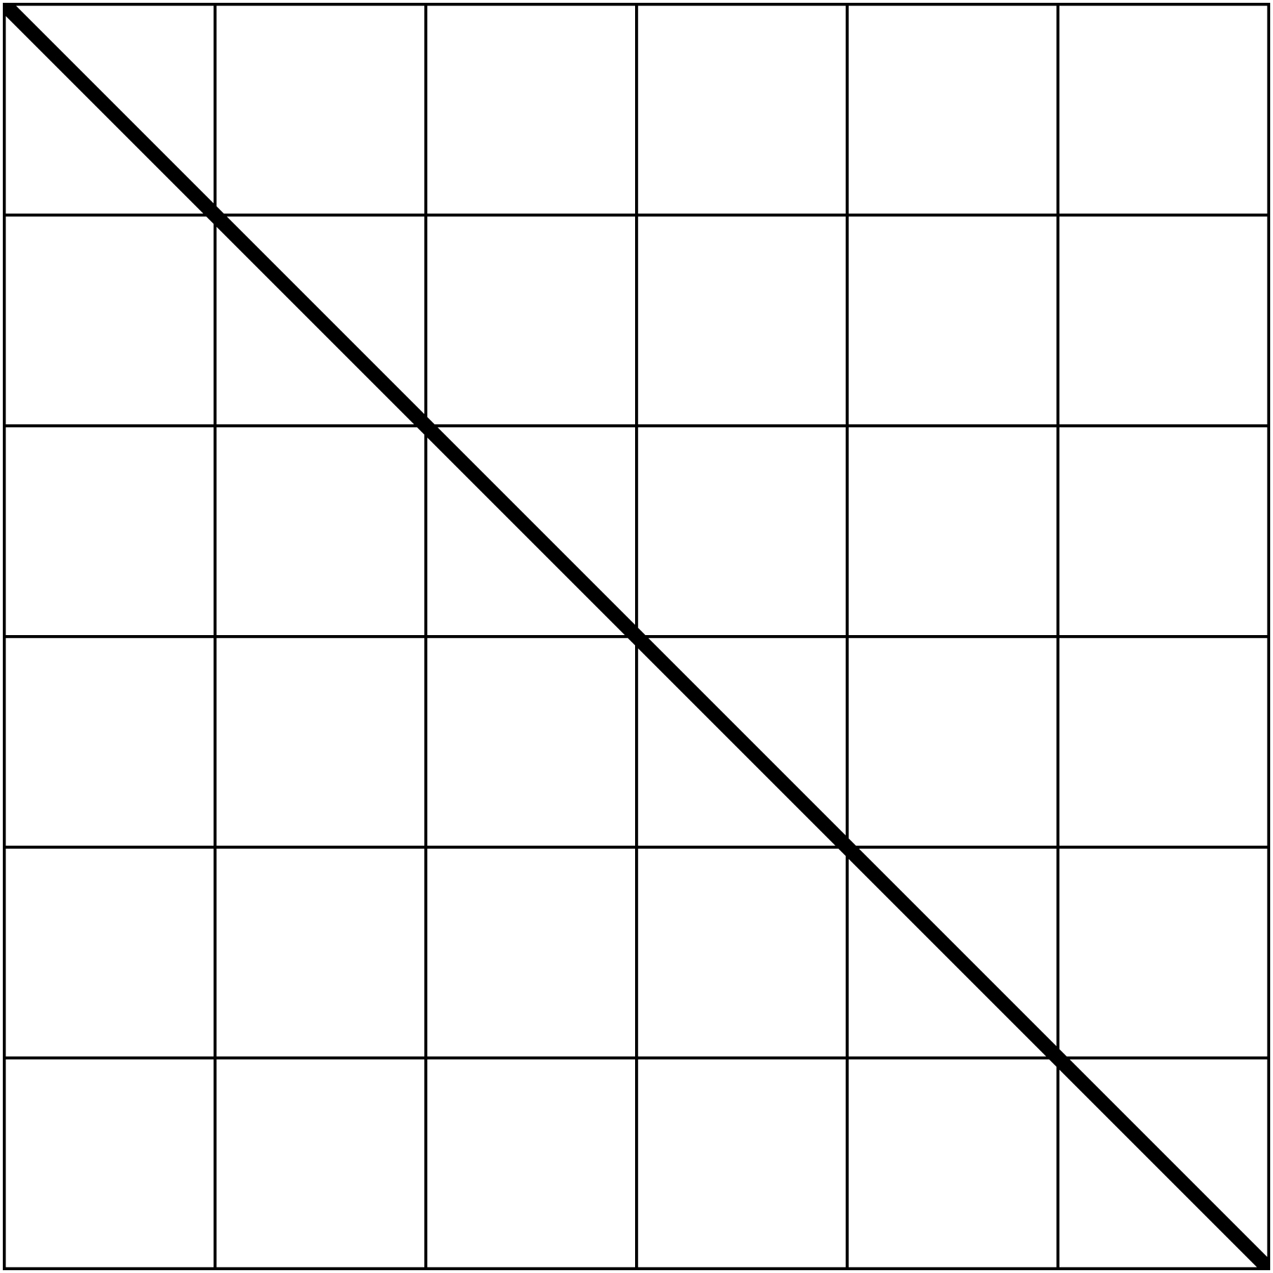

Shape Story Template Line Master 6–1
My Shape Story  By _____________________________ | ____________________________  ____________________________  ____________________________

Shape Story Template Line Master 6–2
____________________________  ____________________________  ____________________________ | ____________________________  ____________________________  ____________________________

Treasure Hunt Line Master 7
Name: _____________________________

Object | Shape | What I Know About the Shape

Shape Puzzles Line Master 8–1

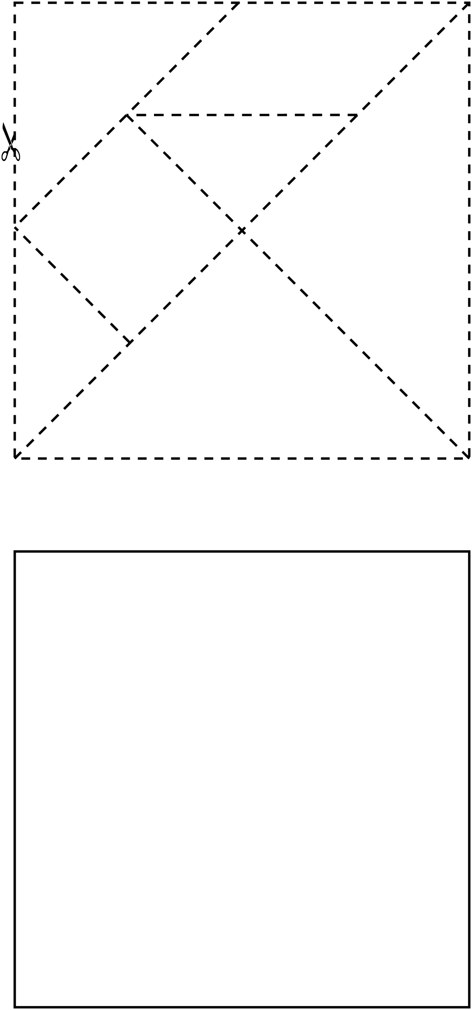

Shape Puzzles Line Master 8–2

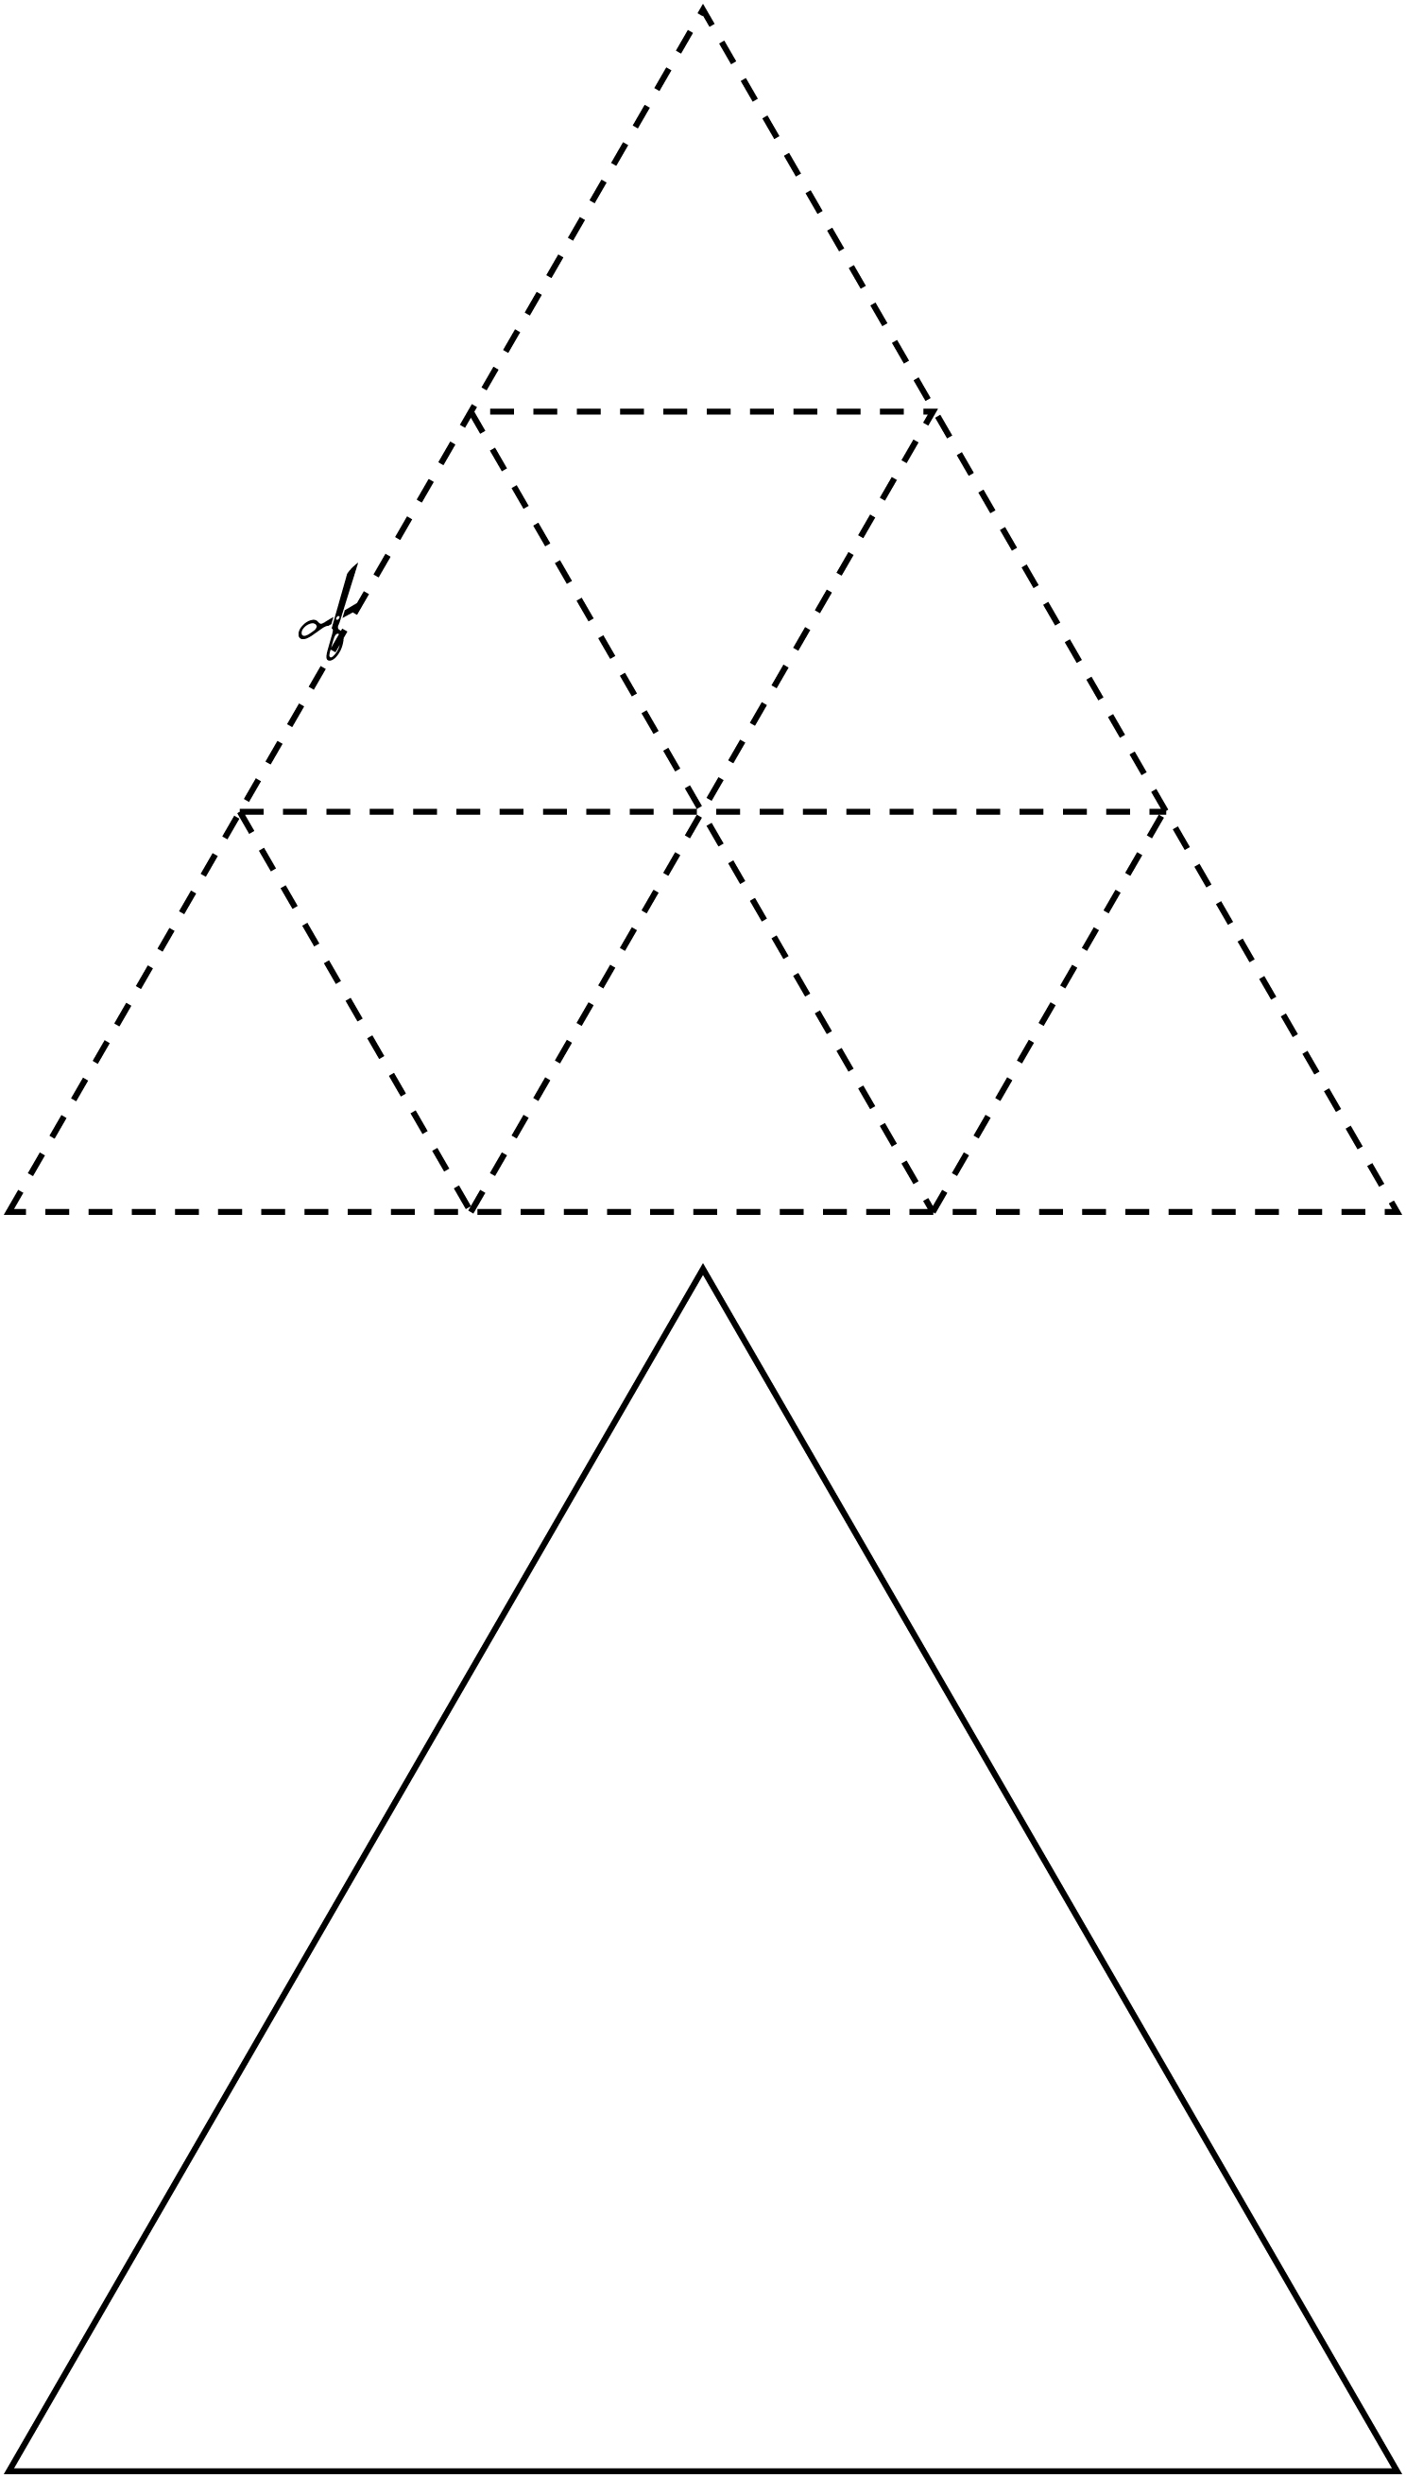

Search for Symmetry Line Master 9
Name: _____________________________

Shape | Number of Lines of Symmetry

Shape Profile Line Master 10
Name: _____________________________
Shape: _____________________________

My shape has ________________ sides.
My shape has ________________ vertices.
My shape has ________________ lines of symmetry.
Interesting fact: ___________________________________________________________
______________________________________________________________________________
______________________________________________________________________________

Symmetry Problems Line Master 11–1
– – – – – – – – – – – – – – – – – – – – – – – – – – – – – – – – – – – – – – – – – –

Draw a shape that has 1 line of symmetry.

– – – – – – – – – – – – – – – – – – – – – – – – – – – – – – – – – – – – – – – – – –

Draw a shape that has more than 1 line of symmetry.

– – – – – – – – – – – – – – – – – – – – – – – – – – – – – – – – – – – – – – – – – –

Draw a shape that has no lines of symmetry.

– – – – – – – – – – – – – – – – – – – – – – – – – – – – – – – – – – – – – – – – – –

Draw a symmetrical shape that has 3 sides.

– – – – – – – – – – – – – – – – – – – – – – – – – – – – – – – – – – – – – – – – – –

Draw a symmetrical shape that has 4 sides.

– – – – – – – – – – – – – – – – – – – – – – – – – – – – – – – – – – – – – – – – – –

Draw a shape that has 3 sides and no lines of symmetry.

– – – – – – – – – – – – – – – – – – – – – – – – – – – – – – – – – – – – – – – – – –

Symmetry Problems Line Master 11–2
– – – – – – – – – – – – – – – – – – – – – – – – – – – – – – – – – – – – – – – – – –
Complete the symmetrical shape.

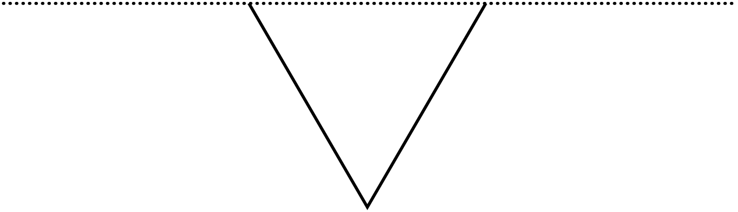
– – – – – – – – – – – – – – – – – – – – – – – – – – – – – – – – – – – – – – – – – –
Complete the symmetrical shape.

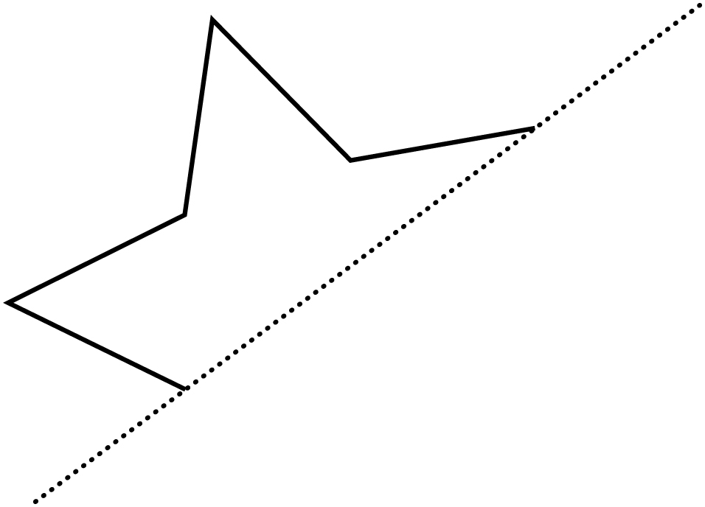

– – – – – – – – – – – – – – – – – – – – – – – – – – – – – – – – – – – – – – – – – –

Symmetry Problems Line Master 11–3
– – – – – – – – – – – – – – – – – – – – – – – – – – – – – – – – – – – – – – – – – –
I have 4 sides and 2 lines of symmetry. What shape am I?

Show how you know.

– – – – – – – – – – – – – – – – – – – – – – – – – – – – – – – – – – – – – – – – – –
I have 5 sides and 1 line of symmetry. What shape am I?

Show how you know.

– – – – – – – – – – – – – – – – – – – – – – – – – – – – – – – – – – – – – – – – – –

