The Discovery Line Master 1
(Assessment Master)
Name: _____________________________

Estimate and Measure Length, Perimeter, and Area | Not observed | Sometimes | Consistently
Estimates and measures length
Estimates and measures perimeter
Estimates and measures area
Uses personal referents and benchmarks
Selects and uses appropriate measuring tools
Compare and Describe Length, Perimeter, and Area
Compares and orders objects according to length, perimeter,
and area
Uses relative terms to describe length, perimeter, and area
Strengths:

Next Steps:

Connecting Home and School Line Master 2–1

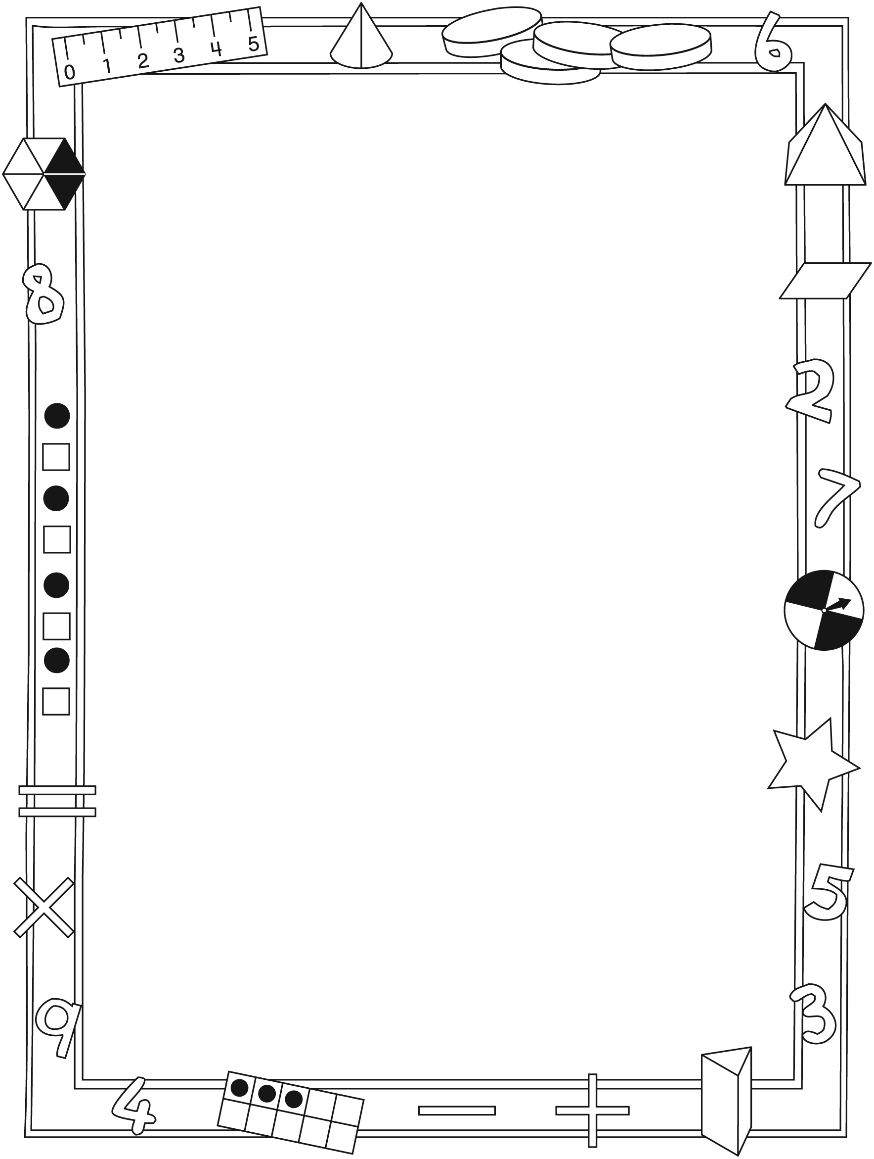

NOTE TO THE TEACHER

You may wish to send families a The Discovery letter outlining a familiar activity or two they can do at home with their children.

Create a letter using this template and select one or two activities from the suggestions on the next page. Simply delete these instructions and cut and paste the activities you have selected, adapting them to fit your needs.

Connecting Home and School Line Master 2–2

Dear Family:

We have been working on The Discovery, which engages children in conversations, investigations, and activities that help to develop their understanding of the big math idea that “Units can be used to measure and compare attributes.” Particular focus is placed on estimating, measuring, and comparing length, perimeter, and area. Try this activity at home with your child.
– – – – – – – – – – – – – – – – – – – – – – – – – – – – – – – – – – – – – – – – – –
Reading the Story: As you read the story, enjoy talking about the different things the robots measure, the various methods they use, and the problems they run into. Consider acting out parts of the story. For example, pick a distance or object to measure. Use the heel-to-toe method the robots used on pages 8–9 (estimate the number of steps before measuring). What did you discover? Did you end up with a different number of steps when you both measured the same thing? Talk about why that happened. Try other distances.
– – – – – – – – – – – – – – – – – – – – – – – – – – – – – – – – – – – – – – – – – –
Distance Around: Ask your child how many finger-widths he/she thinks it will be to measure around this piece of paper. Help your child mark the starting point and then count aloud together as he/she measures the 4 sides. Then ask: How many centimetres do you think it will be around the paper? Use a ruler to check.
– – – – – – – – – – – – – – – – – – – – – – – – – – – – – – – – – – – – – – – – – –
Measuring at Home: We have been talking about when and how to measure things. Sometimes we used non-standard units such as paper clips and craft sticks. Sometimes we measured in centimetres and metres. Look for measuring opportunities as they arise and elicit your child’s help. You might ask: What are we measuring? What should we use? How will we use the ruler to measure? What do you think the measure will be? Let’s find out.
– – – – – – – – – – – – – – – – – – – – – – – – – – – – – – – – – – – – – – – – – –
Centimetre and Metre Search: Find things around the home and outdoors that measure—in some way—to be about 1 centimetre or 1 metre. Start a list and keep adding to it. Let us know what you find.
– – – – – – – – – – – – – – – – – – – – – – – – – – – – – – – – – – – – – – – – – –
Sincerely,

___________________________

The Discovery Math Mat Line Master 3

Measuring Zap Lines Line Master 4
Name: _____________________________

Measuring units | Zap line 1 |  | Zap line 2 |  | Zap line 3
 | Estimate | Measure | Estimate | Measure | Estimate | Measure
cubes

Compare your measures. What do you notice?

Distance Around Holes Line Master 5
Name: _____________________________

Draw a picture of your shapes. Include the labels.
Estimate, then measure.
What unit did you use to measure?

Our shape | Our estimate | Our measure

Which shape has the shortest distance around?

Exploring Different Units Line Master 6–1

Exploring Centimetres

 | Fingers |  | Cubes |  | Ruler
Object | Estimate | Measure | Estimate | Measure | Estimate | Measure

Exploring Different Units Line Master 6–2

Exploring Metres

 | Strides |  | Metre stick
Object | Estimate | Measure | Estimate | Measure

Orbo and Bot Photos Line Master 7

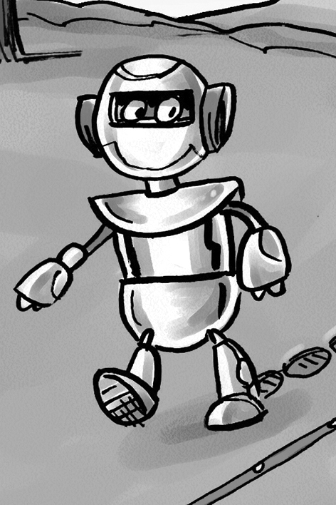

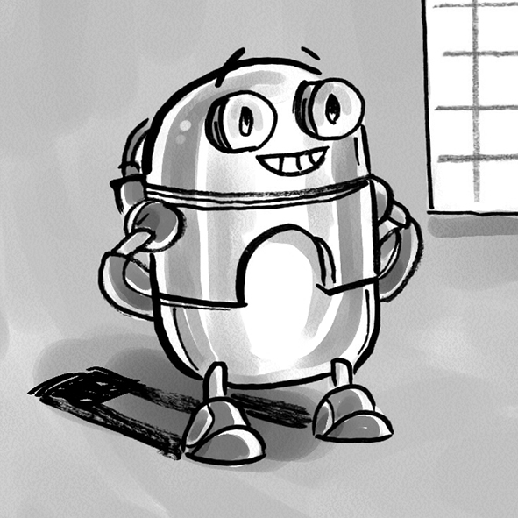

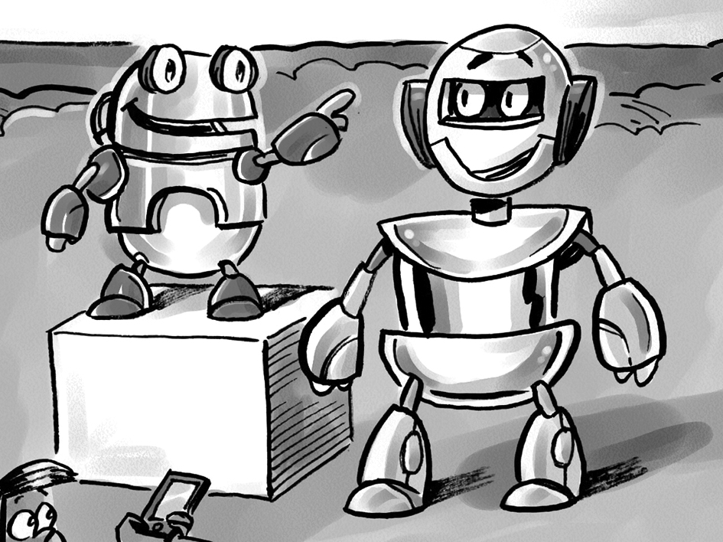

Centimetre Grid Paper Line Master 8

Making Shapes Line Master 9

Record how many units are in all of your shapes.
The player with the greatest number of units wins!

Player 1: ___________________ | Player 2: ___________________

Centimetre Dot Paper Line Master 10

Meet My Robot Line Master 11
Name: _____________________________

My robot’s name: ____________________________________

My robot is interesting because

It is _______________ squares tall.

Part | Area
head | ___________ squares
body | ___________ squares
other _______________ | ___________ squares
other _______________ | ___________ squares

The total area of my robot is _______ squares.

Problems to Solve Line Master 12–1

Area 1
Circle the viewing platform that covers more space.

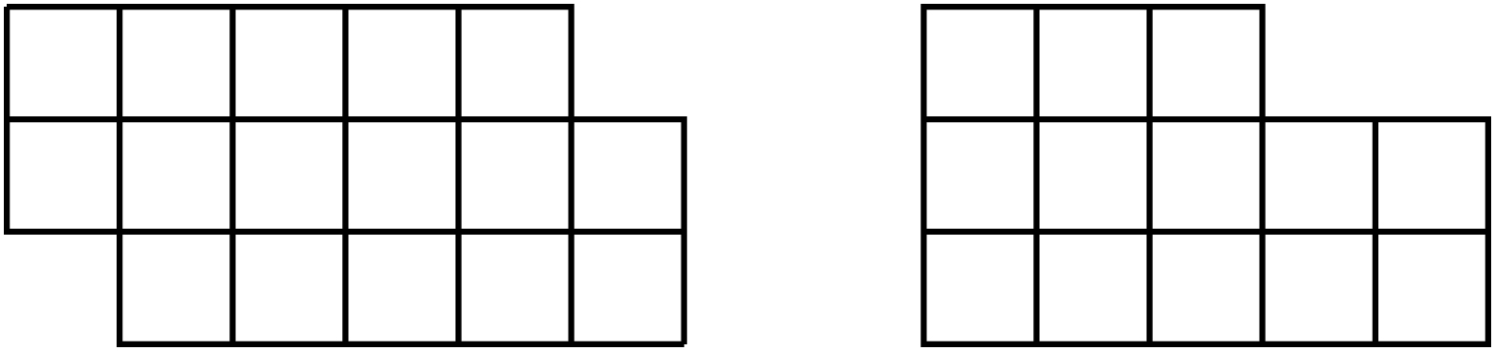
Orbo Bot

How do you know?

Colour in your own viewing platform.

How does the area of your viewing platform compare to Bot’s and Orbo’s?

Problems to Solve Line Master 12–2

Perimeter 2
Who needs to build a longer fence?

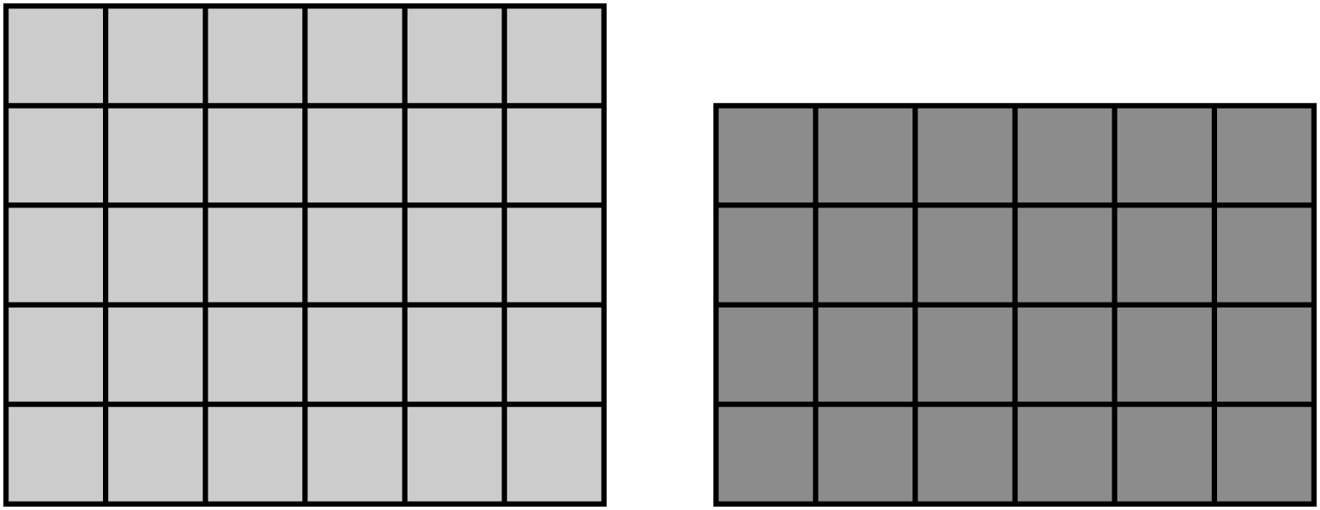
Orbo Bot

How do you know?

Colour in your own viewing platform.

Now who will need to build the longest fence? ______________
Who will build the shortest fence? ______________

Problems to Solve Line Master 12–3

Area and Perimeter
– – – – – – – – – – – – – – – – – – – – – – – – – – – – – – – – – – – – – – – – – –
Use tiles. Design 3 different shapes with 8 tiles.
Draw your designs.

Write the area and distance around under each design.
– – – – – – – – – – – – – – – – – – – – – – – – – – – – – – – – – – – – – – – – – –
Use tiles. Design 2 different shapes with 12 tiles.
Draw your designs.

Write the area and distance around under each design.
– – – – – – – – – – – – – – – – – – – – – – – – – – – – – – – – – – – – – – – – – –
Use tiles. Design 2 different shapes with 20 tiles.
Draw your designs.

Write the area and distance around under each design.
– – – – – – – – – – – – – – – – – – – – – – – – – – – – – – – – – – – – – – – – – –

Problems to Solve Line Master 12–4

Estimating Length
– – – – – – – – – – – – – – – – – – – – – – – – – – – – – – – – – – – – – – – – – –
Estimate how far 6 craft sticks will go if you line them up end to end. Mark the beginning and end with tape.
Try it! Line up 6 craft sticks.
Compare your estimate to the length.
Circle: My estimate was too short too long close

Now, estimate how far 8 craft sticks will go.
Use what you know.
Line up 8 craft sticks. Compare your estimate to
the length.
Circle: My estimate was too short too long close
– – – – – – – – – – – – – – – – – – – – – – – – – – – – – – – – – – – – – – – – – –
Estimate how far 10 linking cubes will go if you link them in a row. Mark the beginning and end with tape.
Try it! Connect 10 linking cubes.
Compare your estimate to the length.
Circle: My estimate was too short too long close

Now, estimate how far 20 linking cubes will go.
Use what you know.
Connect 20 linking cubes. Compare your estimate to
the length.
Circle: My estimate was too short too long close
– – – – – – – – – – – – – – – – – – – – – – – – – – – – – – – – – – – – – – – – – –

