Comparing Angles
Recognizes angles in various situations (including shapes, clock, motion)  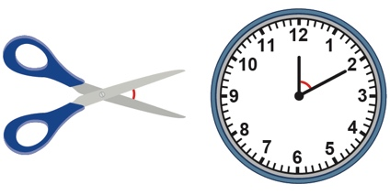  “I see an angle between the blades of scissors and between the hands of a clock as they move.” | Classifies angles using 90° benchmark (i.e., is or is not a right angle)  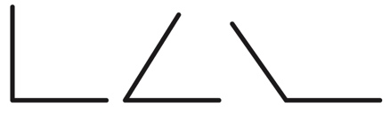  “The first angle is a right angle. The others are not right angles.” | Compares directly by superimposing, using a right angle  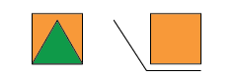  “This triangle has angles less than a right angle. The angle is greater than a right angle.”
Observations/Documentation

Comparing Angles (con’t)
Compares angles indirectly, using a third angle  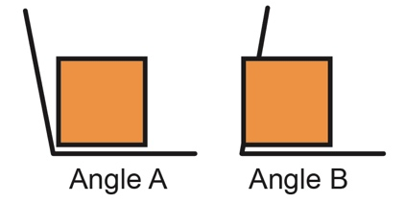  “Angle A is a bit bigger than a right angle. Angle B is a bit smaller than a right angle. So, Angle A is bigger than Angle B.” | Estimates and compares angles flexibly  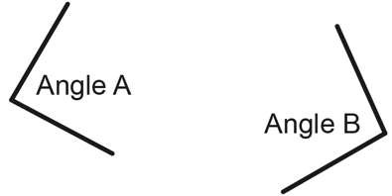  “I think Angle B is a little bigger. I placed Angle A on top of Angle B, and it just fit inside.  So, Angle B is a bit bigger.” | Uses angles to explore and better understand the world around them  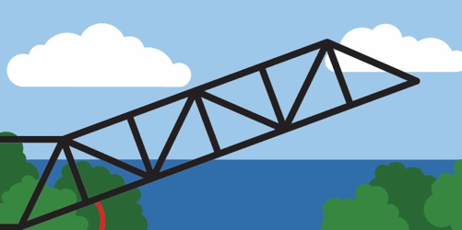  “As the drawbridge goes up, the angle gets bigger. As the bridge comes back down, the  angle gets smaller.”
Observations/Documentation

