Developing Meaning of Addition and Subtraction
Models concretely to add and subtract  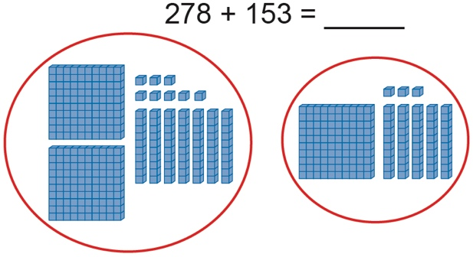  “278” “378, 388, 398, 408, 418, 428, 429,  430, 431” | Models and symbolizes addition and subtraction  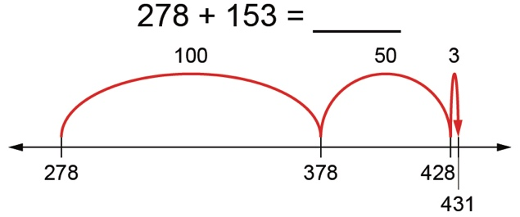  “I add 5 tens and 3 ones.  78 + 53 = 78 + 50 + 3, or 131” | Uses standard algorithm to add and subtract  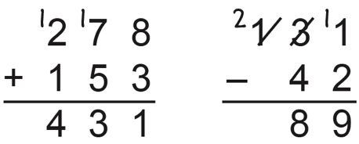
Observations/Documentation

Developing Meaning of Addition and Subtraction (con’t)
Estimates sums and differences to check reasonableness  131 – 42 = 89  “130 – 40 = 90, which is close to  89 so my answer is reasonable.” | Creates and solves problems  “There are 131 birds in the tree.  Some birds flew away.  Now there are 42 birds in the tree.  How many birds flew away?”  131 − = 42  89 birds flew away. | Uses properties and inverse operations of addition and subtraction to solve problems  131 − = 42  “I can think addition to help me solve the problem:  42 + = 131”
Observations/Documentation

Developing Fluency for Addition and Subtraction
Fluently adds and subtracts within 5  “I know 4 + 1 = 5 and 5 – 1 = 4.” | Fluently adds and subtracts to 10  “I know 8 + 2 = 10 and 10 – 2 = 8.”  (complements to 10) | Fluently adds and subtracts to 20  “I can use doubles.  I know 9 + 9 = 18 and 18 – 9 = 9.”
Observations/Documentation

Uses known sums and differences to solve addition and subtraction equations  “25 + 37 =  I know 25 + 30 = 55, and 55 plus 5 is 60,  and 2 more makes 62.”  (decomposing, known facts) | Develops mental strategies and algorithms  29 + 32 =  I take 1 from 32 and give it to 29 to get 30 + 31.  30 + 30 = 60, and 1 more is 61.”  (compensation) | Estimates sums and differences  49 + 38 =  “49 is close to 50.  38 is close to 40.  50 + 40 = 90”  (using benchmarks)
Observations/Documentation

