Estimating Money Amounts
Scans quantity of coins (disregards value of the coins)  “There’s a lot of coins.  I think it’s about $100.” | Uses a referent to estimate the value of a collection of one denomination  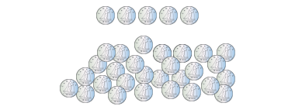  “There’s about 5 groups of 5 dimes, so about $2.50.” | Estimates the value of a mixed collection of coins to the nearest dollar  “I see about 10 loonies and  10 quarters, which is about $12.” | Makes reasonable estimates of mixed collections in dollars and cents  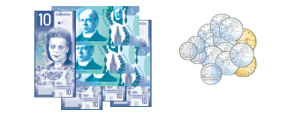  “There’s $55 dollars in bills and about $4 in loonies and quarters.  I don’t think the rest of the coins make a dollar.  So, my estimate is about $59.50.”
Observations/Documentation

Counting Money Amounts
Skip-counts to find value of collection of coins/bills of one denomination  “5, 10, 15, 20, 25. I count 25 cents.” | Sorts coins and/or bills when collection is of mixed denominations.  “10, 20, 25, 30. I count 30 cents.” | Skip-counts to count collections of coins and/or bills of different denominations.  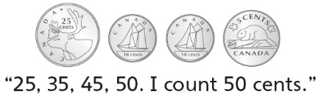  . | Successfully and flexibly counts collections of money of different denominations  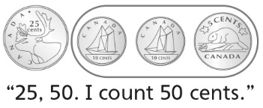
Observations/Documentation

