Responsible Money Management
Understands the difference between spending, saving, and donating  “When I buy something at the store, I spend. When I give to a charity, I donate. When I put money in my piggy bank, I save.” | Identifies ways to spend and save responsibly  “I can wait for the item to go on sale, or I can buy the item in a thrift shop.” | Identifies short- and long-term savings goals  Short-term savings goals: pack of trading cards, new baseball cap  Long-term savings goals: new cellphone, new bicycle  “The long-term goals would take me years to save for.” | Creates a savings plan to reach a financial goal  “To buy a new baseball cap, I will save $4 of the $7 I earn each week walking the neighbour’s dog. I will have enough to buy the cap in 1 or  2 months.”
Observations/Documentation

Counting Money Amounts
Skip-counts to find value of collection of coins/bills of one denomination  “5, 10, 15, 20, 25. I count 25 cents.” | Sorts coins and/or bills when collection is of mixed denominations.  “10, 20, 25, 30. I count 30 cents.” | Skip-counts to count collections of coins and/or bills of different denominations.  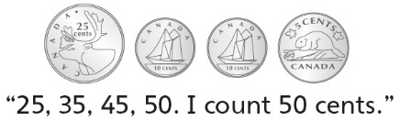  . | Successfully and flexibly counts collections of money of different denominations  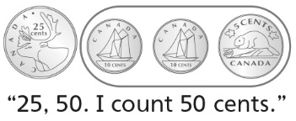
Observations/Documentation

