Generalizing and Representing Increasing and Decreasing Patterns
Recognizes that a pattern increases or decreases  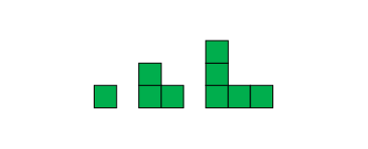  “The terms are getting bigger.” | Identifies how a pattern changes (describes rule)  “To get from the first term to the second term, and from the second term to the third term, we add 2 tiles. The pattern grows by 2 tiles each time.” | Represents patterns symbolically and writes rules using addition or subtraction  1, 3, 5, …  “Start at 1 and add 2 each time.”  17, 14, 11, …  “Start at 17 and take away 3  each time.” | Extends patterns using repeated addition and subtraction  1, 3, 5, 7, 9, 11, …  “I added 2 over and over.”  17, 14, 11, 8, 5, 2  “I subtracted 3 over and over.”
Observations/Documentation

Generalizing and Representing Increasing and Decreasing Patterns (cont’d)
Finds missing terms or errors in patterns  3, 8, 13, 18, 22, 28, ….  “Start at 3 and add 5 each time.  18 + 5 = 23, so 22 should be 23.” | Creates number patterns and identifies finite and infinite whole-number sequences  “85, 75, 65, 55, ….  “I skip-counted back by 10s.  All the numbers are odd.  It is a finite sequence because I will run out of numbers.” | Uses patterns to solve problems  “If I save 2 quarters a day, when will  I have 10 quarters?  2, 4, 6, 8, 10  I will have 10 quarters after 5 days.” | Identifies and extends patterns involving multiplication  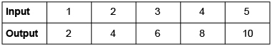  “Each input number is  multiplied by 2.”
Observations/Documentation

