Connections:
Protecting Our Environment
Master 72

Did You Know?
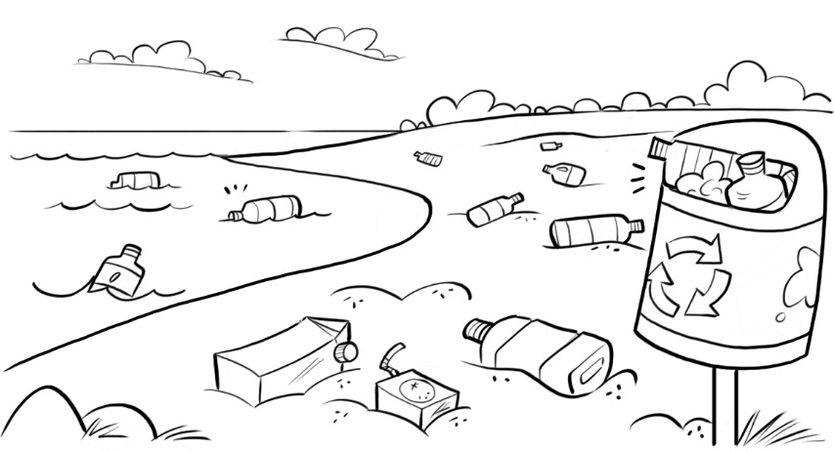
20 000 plastic bottles are bought
around the world every second.

It takes a lot more water to make
a plastic bottle than it does to fill it.

It can take up to 1000 years for
plastic to decompose.
That’s 10 times as long as a
person might live!

What Can We Do to Help Protect Our Environment?

- Drink water from reusable bottles.
- Place lunch and snacks in reusable containers.
- Use reusable cloth bags.
- Use paper straws.
Do you do any of these things?
How much plastic do you save?

Plastic Footprint Challenge

Over one week, collect data on the number of single-use plastics you
use each day.

Record how many of each type you use (for example, bottles, bags, straws,
and cutlery).

Display the data and present them to the class.

You may choose to use more than one graph.

