Master 58a

Time Task B

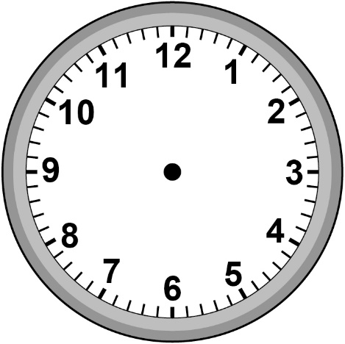
Five past three | Four thirty-six | Twelve thirty
Eight minutes to two | Seven fifteen | Twenty-five to four

Master 58b

Time Task B (cont’d)

Digital Clocks

