Master 61a

Connect the Times! Cards

I have:  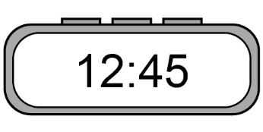 | Who has?  3 min
I have:  180 s | Who has?  Midnight
I have:  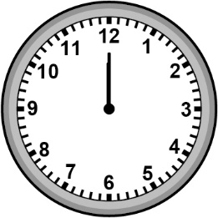 | Who has?  480 min
I have:  8 h | Who has?  Half past 3  in the afternoon

Master 61b

Connect the Times! Cards (cont’d)

I have:  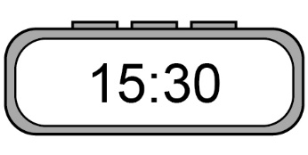 | Who has?  120 s
I have:  2 min | Who has?  23:11
I have:  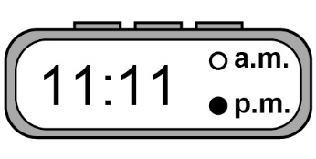 | Who has?  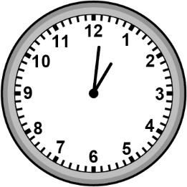
I have:  One minute past one | Who has?  18:00

Master 61c

Connect the Times! Cards (cont’d)

I have:  6 p.m. | Who has?  5 h
I have:  300 min | Who has?  2:05 p.m.
I have:  14:05 | Who has?  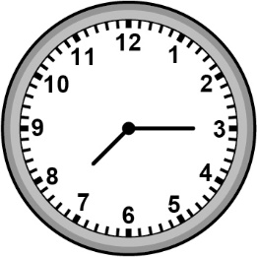
I have:  Fifteen minutes  after seven | Who has?  1 h

Master 61d

Connect the Times! Cards (cont’d)

I have:  60 min | Who has?  half an hour
I have:  30 min | Who has?  19:25
I have:  7:25 p.m. | Who has?  360 min
I have:  6 h | Who has?  9:10 p.m.

Master 61e

Connect the Times! Cards (cont’d)

I have:  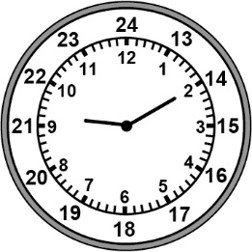 | Who has?  Twenty minutes  after nine
I have:  Forty minutes  before ten | Who has?  Fifty minutes before five in the afternoon
I have:  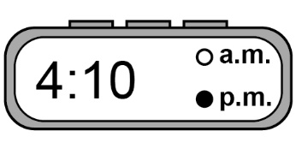 | Who has?  150 s
I have:  Two and one-half minutes | Who has?  600 s

Master 61f

Connect the Times! Cards (cont’d)

I have:  10 min | Who has?  Fifty-nine minutes  to eleven
I have:  One minute after ten | Who has?  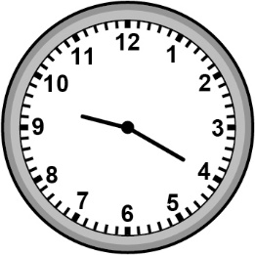
I have:  40 minutes before 10 | Who has?  90 min
I have:  One and one-half hours | Who has?  Fifteen minutes  to one

