Connections: Arrays at the Store
Master 19

An array is a way of organizing items in equal rows and columns.
If you look around the grocery store, you will find many arrays.
Why do you think items are packaged in arrays?
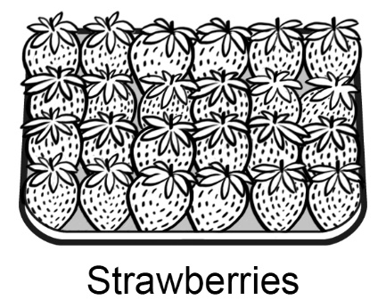
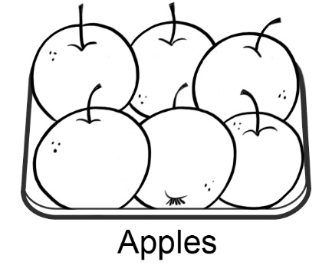

Arrays are a very efficient way to store and package goods.
They save space and help us know how many without
counting by ones.
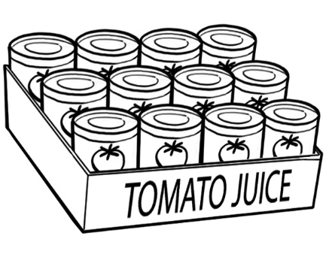
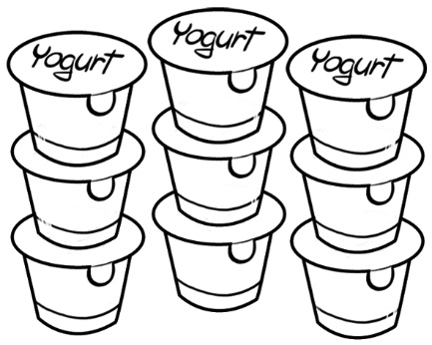
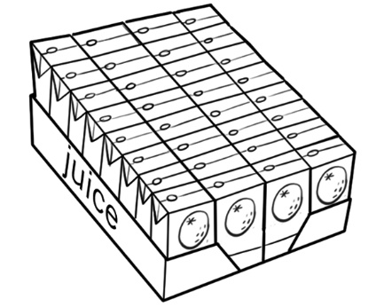

Find how many are in each picture. How did you find out?
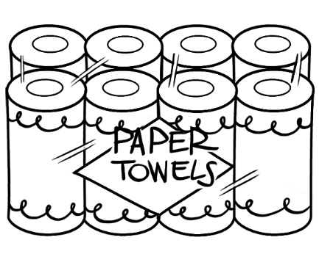
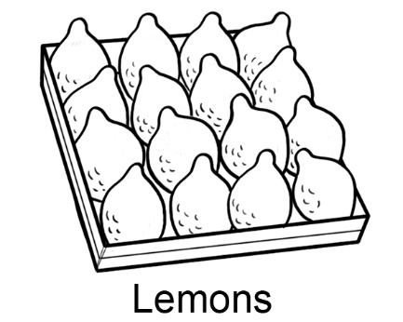

The next time you are in a grocery store, take pictures of some arrays you see and share them with the class.

