***Multiplication Squares* Instructions**

**Master 20**

**Group size:** 2  
 **Materials:**• Student Card 17A: Multiplication Squares  
• 2 number cubes, labelled 1−6  
• 2 dry-erase markers (different colours)

**Instructions:**

Take turns rolling the number cubes and drawing a matching array on the grid.   
Write the product inside the array.

For example, if you roll a 2 and a 3, you can draw an array of   
 2 rows of 3 squares, or 3 rows of 2 squares.

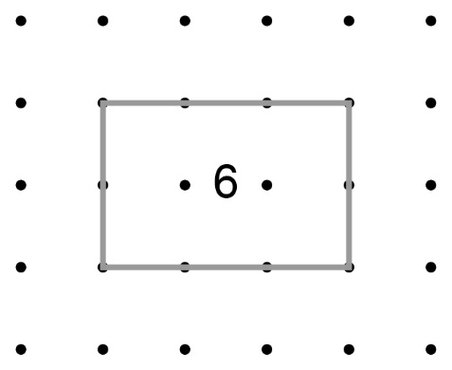

Continue to take turns until one of you runs out of room and cannot draw an array.   
The other player wins.

**Note:** Arrays cannot overlap.