Connections: Balance Puzzles
Master 40a

Do you like to do puzzles?
Have you ever tried a balance puzzle?

When things are balanced, the quantities on both sides are equal.

What do you know about the shapes on this pan balance?

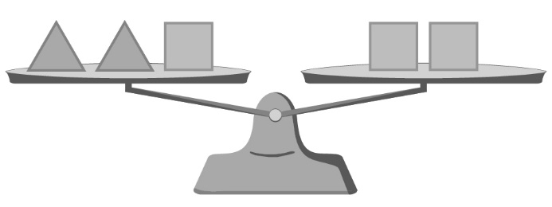

A triangle has a mass equal to one-half the mass of a square.

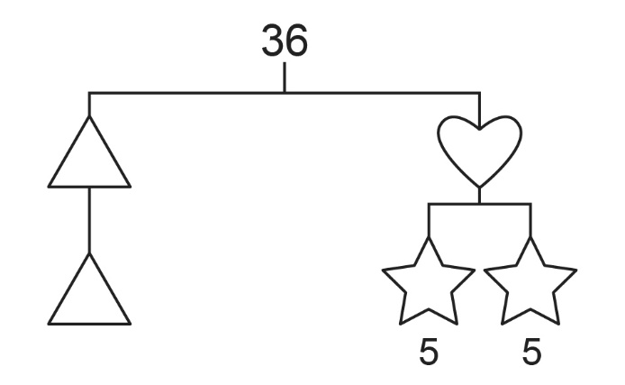
What do you know about the shapes on this balance mobile?

The whole mobile represents 36.
What does each side represent?
Find what each shape represents, given that a star is 5.

Connections: Balance Puzzles
Master 40b

Solve this puzzle.

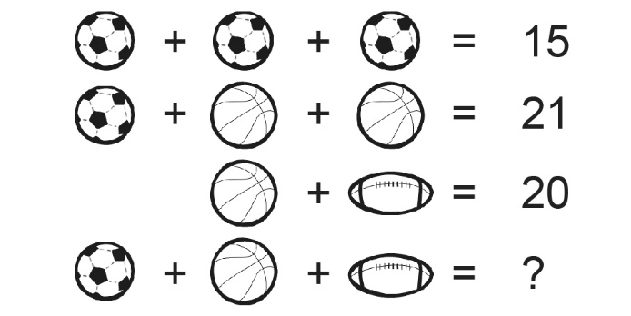

Try making a balance puzzle of your own.
Then trade puzzles with a classmate and solve each other’s puzzles.

