Bean Bag Toss
Master 35a

Amani and Avery each scored 50 points in the bean bag toss.
They each tossed the bean bag 3 times,
but their tosses were not the same.
What might they have scored on each toss?”

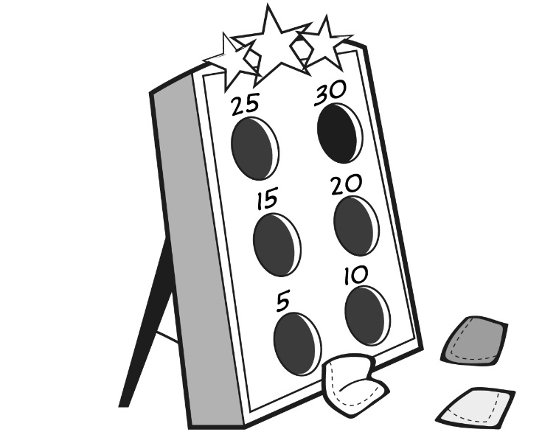

For each player, write the score for each toss and a number sentence to show the sum.
Score | Toss  1 | Toss  2 | Toss  3 | Sum
Amani

Avery

Bean Bag Toss
Master 35b

Look at the expressions in each number sentence.
Are the expressions equal?
How do you know? Show your work.

Bean Bag Toss (Accommodations)
Master 35c

Amani and Avery each scored 30 points in the bean bag toss.
They each tossed the bean bag 3 times,
but their tosses were not the same.
What might they have scored on each toss?”
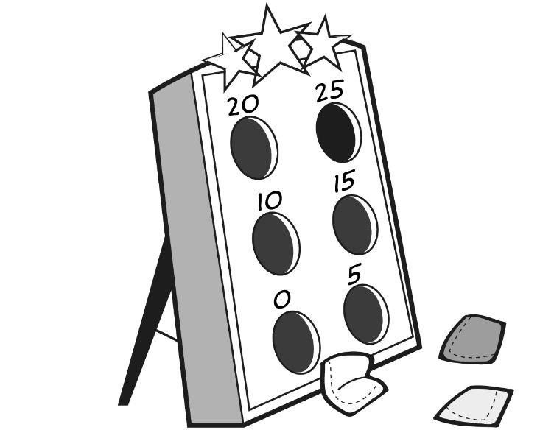

For each player, write the score for each toss and a number sentence to show the sum.
Score | Toss  1 | Toss  2 | Toss  3 | Sum
Amani

Avery

Bean Bag Toss (Accommodations)
Master 35d

Look at the expressions in each number sentence.
Are the expressions equal?
How do you know? Show your work.

