Formulating Questions
Makes statements that don’t generate answers  “I really like fish.” | Formulates questions to learn about people (no response options)  “What type of animal do you  like best?” | Formulates questions to learn about people (incomplete response options)  “What type of animal do you  like best: fish, birds, mammals?” | Formulates clear questions with complete response options to collect relevant data  “What type of animal do you  like best: fish, birds,  mammals, other?”
Observations/Documentation

Collecting and Organizing Data
No organization of data  fish, mammals,  mammals, other,  birds, mammals,  fish, mammals,  mammals, fish | Uses class list; no interpretation  ✓ Juin Fish  Tommy  ✓ Tai Fish  ✓ Ioana Mammals  ✓ Mark Mammals  ✓ Alex Mammals  ✓ Kim Other  Jon  ✓ Sadia Fish  ✓ Lise Mammals  ✓ Dimitri Birds  Vicky  ✓ Ali Mammals  “I’m not sure which answer was chosen most often.” | Uses tally chart, table, list, or line plot  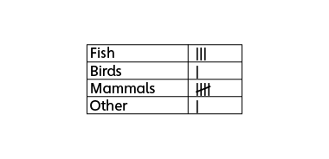  “I made a tally chart so I can easily see how many chose each answer.” | Uses collected data to answer question  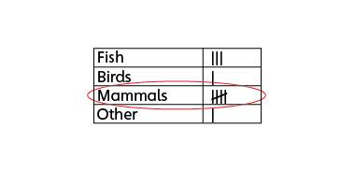  “Most students like mammals best.”
Observations/Documentation

