Drawing Conclusions Based on Data
Asks and answers simple questions about an experiment  “If I toss the coin, I could get heads or tails. Getting heads or tails is equally likely.” | Makes simple decisions based on data  “I can roll a 1, 2, 3, 4, 5, or 6.  I would choose to roll a number less than 5 rather than a number greater than 5 because  I’m more likely to be right.” | Connects fairness of a game to equally-likely outcomes  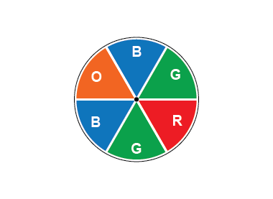  “There is an equal chance of landing on green or blue because they cover the same amount of space.  So, if I need to land on green and my partner on blue, the game is fair. In 12 spins, I expect the pointer to land on green 4 times  and on blue 4 times.” | Creates a game that is fair or unfair and justifies why it is or isn’t fair  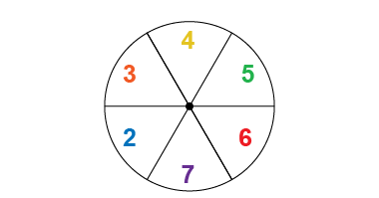  “Fair: rolling an even number or rolling an odd number because the outcomes are equally likely.”  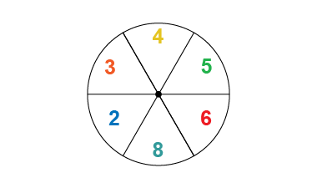  “Unfair: rolling an even number or rolling an odd number because it is more likely for the pointer to land on an even number.”
Observations/Documentation

