Composing and Decomposing 3-D Solids
Constructs skeletons of 3-D solids by decomposing solids into 2-D shapes and matching  “I started by making a square  as the base, then added  the triangular faces.” | Identifies nets of 3-D solids by folding  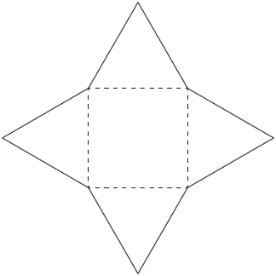  “I folded this net and made  a square-based pyramid.” | Recognizes nets of 3-D solids by decomposing and matching (visualization)  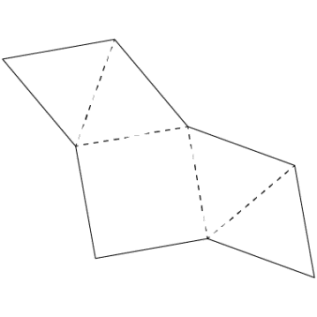  “When I imagine folding it in my mind, I see the triangles wrapping around the square to make a pyramid.” | Constructs and deconstructs solids flexibly using skeletons and nets  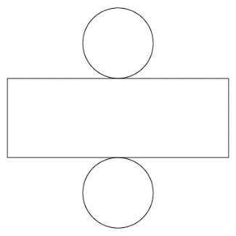  “This net will make a cylinder, but I can’t make a skeleton of a cylinder because it doesn’t have vertices  and edges.”
Observations/Documentation

