Applying Movements to 2-D Shapes
Gives and follows instructions to move congruent shapes to matching orientations  “I can turn one shape half a turn to match the other.” | Gives and follows instructions to slide (translate) shapes but struggles to differentiate between flips (reflections) and turns (rotations)  “I would slide A to the right to get to B. I’m not sure whether I would flip or turn C to get to D.” | Gives and follows instructions to move shapes from one location to another (e.g., turn (rotation), flip (reflection), or slide (translation))  “I used a Mira and the two shapes matched exactly. So, I flipped Shape C onto D.” | Uses orientation of shape to predict, describe, and move shapes from one location to another  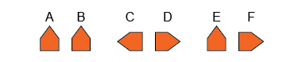  “To move from A to B: same orientation, so slide A to the right; from C to D: opposite orientations, so a flip in vertical line between C and D; from E to F:  different orientations,  so a quarter-turn clockwise.”
Observations/Documentation

