Measuring Length and Perimeter
Uses non-standard units to measure  “The rectangle is 5 paper clips long. Its perimeter is 16 paper clips.” | Uses standard-sized items to measure  “The rectangle is 17 centicubes long. Its perimeter is 54 centicubes.” | Uses benchmarks to estimate in standard units (m, cm)  “I used a big step as a referent for one metre. The classroom is about  7 big steps, or 7 m wide.  Its perimeter is about 30 big steps, or 30 m.” | Measures using standard units (m, cm)  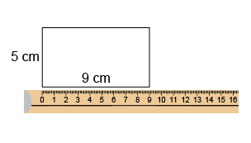  “The perimeter is 28 cm.”
Observations/Documentation

Measuring Length and Perimeter (con’t)
Selects and uses appropriate standard units  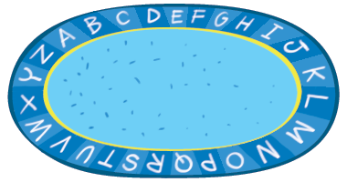  “I would use m because mm and cm are too small. The length of string I wound around the edge is 10 m.  So, the perimeter is 10 m. | Relates standard units of length  (1 m = 100 cm)  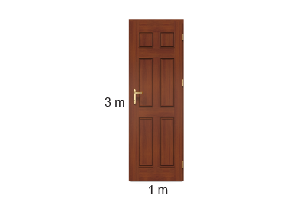  “The door has a perimeter of 8 m. Since 1 m = 100 cm, 8 m = 800 cm.” | Uses smaller units to give more accurate measures  “The pen is between 13 cm and 14 cm long. If I use mm, I can be more accurate: 137 mm.” | Compares using standard units  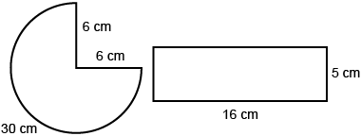  “Rectangle:  5 + 16 + 5 + 16 = 42 cm  Three-quarter circle:  6 + 6 + 30 = 42 cm  The perimeters are the same.”
Observations/Documentation

Time and Measurement Relationships
Uses standard units to measure passage of time  “I used a stopwatch.  Recess lasts 20 minutes.  I used a watch.  Kayla ran 50 m in 7 seconds.” | Selects and uses appropriate unit to measure time  “I would measure a school day in hours, the time to walk to the library in minutes, and the blink  of an eye in seconds.” | Reads time on an analogue and digital clock  “It is 10 minutes after 9.” | Understands relationships among time units  “1 hour is 60 minutes.  So, 2 hours is 120 minutes.  1 minute is 60 seconds.  So, 2 minutes is 120 seconds.”
Observations/Documentation

