Comparing and Ordering Quantities
Orders numbers randomly  125 245 179  “I just put down any card.” | Models with manipulatives  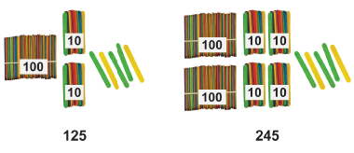 | Uses benchmark on hundred chart or number line  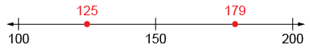  “I compared the numbers to 150.”
Observations/Documentation

Visualizes hundred chart or number line  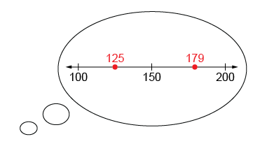  “I picture 179 farther to the right than 125.” | Compares numbers, digit by digit (with the same place value)  “Both start with 1, 2 is less than 7, and 5 is less than 9. So, 125 is less than 179.” | Orders three or more quantities (e.g., using early place-value, mental strategies)  179 245 326  “326 is greatest because 3 hundreds is more than both 2 hundreds and 1 hundred.”
Observations/Documentation

