Developing Fluency with Multiplication and Division
Models with concrete materials and counts by 1s | Uses skip-counting forward and backward  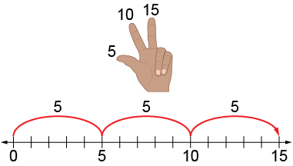 | Works flexibly with numbers (e.g., uses repeated addition or subtraction, familiar facts, commutative property)  “5 + 5 + 5 = 15  I know 2 × 5 = 10 and one more group of 5 is 15,  so 3 × 5 = 15.  I know 5 × 3 = 15, so 3 × 5 also equals 15.”
Observations/Documentation

Developing Fluency with Multiplication and Division (con’t)
Uses distributive property to help with unfamiliar facts  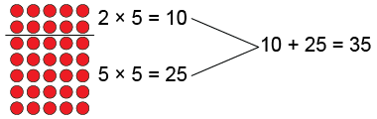  “7 × 5 = 35” | Applies multiplicative thinking to compare quantities (solve ratio problems)  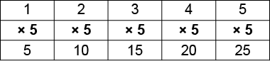  “For each hand there are 5 fingers. The ratio of hands to fingers is 1:5. That means I multiply by 5. So, on 2 hands there are 2 × 5, or 10 fingers.” | Fluently multiplies and divides  “I just know that 7 × 5 = 35.”
Observations/Documentation

Multiplying 1-Digit Numbers
Groups objects and counts by 1s  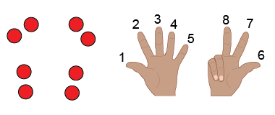 | Groups objects and skip-counts  “2, 4, 6, 8” | Uses repeated addition  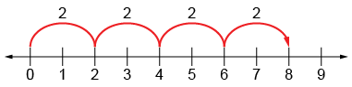  “2 + 2 + 2 + 2 = 8.” | Models using multiplicative thinking  “4 rows of 2 is 8.”
Observations/Documentation

Understands relationship between operations  “I can think of 2 + 2 + 2 + 2 = 8  as 4 groups of 2.” | Uses multiplication symbol  “4 × 2 = 8” | Multiplies fluently (e.g., uses properties of multiplication)  “4 × 2 = 8  2 × 4 = 8” | Creates and solves problems involving equal groups  4 × 2 = 8  “There are 4 bicycles in the shed. How many wheels  are there altogether?”
Observations/Documentation

