Developing Fluency with Multiplication and Division
Models with concrete materials and counts by 1s | Uses skip-counting forward and backward  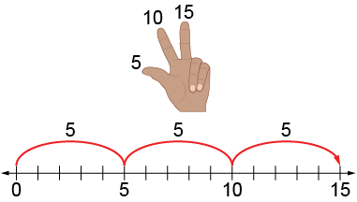 | Works flexibly with numbers (e.g., uses repeated addition or subtraction, familiar facts, commutative property)  “5 + 5 + 5 = 15  I know 2 × 5 = 10 and one more group of 5 is 15,  so 3 × 5 = 15.  I know 5 × 3 = 15, so 3 × 5 also equals 15.”
Observations/Documentation

Developing Fluency with Multiplication and Division (con’t)
Uses familiar facts to solve ratios  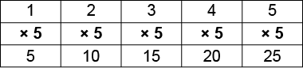  “The ratio is 1:5. That means I multiply by 5. 2 × 5 = 10, so 2:10. 3 × 5 = 15, so 3:15.” | Uses distributive property to help with unfamiliar facts  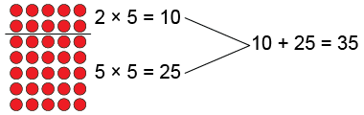  “7 × 5 = 35” | Fluently multiplies and divides  “I just know that 7 × 5 = 35.”
Observations/Documentation

