Identifying Equivalent Expressions
Models expressions concretely to determine equivalence  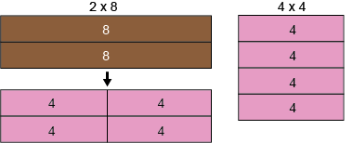  “I could trade rods for other rods to make both models look the same. So, 2 × 8 and 4 × 4 are equivalent.” | Use number relationships or mental math strategies to determine equivalence  9 + 7 and 42 – 27  “9 + 7: take 1 from 9 and give it to 7 to make 8 + 8, or 16.  42 – 27: add 3 to each number to make 45 – 30, or 15.  Since 15 doesn’t equal 16, the expressions are not equivalent.” | Uses equal sign as balance (left side equals right side) and not equal sign as imbalance  2 × 8 = 4 × 4  9 + 7 ≠ 42 − 27  “The equal sign means that the expressions on both sides are worth the same amount.” | Records an equation with an unknown to match a given situation  “I started with 12 stickers.  My friend gave me some more.  Now I have 21 stickers.  12 + ■ = 21  I used a box to represent the unknown, but I could have used a different shape.”
Observations/Documentation

