**Types of Transportation**

**Master 70a**

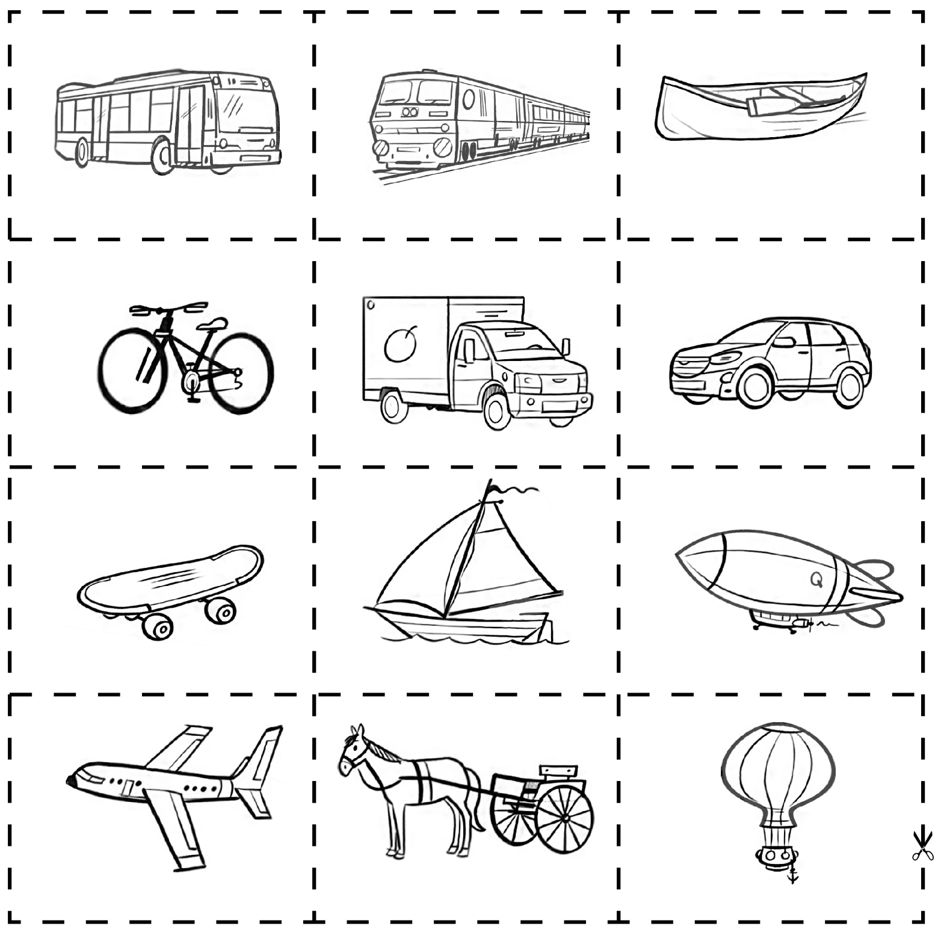

**Types of Transportation**

**Master 70b**

