**Perimeter Shapes**

**Master 37a**

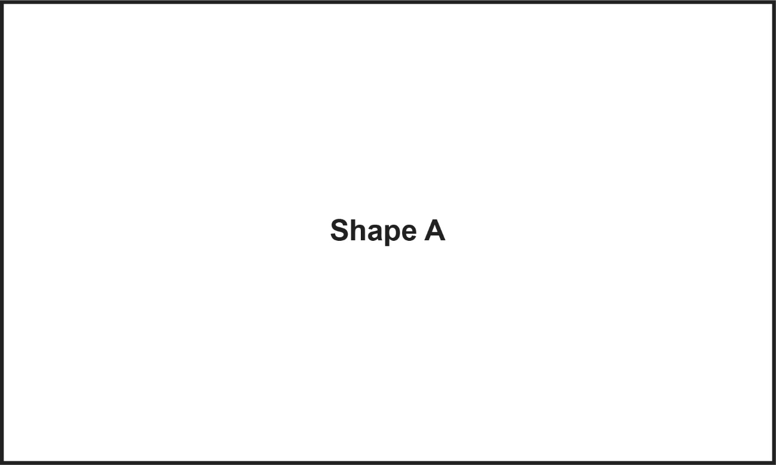

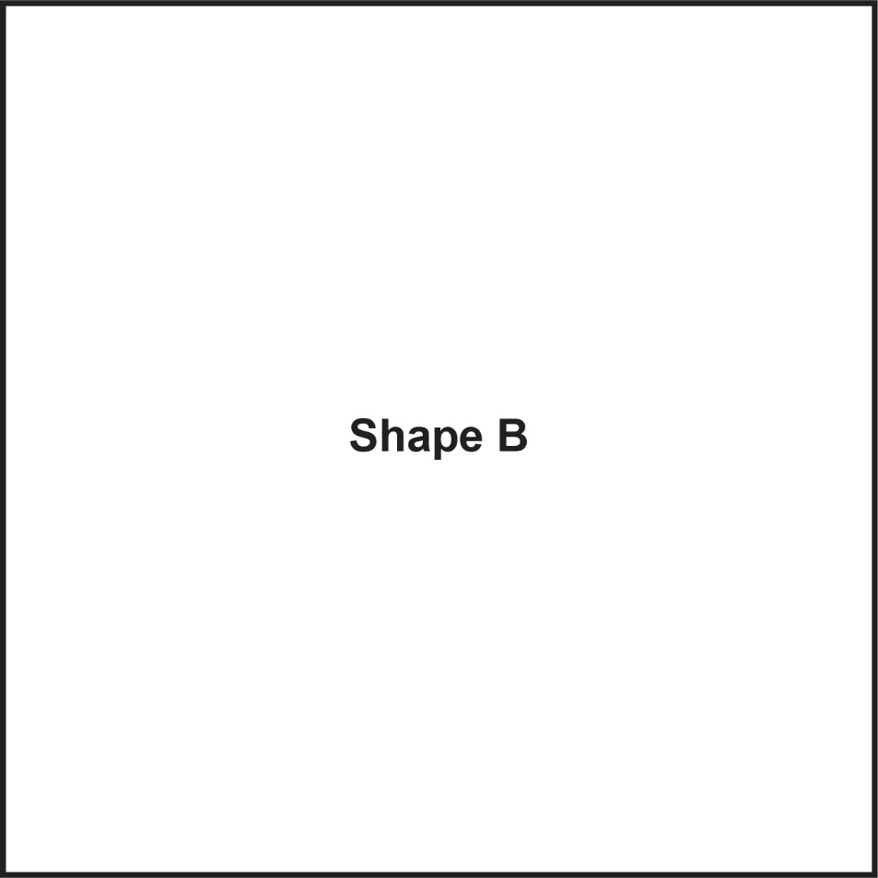

**Perimeter Shapes**

**Master 37b**

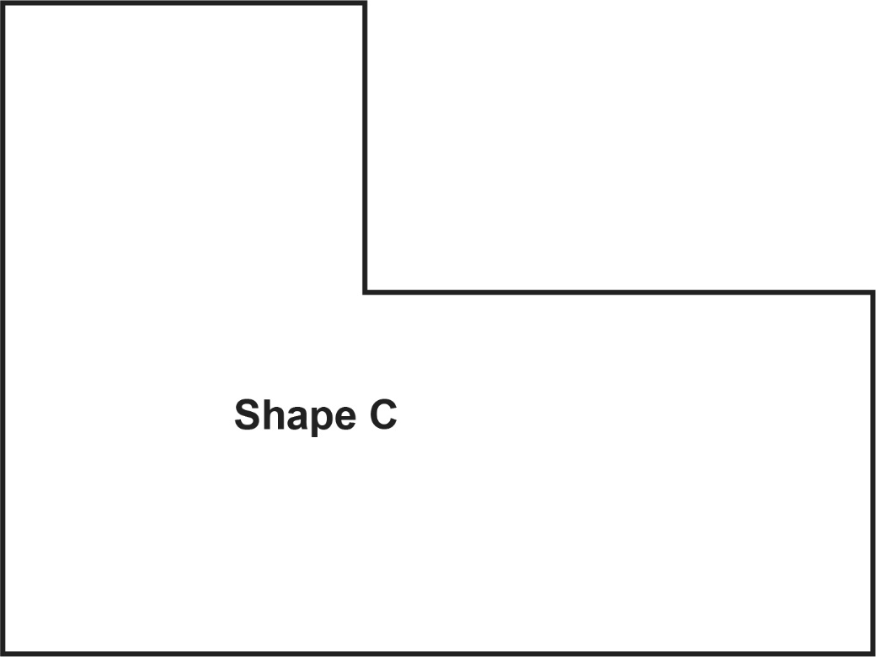

**Perimeter Shapes**

**Master 37c**

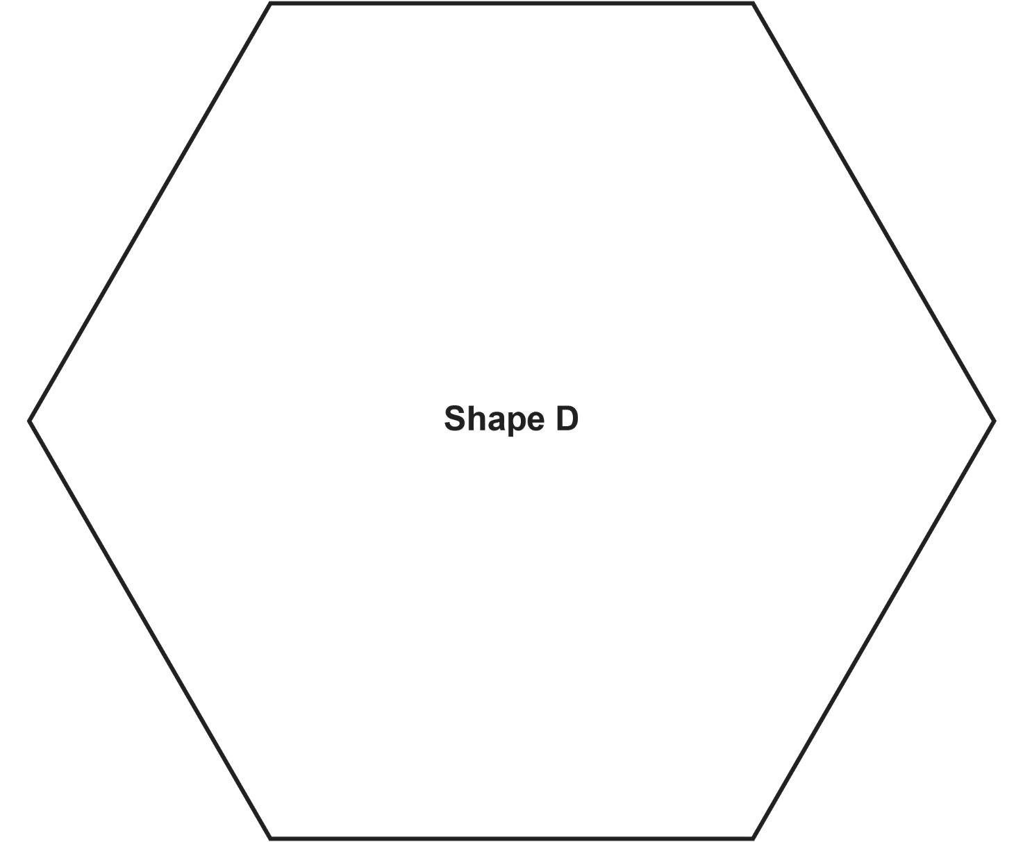

**Perimeter Shapes**

**Master 37d**

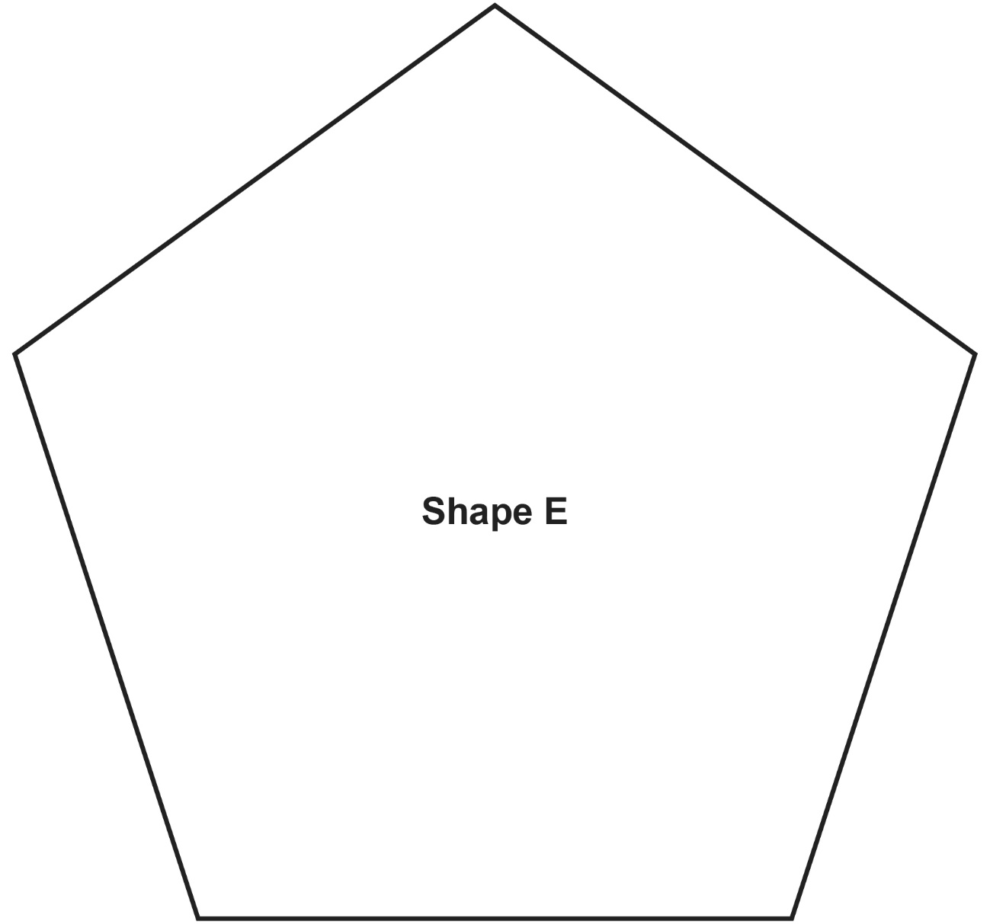

**Perimeter Shapes**

**Master 37e**

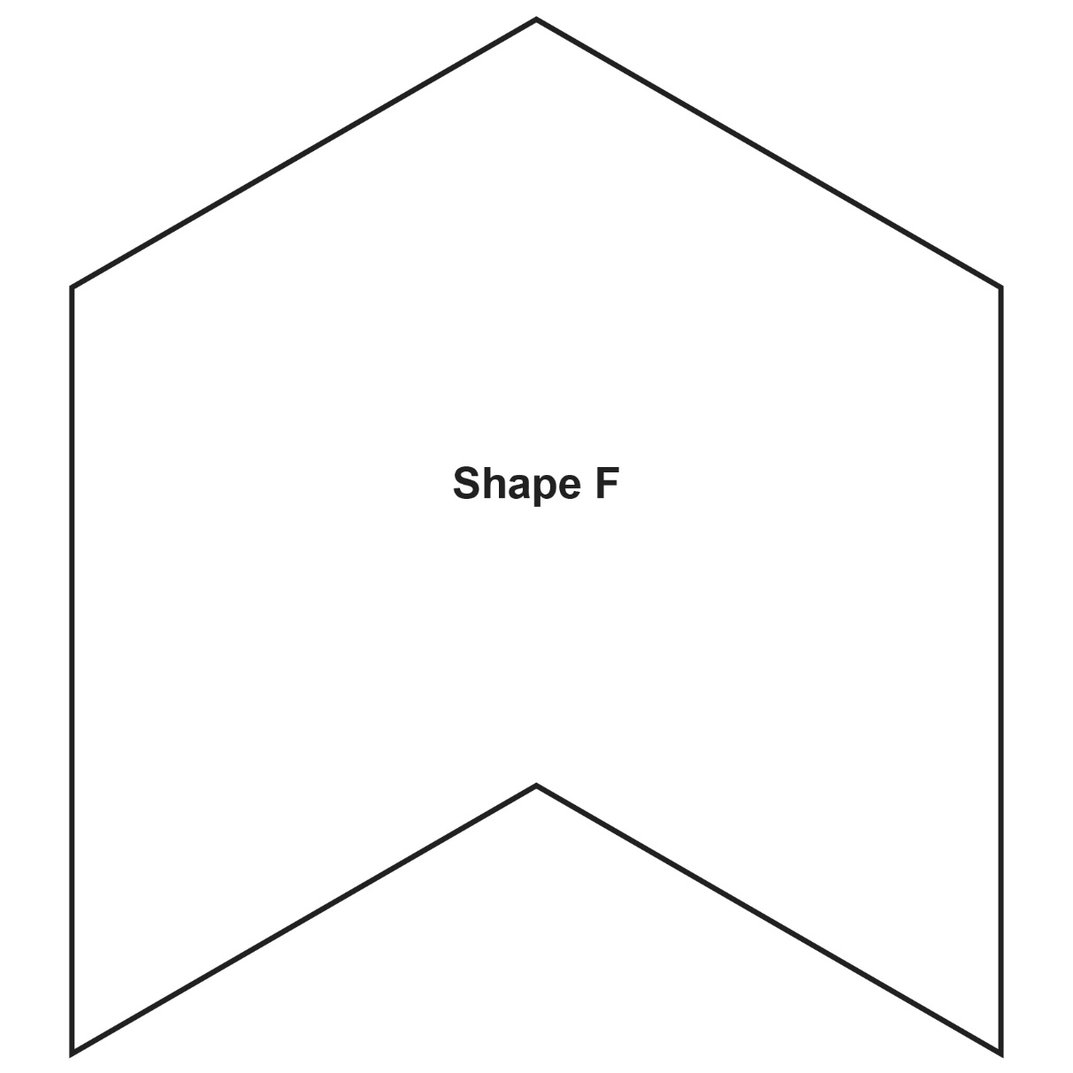

**Perimeter Shapes**

**Master 37f**

**Perimeter Shapes**

**Master 37g**

