**T-Shirt Cards**

**Master 3a**

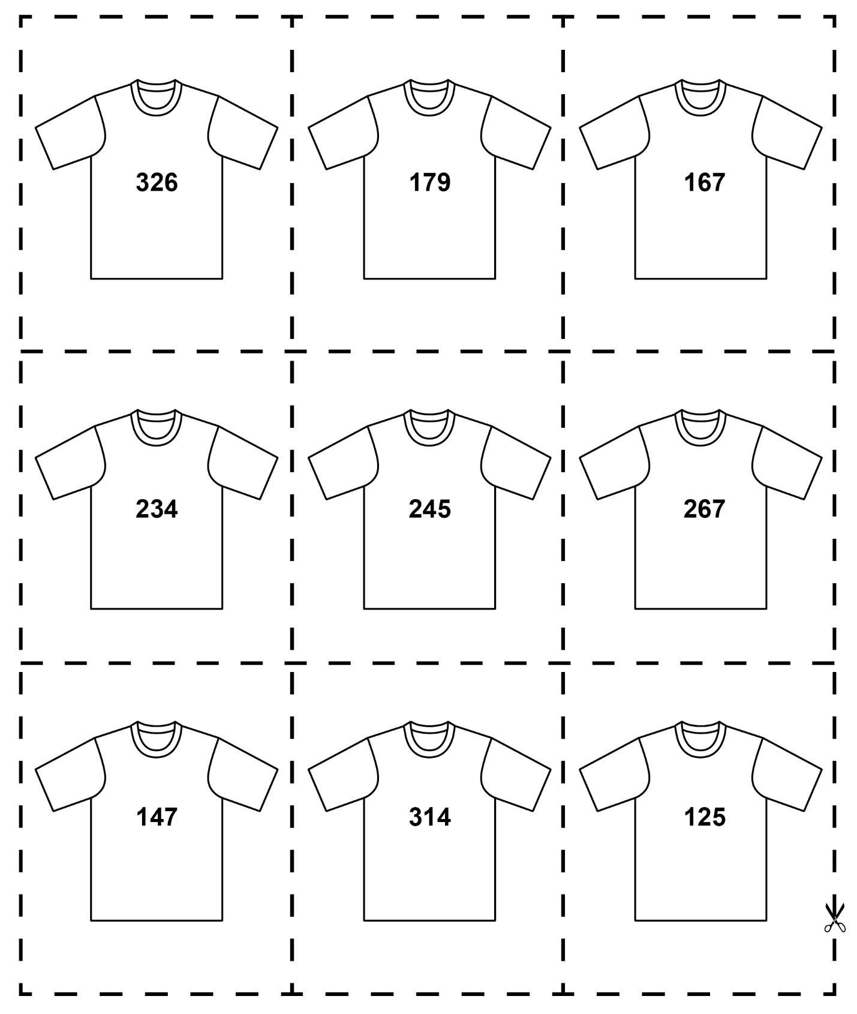

**T-Shirt Cards**

**Master 3b**

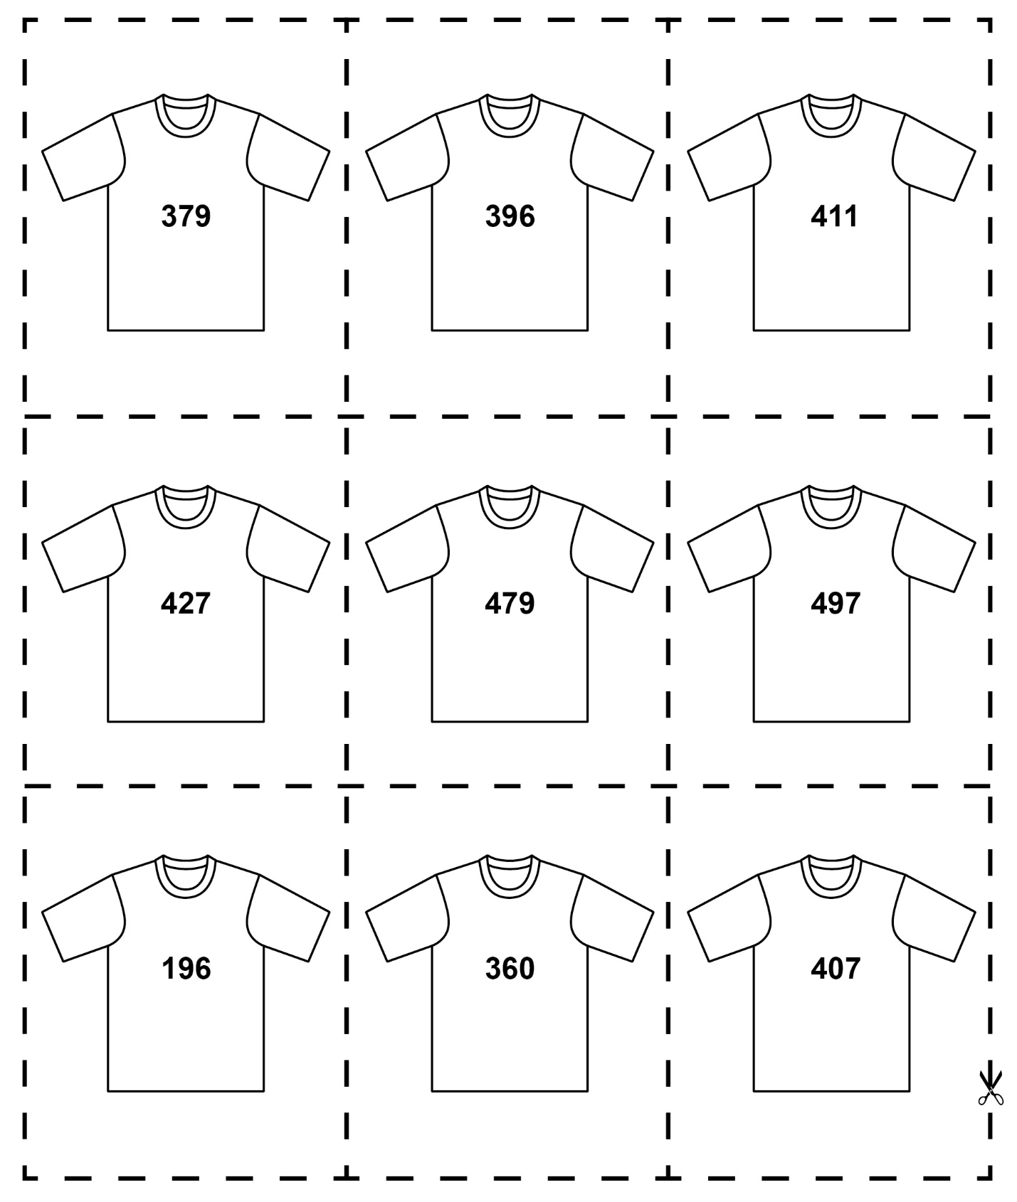

**T-Shirt Cards**

**Master 3c**

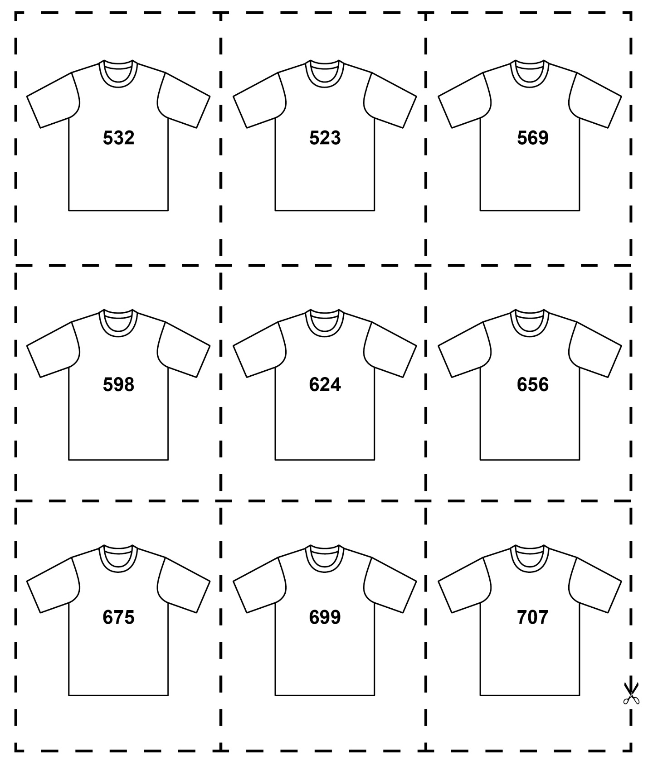

**T-Shirt Cards**

**Master 3d**

