Multiplication Squares Instructions
Master 19

Group size: 2
Materials:
• Student Card 17A: Multiplication Squares (or Math Mat 24: Square Dot Paper
• Math Mat 37: Spinner
• Pencil and paper clip for pointer
• 2 dry-erase markers (different colours)

Instructions:
Write a 1 before the 0 on Math Mat 37: Spinner to make the number 10.
Take turns spinning the spinner twice and drawing a matching array on the grid.
Write the product inside the array.
For example, if you spin a 2 and a 3, you can draw an array of 2 rows of 3 squares, or 3 rows of 2 squares.
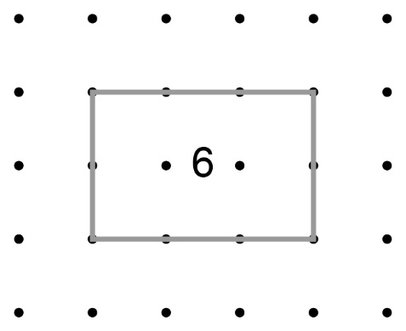

Continue to take turns until one of you runs out of room and cannot draw an array.
The other player wins.

Note: Arrays cannot overlap.

