Creating Graphical Displays
Creates graph but does not relate sample responses to labels  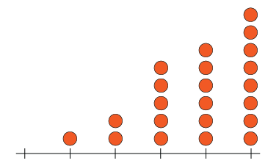 | Creates graph with labels but omits title or scale  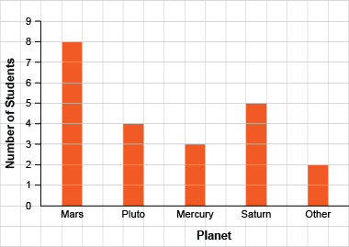 | Successfully creates graphs (always of same type)  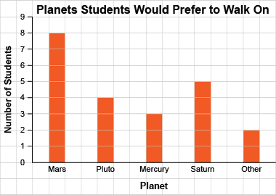 | Creates graphs flexibly; shows same data on different graph types  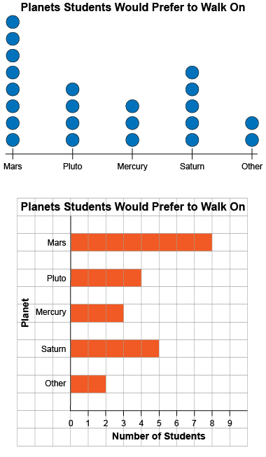
Observations/Documentation

