Investigating Geometric Attributes of 3-D Solids
Identifies and describes geometric attributes of individual solids  “This 3-D solid has 2 square bases, 4 rectangular faces, 12 edges, and 8 vertices.”  Or “This 3-D solid has  2 rectangular bases,  2 square faces, 2 rectangular faces, 12 edges, and 8 vertices.” | Groups solids that share the same geometric attributes  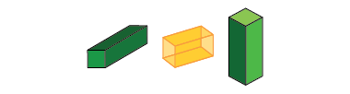  “All these solids have the same geometric attributes, so they are all square-based prisms.” | Builds solids based on given geometric attributes  “I made a square pyramid. It has 4 triangle faces and 1 square base.” | Sorts, classifies and names solids using geometric attributes  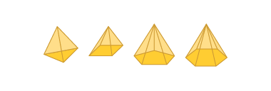  “All pyramids have faces that are triangles.”
Observations/Documentation

Composing and Decomposing 3-D Solids
Constructs skeletons of 3-D solids by decomposing solids into 2-D shapes and matching  “I started by making a square  as the base, then added  the triangular faces.” | Identifies nets of 3-D solids by folding  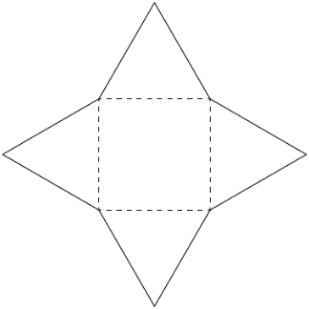  “I folded this net and made  a square-based pyramid.” | Recognizes nets of 3-D solids by decomposing and matching (visualization)  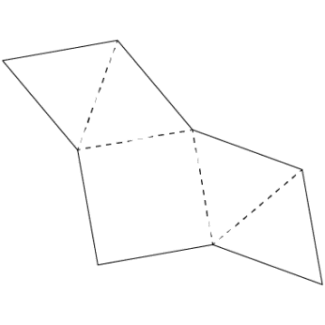  “When I imagine folding it in my mind, I see the triangles wrapping around the square to make a pyramid.” | Constructs and deconstructs solids flexibly using skeletons and nets  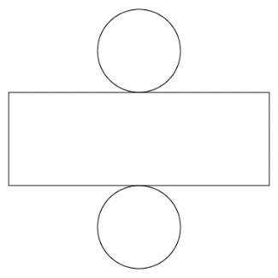  “This net will make a cylinder, but I can’t make a skeleton of a cylinder because it doesn’t have vertices  and edges.”
Observations/Documentation

