Understanding Temperature
Relates temperature to experiences  “When it is hot outside,  I don’t need to wear a jacket. I can wear shorts.” | Creates benchmark temperatures for air and water  “Room temperature is a benchmark for 20°C.” | Uses benchmarks to estimate temperatures  “It is a bit warmer outside than the temperature in the classroom.  I think it is about 23°C.” | Uses a thermometer to measure temperature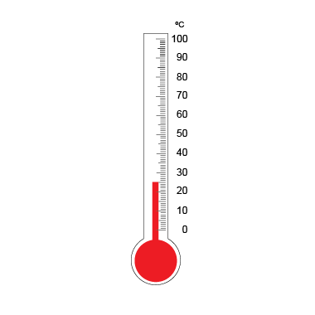  “The outside temperature is 25°C.”
Observations/Documentation

