Using Standard Units to Estimate and Measure Mass and Capacity
Uses non-standard units to measure  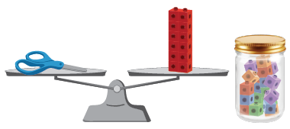  “The scissors have a mass of  about 12 linking cubes.  The jar has a capacity of  about 20 linking cubes.” | Uses multiple copies of standard-sized items to measure  “I added 1-g masses to the pan until the pans balanced. The eraser has a mass of 20 g.  I filled the 100-mL cylinder and poured it  into the jug. I did this 6 times.  The capacity of the jug is 600 mL.” | Measures using intermediary object (e.g., object whose mass/capacity is known)  “I know the soup can has a mass of about 300 g, so I started with that and added other masses.  I used the water bottle to fill the bowl. It didn’t quite fill it, so I then used the 100-mL cylinder.”
Observations/Documentation

Using Standard Units to Estimate and Measure Mass and Capacity (con’t)
Uses benchmarks to estimate in standard units  “My pencil case is a bit heavier than a can of tuna, so I estimate 225 g.  The bottle is a bit smaller than a carton of milk, so I estimate 900 mL.” | Selects and uses appropriate standard units  “It’s lighter than a box of salt,  so I will use grams.  It’s bigger than a milk carton,  so I will use litres.” | Compares using standard units  “1 L is more than 750 mL, so the milk carton holds more than the yogurt tub.”
Observations/Documentation

Relationships in Area, Mass, and Capacity
Measures using different non-standard units for area, mass, and capacity  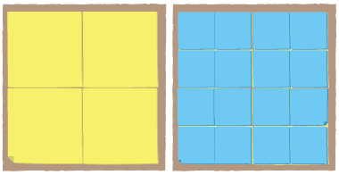  “I covered the shape with big squares, then with small squares.” | Uses the relationship between non-standard units to explain measures  “The bigger the cube, the fewer I needed to fill the milk carton.  The smaller the square, the more I needed to cover the shape.” | Uses conservation of area and mass to predict measures  “I reshaped the modelling clay and its mass didn’t change. It was 375 g both times.” | Flexibly uses the relationships among measurement units  “375 g is less than 1 kg  because 1 kg is 1000 g.”
Observations/Documentation

