Composing and Decomposing 3-Digit Numbers
Composes and decomposes using tens and ones (one way)  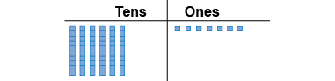  “I modelled 67.” | Composes and decomposes using tens and ones (more than one way)  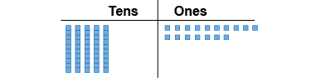  “I traded a ten for 10 ones.” | Composes and decomposes using hundreds, tens, and ones (one way)  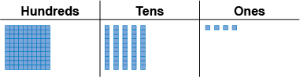  “I modelled 154.”
Observations/Documentation
Composes and decomposes using hundreds, tens, and ones (more than one way)  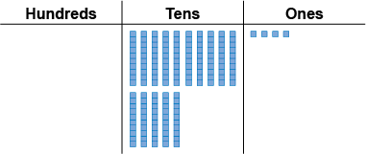  “I traded the hundred for 10 tens.” | Uses place value to write a number in different ways  “One hundred fifty-four  154 = 100 + 50 + 4;  1 hundred, 5 tens, 4 ones;  1 hundred, 4 tens, 14 ones  □IIIII▪▪▪▪” | Understands relationships among digits  “The digit 4 in 429 represents  4 hundreds, 40 tens, or 400 ones.”
Observations/Documentation

