Composing and Decomposing 3-Digit Numbers
Composes and decomposes using tens and ones (one way)  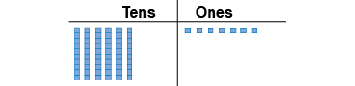  “I modelled 67.” | Composes and decomposes using tens and ones (more than one way)  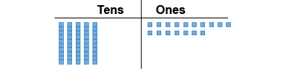  “I traded a ten for 10 ones.” | Composes and decomposes using hundreds, tens, and ones (one way)  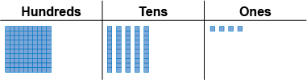  “I modelled 154.”
Observations/Documentation

Composes and decomposes using hundreds, tens, and ones (more than one way)  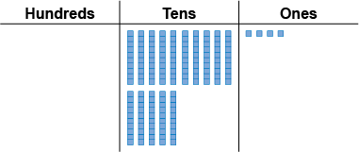  “I traded the hundred for 10 tens.” | Uses place value to write a number in different ways  “One hundred fifty-four  154 = 100 + 50 + 4;  1 hundred, 5 tens, 4 ones;  1 hundred, 4 tens, 14 ones  □IIIII▪▪▪▪” | Understands relationships among digits  “The digit 4 in 429 represents  4 hundreds, 40 tens, or 400 ones.”
Observations/Documentation

Estimating Numbers
Compares to benchmark of 10  “23 is greater than 10.” | Identifies benchmark numbers (multiples of 10)  “23 lies between 20 and 30.” | Compares to benchmark numbers (multiples of 10)  “23 is closer to 20 than to 30.” | Uses benchmark numbers to round to nearest 10  “Since 23 is closer to 20 than to 30,  23 rounds to 20.”
Observations/Documentation

