Partitioning Quantities to Form Fractions
Partitions whole (area or length) into parts that are not equal  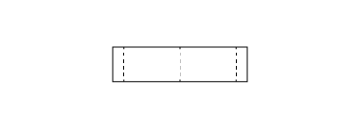  “I folded the strip into 4 parts.” | Partitions whole (area or length) into equal parts  “I folded the line into 4 equal parts.” | Names the unit fraction  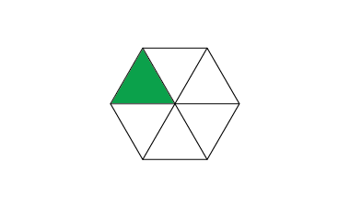  “Each part represents one-sixth.” | Counts parts using unit fractions  “1 one-fourth, 2 one-fourths,  3 one-fourths, 4 one-fourths”
Observations/Documentation

Partitioning Quantities to Form Fractions (con’t)
Compares unit fractions  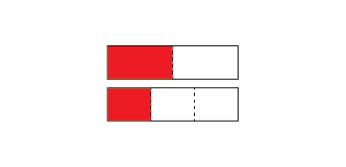  “One-half is bigger than one-third of the same whole.” | Understands relationship between number of parts and size of parts  “When I divide the whole into more parts, the parts get smaller. | Uses fraction symbol to represent fractional quantities of whole  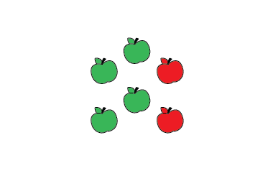  “$\frac{4}{6}$ of the apples are green.” | Compares fractions with the same denominator  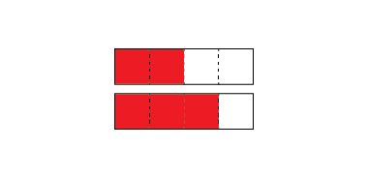  “$\frac{3}{4}$ is bigger than $\frac{2}{4}$ because one more part is shaded.”
Observations/Documentation

