Understanding Equality with Money
Uses like coins to show equivalent amounts  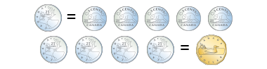  “I know 5 nickels make 1 quarter  and 4 quarters make $1.” | Uses different denominations of coins to show equivalent amounts  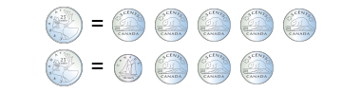  “I can show 25 cents with  5 nickels, then trade 2 nickels  for a dime.” | Determines total cost of purchase and shows equivalent amounts in different ways  $3.70 + $1.25 = $4.95  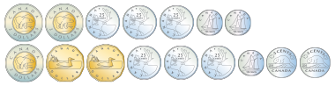  “I can pay $4.95 using lots of different coins, but I could also pay with a $5 bill, and get  5 cents change.” | Determines total value of purchase and shows equivalent amount in most efficient way  $6.25 + $5.45 + $4.50 = $16.20  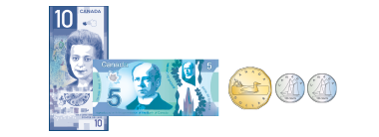  “I know that I can start with  $15 in bills, then add 1 dollar  and twenty cents.”
Observations/Documentation

