Identifying and Extending Repeating Patterns
Identifies repeating pattern (one of the changing attributes)  “Shape is changing. The pattern is: star, triangle, triangle.” | Identifies repeating pattern (two changing attributes)  “Colour and shape are changing.” | Identifies core of a repeating pattern  “The core is: blue star, blue triangle, red triangle.” | Uses core to extend the repeating pattern  “I drew the core on a piece of paper and moved it along the pattern to help me extend it.”
Observations/Documentation

Creating Repeating Patterns
Builds core with one attribute (e.g., always colour)  “red, blue, blue, yellow” | Builds core with one attribute (shape, size, colour)  “I changed shape.” | Creates patterns with one attribute in many ways (shape, size, colour)  “I copied the core two more times.”
Observations/Documentation
Builds core with two attributes  “I changed shape and colour.” | Creates patterns with two attributes  “I copied the core two more times.” | Represents the same pattern in many ways (e.g., letters, numbers, sounds)  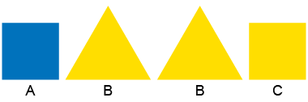  “I represented the pattern core with letters: ABBC.”
Observations/Documentation

