**Animal Sort**

**Master 74a**

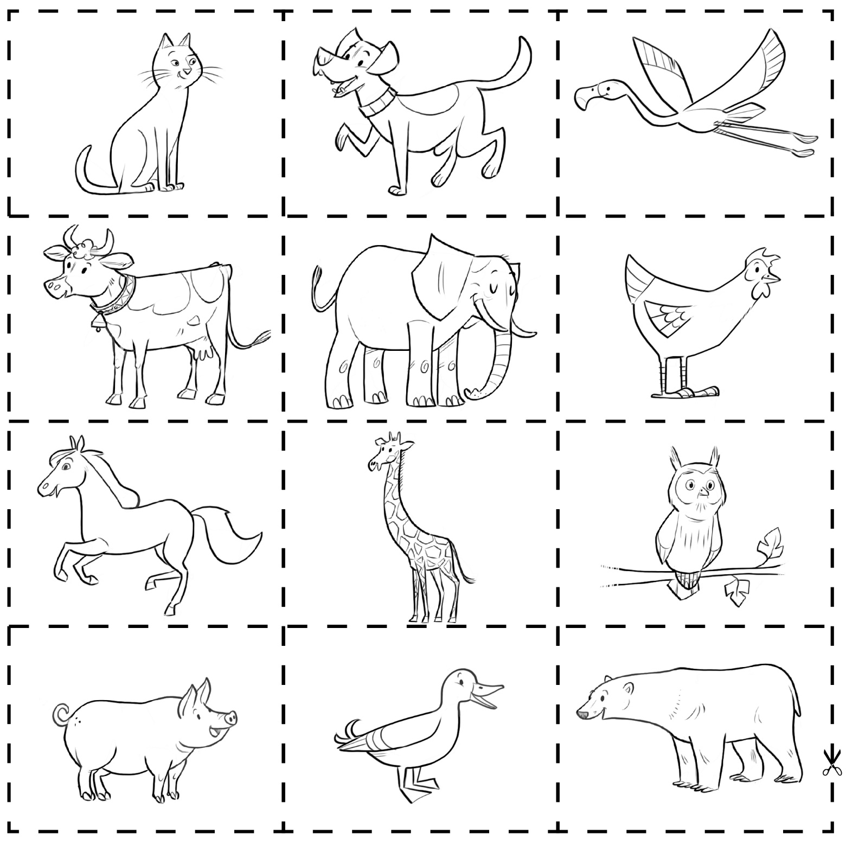

**Animal Sort** (cont’d)

**Master 74b**

