Connections:
Master 52

Drawing from Shapes

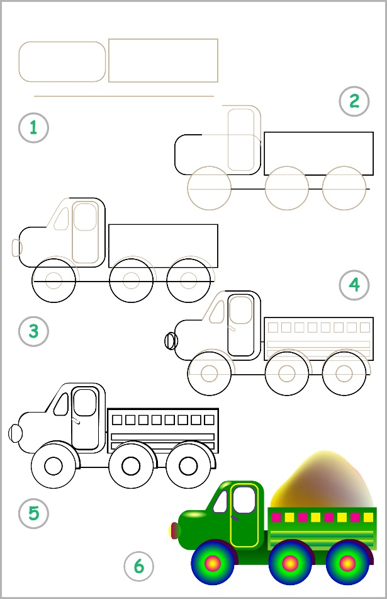
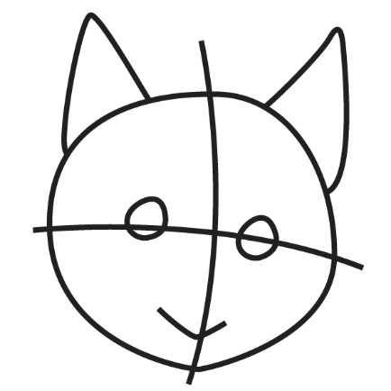
Many artists start their drawings with simple shapes like circles,
rectangles, and triangles.
When first learning to draw, it is often easiest to start with simple
shapes as guides.
For example, to draw a cat, we might start with
a circle for the head and triangles for the ears.
Try using shapes to draw a picture of your favourite animal.
To draw this truck, the artist started with a line, a rectangle, and a rectangle with rounded corners.
What other shapes were used to finish the drawing?
What do they represent?

