**Pattern Block Symmetry**

**Master 58a**

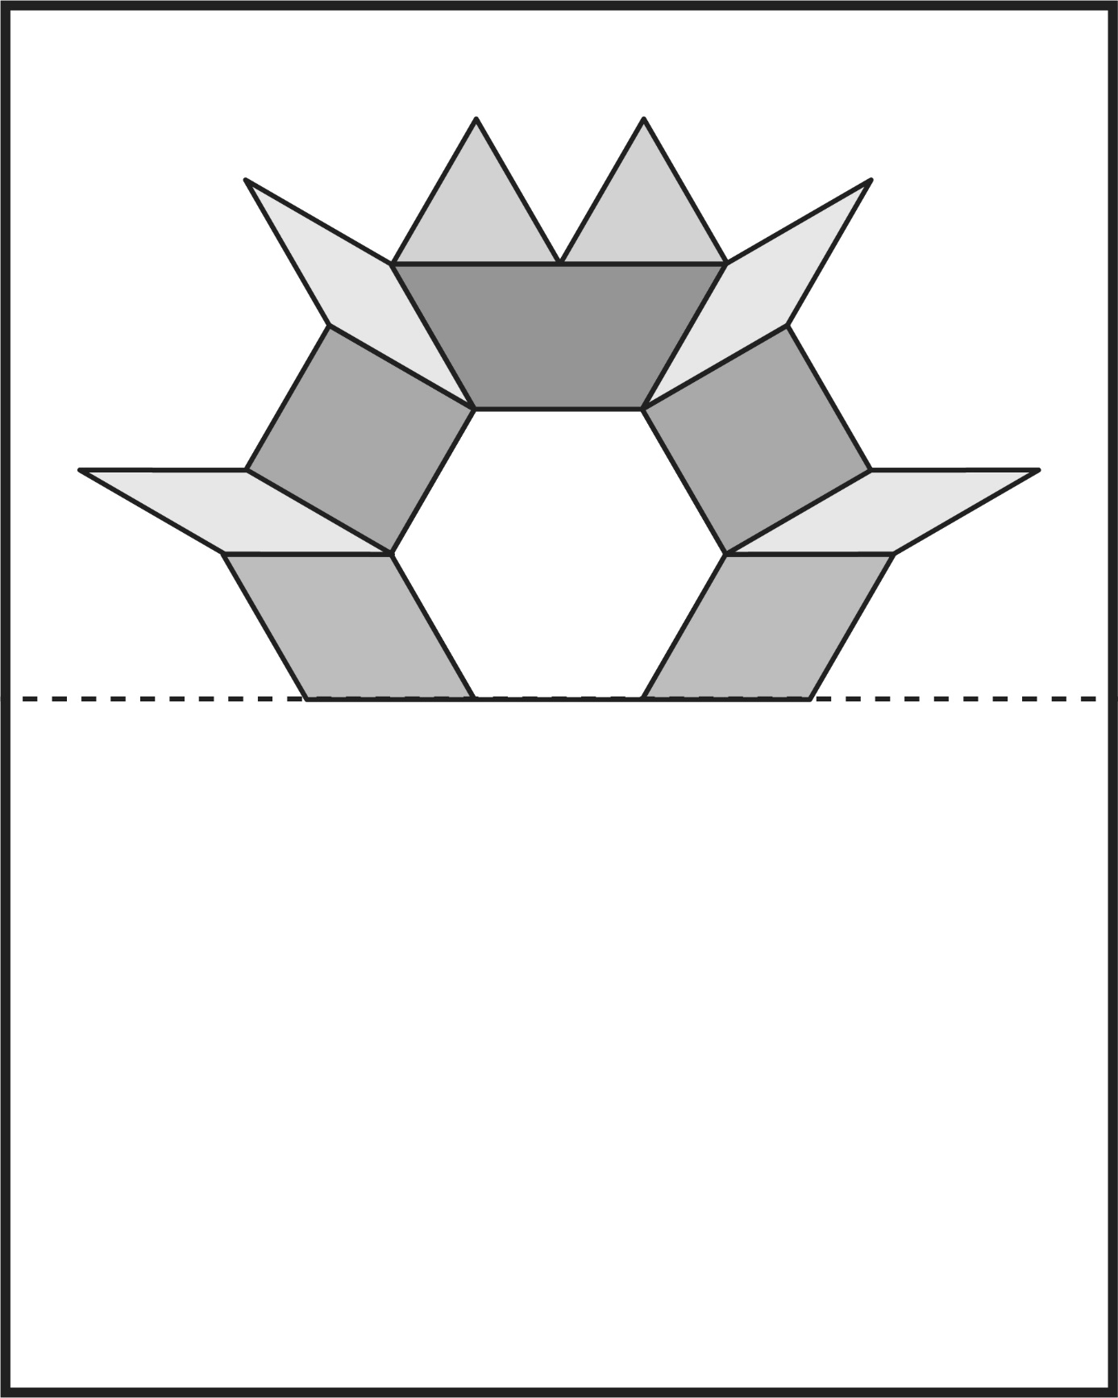

**Pattern Block Symmetry**

**Master 58b**

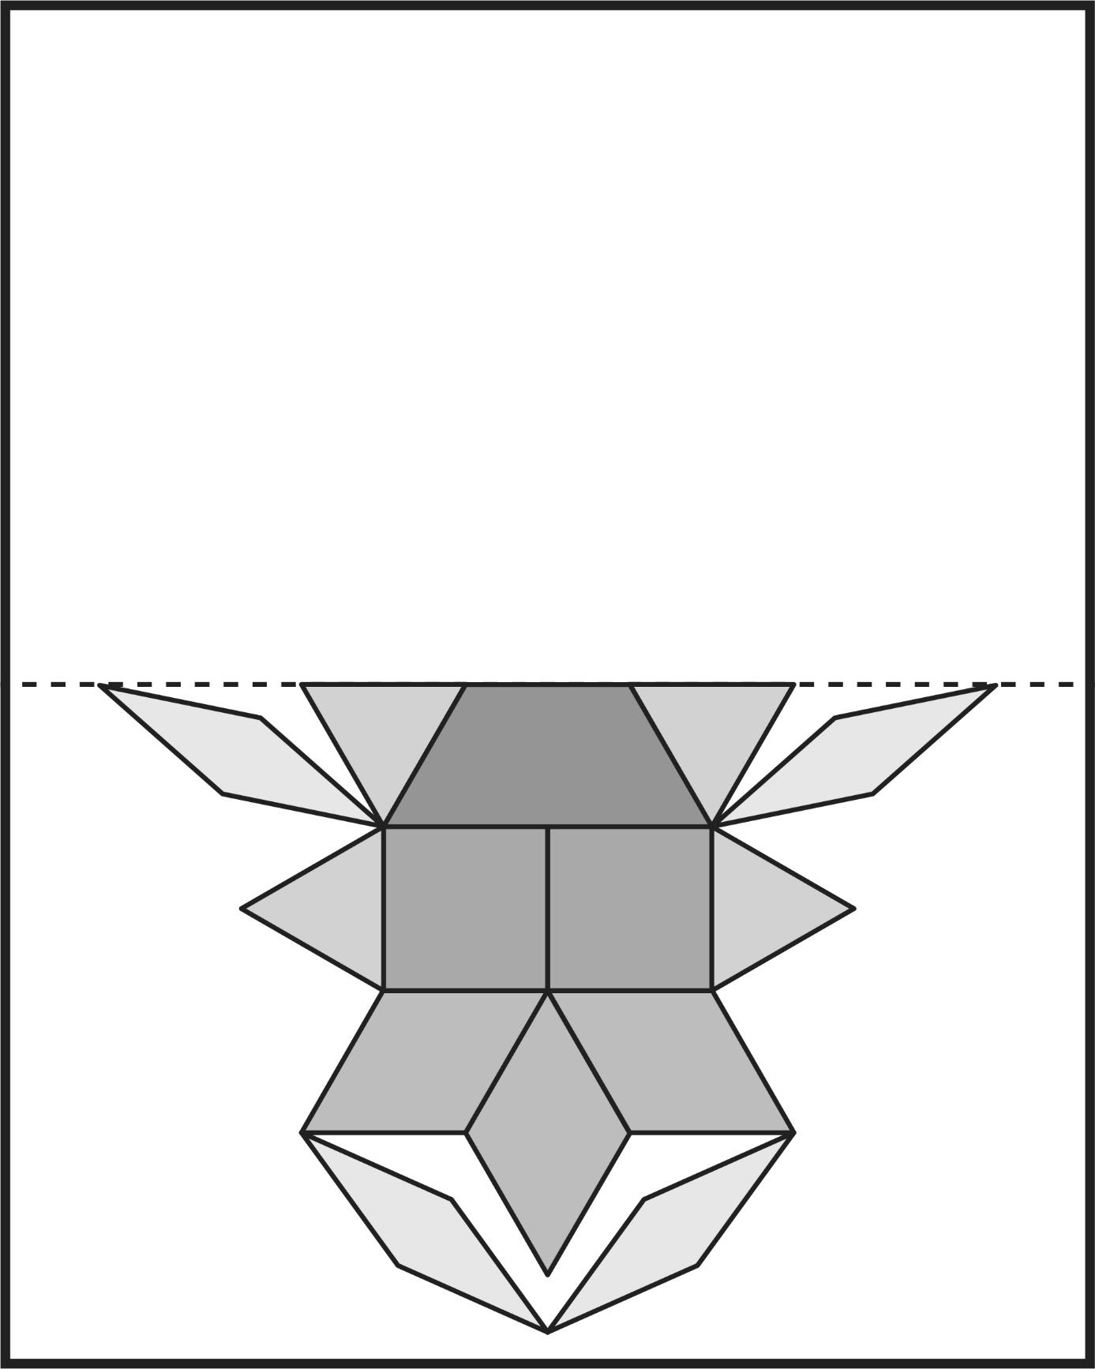

**Pattern Block Symmetry**

**Master 58c**

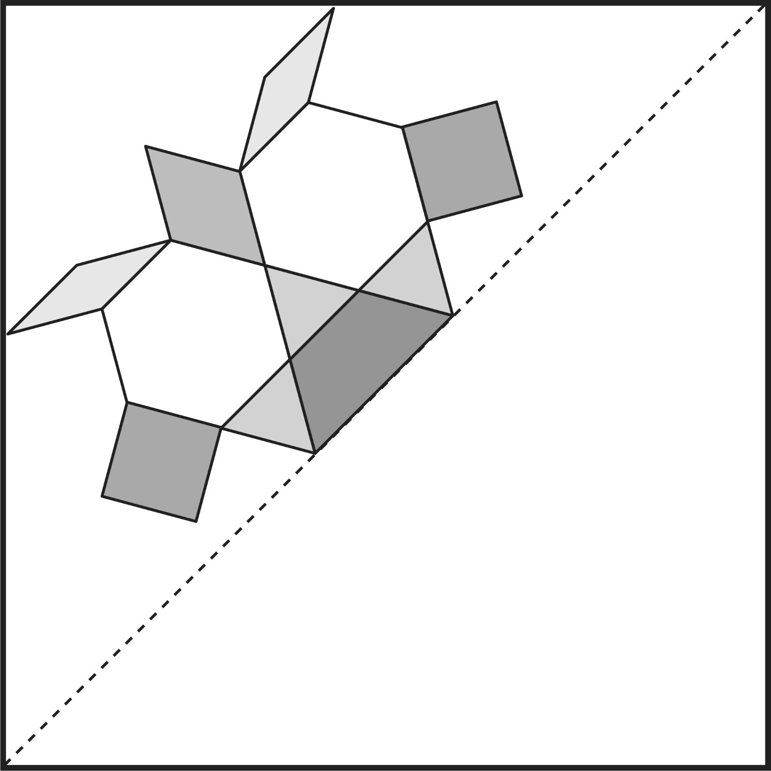

**Pattern Block Symmetry**

**Master 58d**

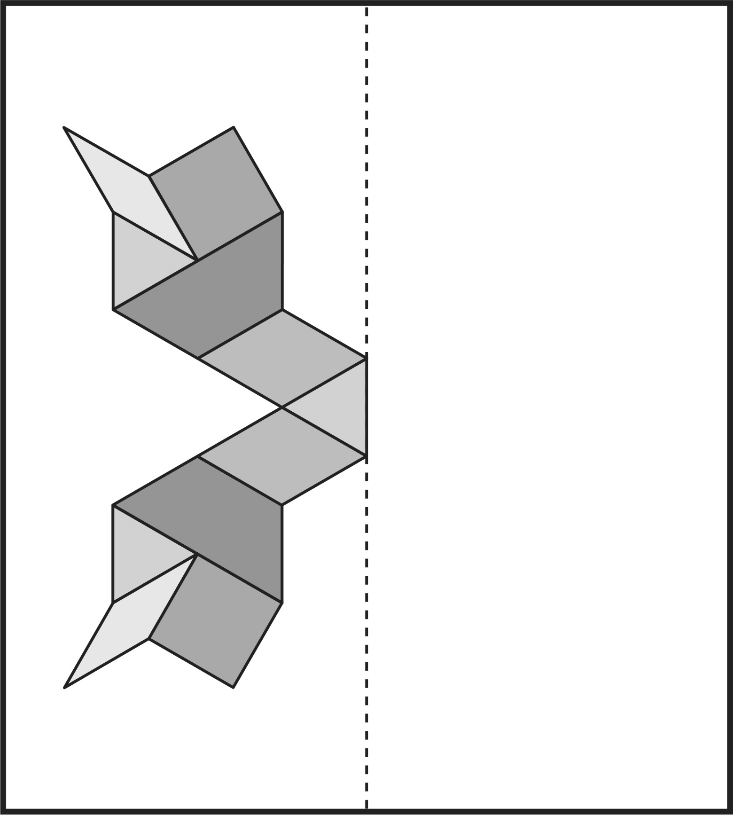

**Pattern Block Symmetry** (Accommodation)

**Master 58e**

