Picture Instructions: Tiles
Master 66a

Place a tile in the second row from the bottom, in the middle square.
Place a tile in the square directly above the first tile so sides  are touching. | 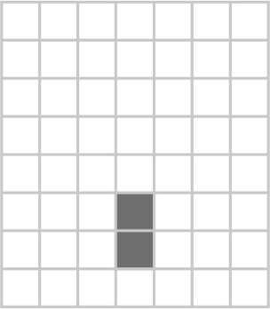
Place a tile in the square directly above the second tile so sides  are touching. | 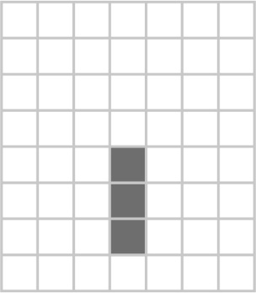
Place one square to the right and left of the top tile so sides are touching. | 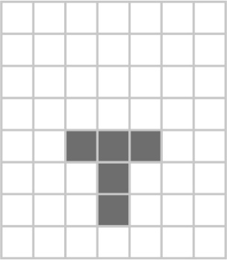
Turn a tile so it is sitting on a vertex.  Place it in the square above the middle tile in the row of  three tiles.  Its vertex should touch the middle of the other tile’s side. | 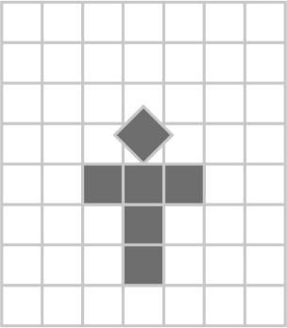

Picture Instructions: Tangram
Master 66b

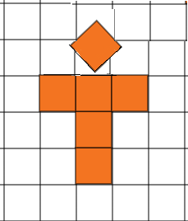  Place the medium triangle so its long side lines up with the bottom of the grid.  Its left vertex touches the 4th vertical grid line from the left. | 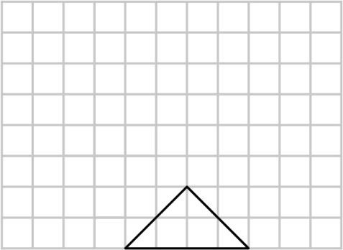
Place a small triangle on each side of the medium triangle.  The long side of each matches a side of the medium triangle to make a rectangle. | 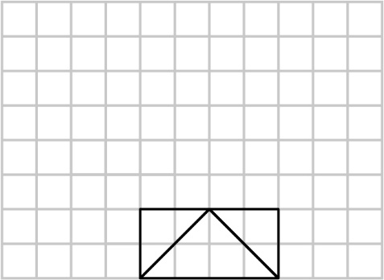
Place the square on the left side of the rectangle to make a longer rectangle. | 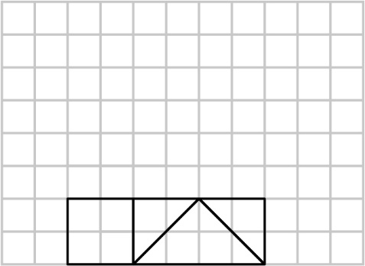
Place the two large triangles together with square corners touching at the bottom to make a larger triangle.  Place this triangle on top of the long rectangle to make a house. | 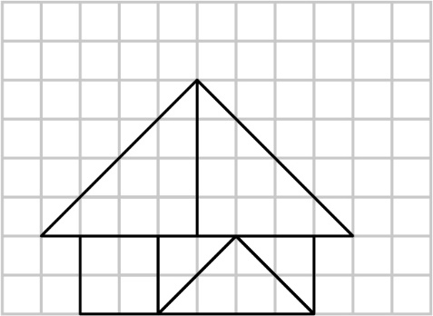
Place the parallelogram to the left of the large triangle to make a chimney.  The short sides of the parallelogram should lie along the 2nd and 4th vertical grid lines from the left. | 