Connections:
Master 69
Code the Vacuum

Coding is what makes lots of things work, like computers, phones,
video games, and even a robot vacuum cleaner.
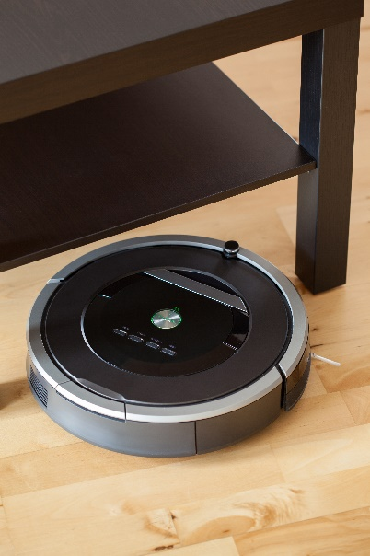
A robot vacuum is coded so that when it senses an obstacle, such as the leg of a table, it gently touches it, then turns.
Some vacuums have cameras so they can
take pictures of the walls, ceiling, doorways, and furniture to build a map of a room.
This way, they can plan an efficient route.

Look at the living room!
Someone spilled cookie crumbs and the dog knocked over the plant.
Code the vacuum to clean up the two messes, avoiding all obstacles.
