**Perimeter Shapes**

**Master 39a**

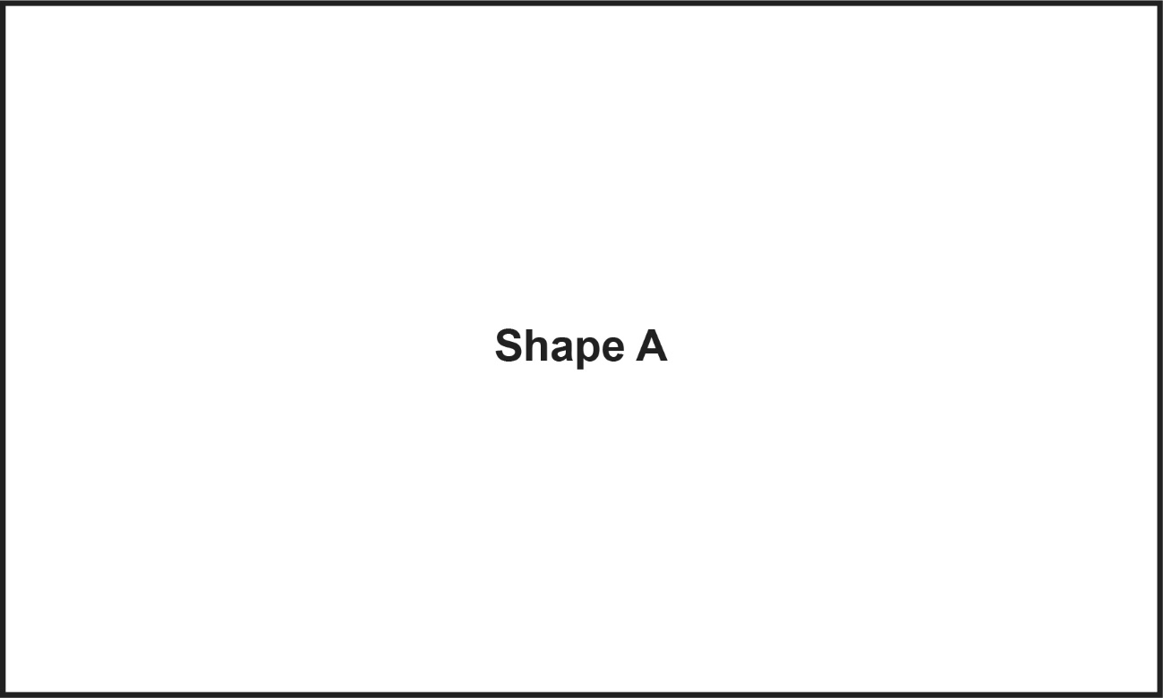

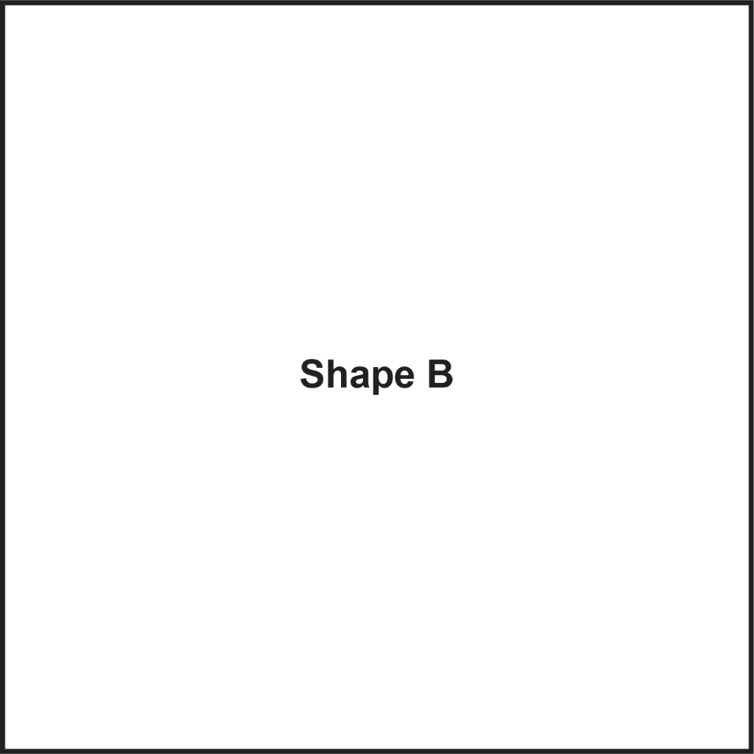

**Perimeter Shapes**

**Master 39b**

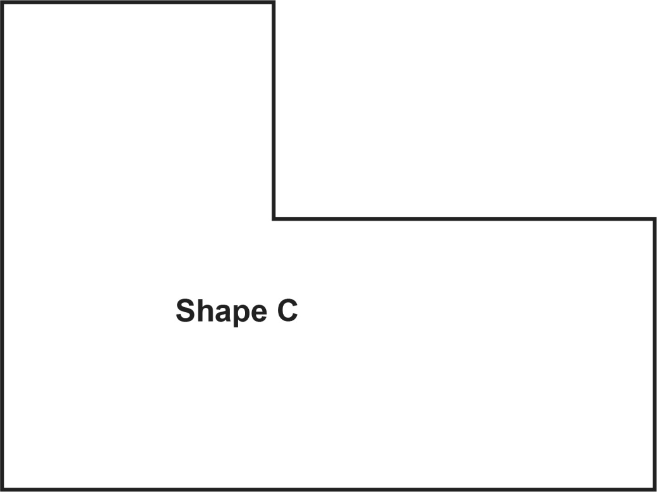

**Perimeter Shapes**

**Master 39c**

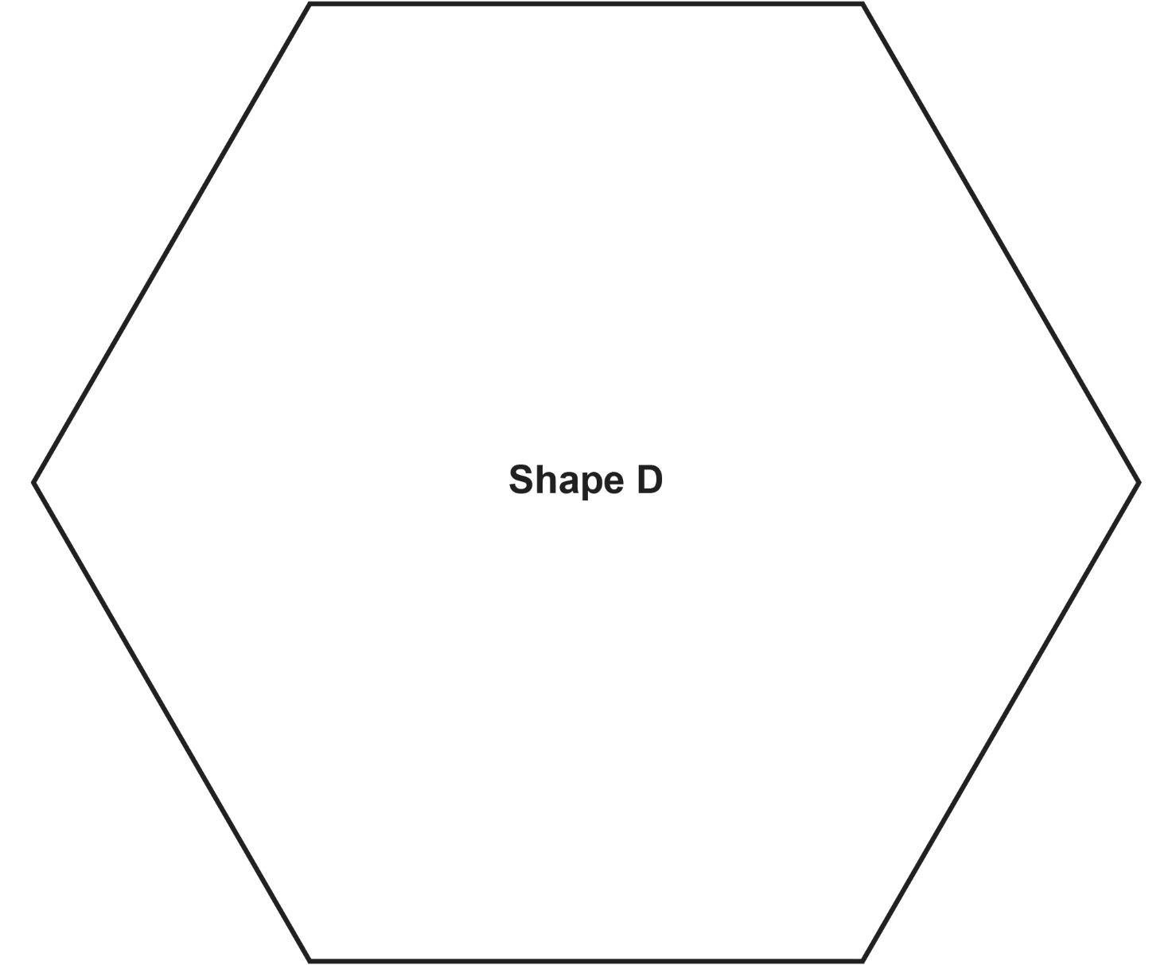

**Perimeter Shapes**

**Master 39d**

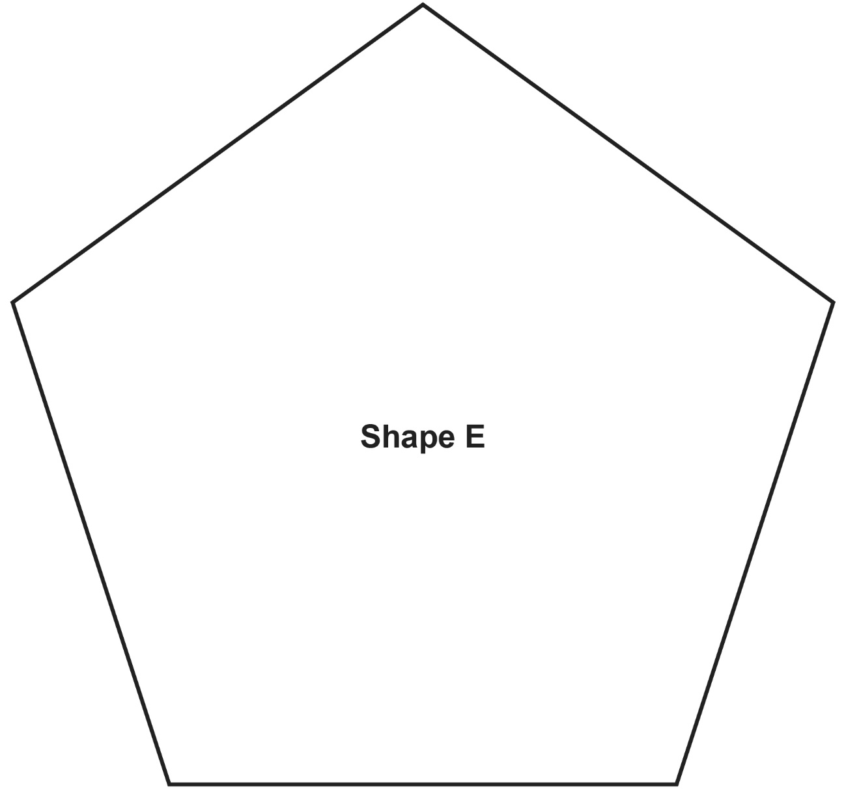

**Perimeter Shapes**

**Master 39e**

