Connections:
Animal Fun Facts
Master 4

Order the animals from least to greatest mass.
Polar bear  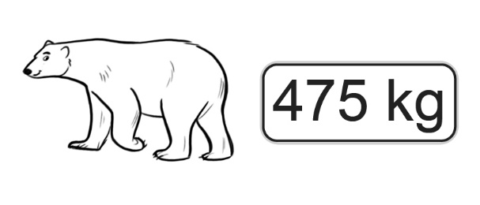  Polar bears feed mostly on seals.  They have a good sense of smell and can smell seals almost 2 km away. | Water buffalo  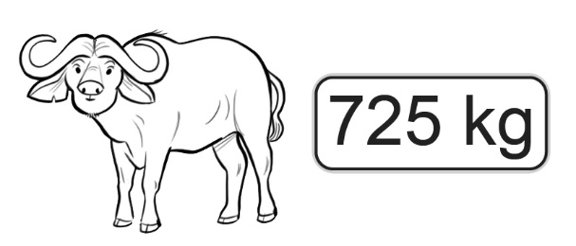  Water buffalo are sensitive to heat.  They are known to roll in mud to help cool themselves down.
Seal  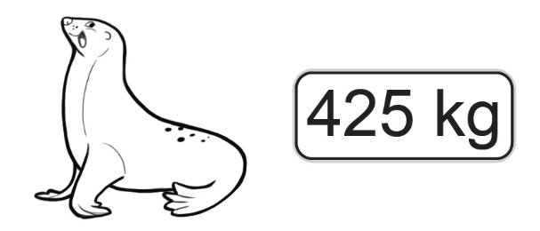  Seals have thick fur and blubber to protect them against freezing temperatures. | Brown bear  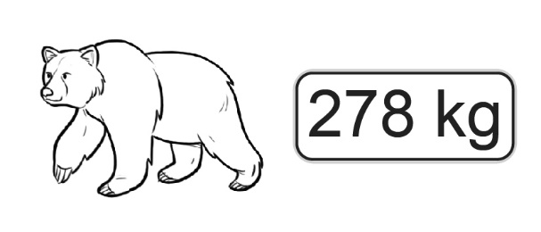  Brown bears dig caves with their long claws. They sleep in the caves for most of the winter.
Moose  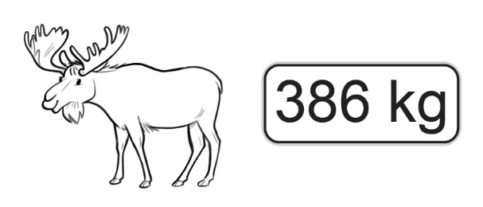  Moose are excellent swimmers.  They can swim 10 km per hour without a break for 2 hours. | Yak  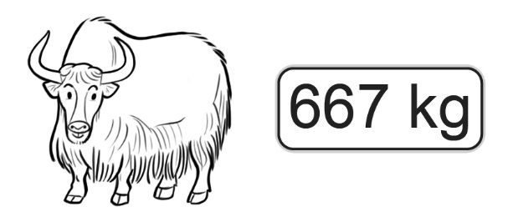  Yaks have very strong horns.  They are used to break through snow to get plants that are buried below.

