Connections:
Crack the Code!
Master 6

Computers talk using only two numbers: 0 and 1.
This is called Binary Code.
Think of a bunch of light switches being turned on and off.
We use 1 to show “On.”
We use 0 to show “Off.”
_____________________________________________________________________________________
2
16
8
4
1
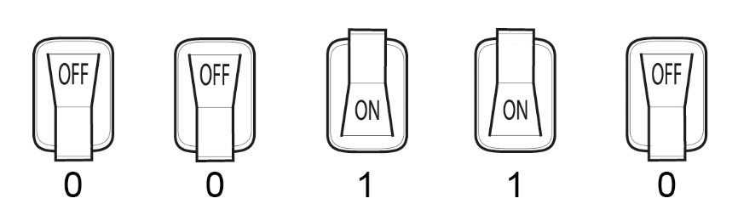
Number 6

The switches for 4 and 2 are “On.”
So, 00110 represents the number 4 + 2, or 6.
_____________________________________________________________________________________
1
2
16
8
4
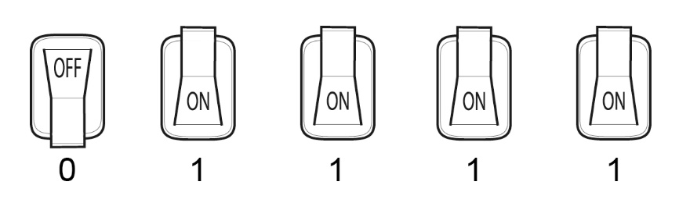
Number 15

The switches for 8, 4, 2, and 1 are “On.”
So, 01111 represents the number 8 + 4 + 2 + 1, or 15.
_____________________________________________________________________________________

Crack the Code to find these numbers:
a) 1 1 1 1 1 b) 1 0 0 0 1 c) 0 1 1 1 0

Use Binary Code to show 8, 9, and 10.

