Fun Day! Patterning Cards (M)
Master 25a

M  What is the pattern rule?  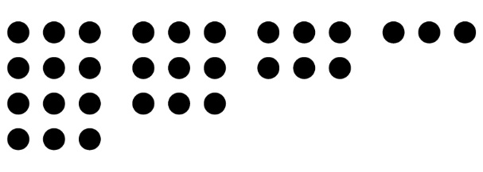 | M  What is the pattern rule?  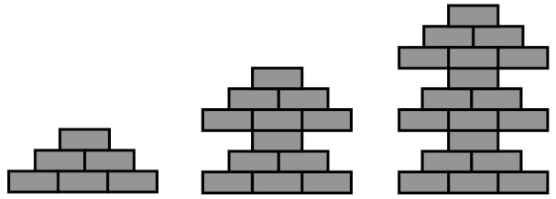
M  What is the pattern rule? | M  What is the pattern rule?  100, 98, 96, 94, …
M  Use this rule to create  a pattern.  Start at 27 and  add 5 each time. | M  Use this rule to create  a pattern.  Start at 31 and take away  3 each time.

Fun Day! Patterning Cards (M)
Master 25b

M  Use this rule to create  a pattern.  Start at 1 and  add 6 each time. | M  Use this rule to create  a pattern.  Start at 335 and take away  9 each time.
M  Show this pattern  another way. | M  Show this pattern  another way.
M  Show this pattern  another way.  545, 547, 549, 551, … | M  Show this pattern  another way.  87, 83, 79, 75, …

Fun Day! Patterning Cards (P)
Master 25c

P  Extend the pattern  by 2 more terms.  200, 196, 192, 188, … | P  Extend the pattern  by 2 more terms.  113, 116, 119, 122, …
P  Extend the pattern  by 2 more terms.  35, 29, 23, 17, … | P  Extend the pattern  by 2 more terms.  5, 10, 15, 20, …
P  Extend the pattern  by 2 more terms.  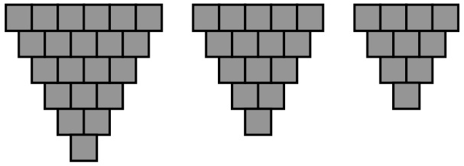 | P  Extend the pattern  by 2 more terms.

Fun Day! Patterning Cards (P)
Master 25d

P  Extend the pattern  by 2 more terms.  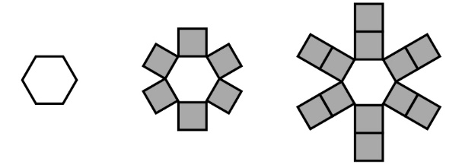 | P  Extend the pattern  by 2 more terms.  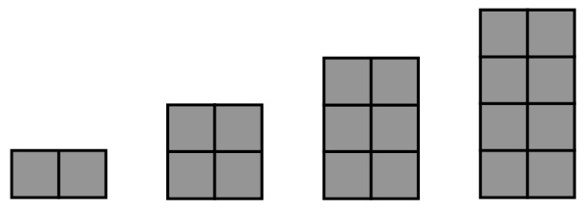
P  Find the missing term.  6, 11, 16, 21, 31, 36, … | P  Find the missing term.  303, 300, 297, 291, 288, …
P  Find and correct the error.  120, 129, 138, 146, 156, … | P  Find and correct the error.  48, 40, 32, 25, 16, 8, …

Fun Day! Patterning Cards (P)
(ON only)
Master 25e

P  Extend the pattern  by 2 more terms.  6, 12, 18, 24, … | P  Extend the pattern  by 2 more terms.  1, 2, 4, 8, …
P  Extend the pattern  by 2 more terms  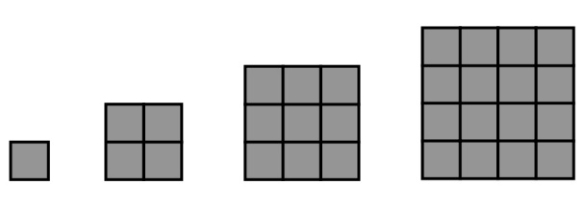 | P  Find the missing term.  Input 2 3 4 5 6  Output 6 9 12 18
P  Find the missing term.  Input 1 2 3 4 5  Output 5 15 20 25 | P  What is the pattern rule?  Input 2 3 4 5  Output 2 3 4 5
P  What is the pattern rule?  1, 3, 9, 27, … | P  What is the pattern rule?  Input 1 2 3 4  Output 4 8 12 16

