A Week of Challenges Line Master 1
(Assessment Master)
Name: _____________________________

Use Properties of Equality to Solve Problems | Not observed | Sometimes | Consistently
Investigates addition and subtraction as inverse operations
Balances sides of an equation using different strategies
Finds missing addends and subtrahends to solve equations
Solves different problem types (start, change, or result unknown)
Use the Language of Algebra
Uses placeholders for unknown values in equations
Solves for an unknown value in a
one-step addition and subtraction problem (e.g., □ + 5 = 15)
Strengths:

Next Steps:

Connecting Home and School Line Master 2–1

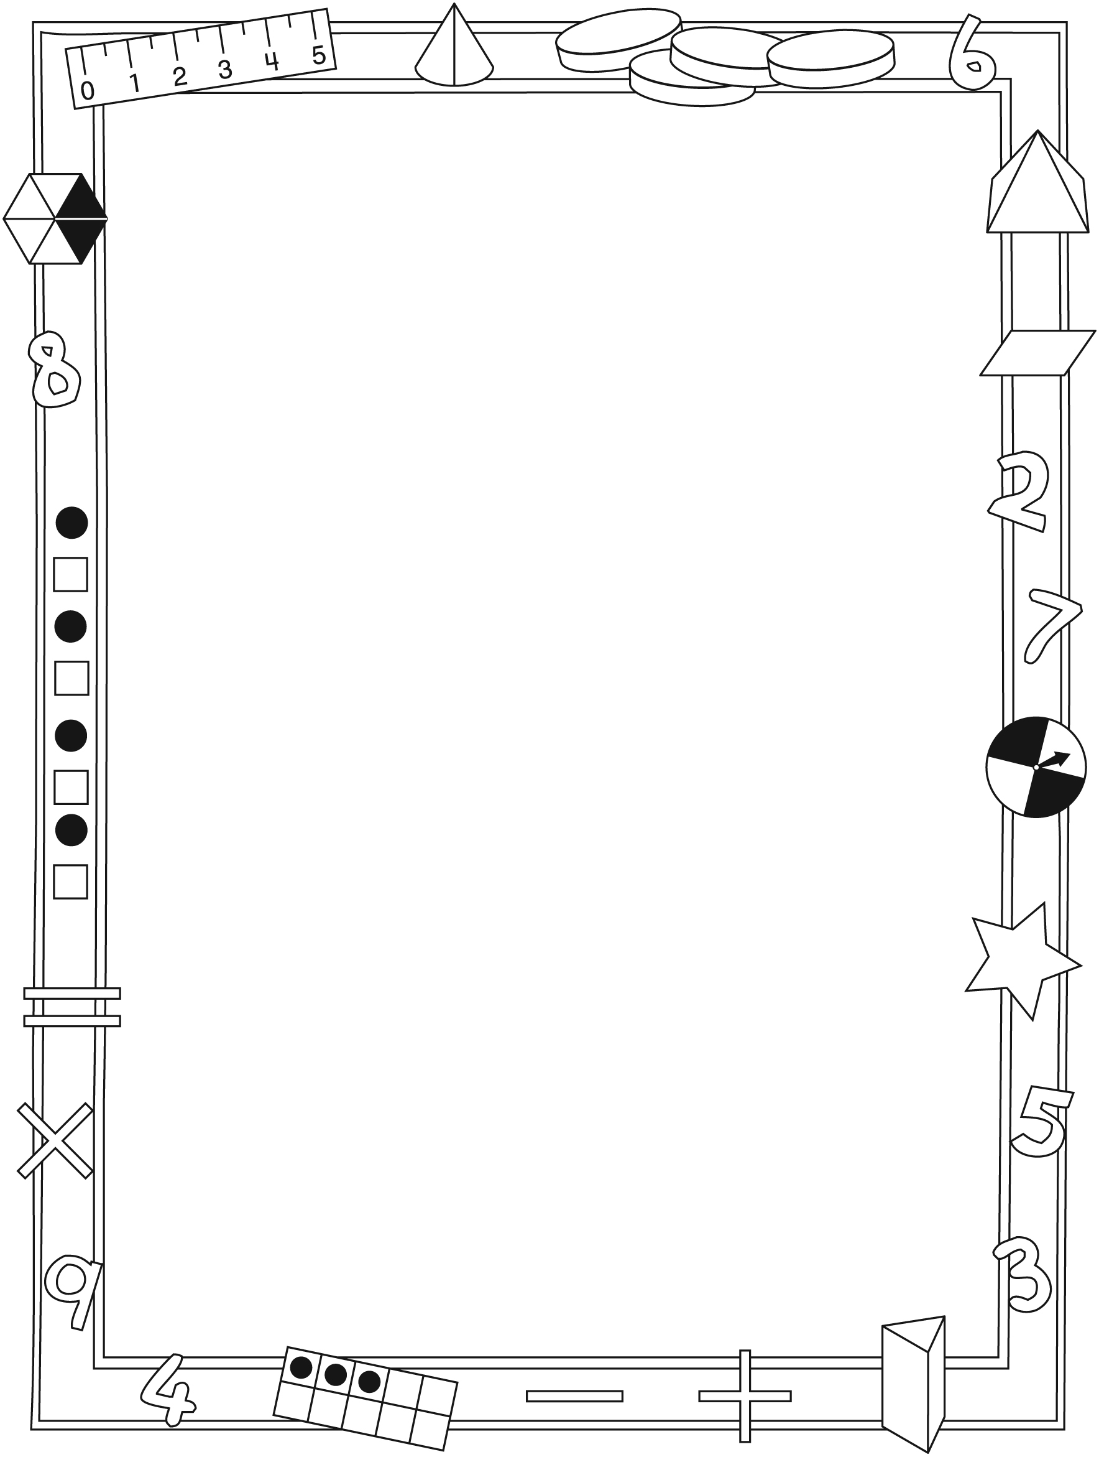

NOTE TO THE TEACHER

You may wish to send families an A Week of Challenges letter outlining a familiar activity or two they can do at home with their children.

Create a letter using this template and select one or two activities from the suggestions on the next page. Simply delete these instructions and cut and paste the activities you have selected, adapting them to fit your needs.

Connecting Home and School Line Master 2–2

Dear Family:

We have been working on A Week of Challenges, which engages children in conversations, investigations, and activities that help to develop their understanding of the big math idea that “Symbols and expressions can be used to represent mathematical relations.” Particular focus is placed on finding the unknown in addition and subtraction equations, and on writing equations using a symbol to represent an unknown. Try this activity at home with your child.
– – – – – – – – – – – – – – – – – – – – – – – – – – – – – – – – – – – – – – – – – –
Reading the Story: As you read the story together, take turns writing addition and subtraction problems based on the action in the story. Write an equation for the problem, using a symbol such as a shape (e.g., a square or triangle) to represent the unknown. Then, encourage your child to take the lead and show you how to solve the problem.
– – – – – – – – – – – – – – – – – – – – – – – – – – – – – – – – – – – – – – – – – –
What’s the Score?: When watching a sporting event, ask your child problems that involve equality, such as: How many more points do the (losing team’s name) need to tie? If the (winning team’s name) scored another (6) points, then how many points will the (losing team’s name) need to tie? Work together to solve the problems.
– – – – – – – – – – – – – – – – – – – – – – – – – – – – – – – – – – – – – – – – – –
What’s Missing?: You will need a collection of small items such as beans, chocolate chips, or marshmallows, and a bowl or mug. To start, count out a number of items, and hide some of them under the bowl or mug. Then, tell your child how many items you have in total. Invite him/her to figure out how many items are hidden.
– – – – – – – – – – – – – – – – – – – – – – – – – – – – – – – – – – – – – – – – – –
Magic Number Cube: You will need a number cube. Explain to your child that you have x-ray vision, so you can see what the number is on the bottom of the cube! Demonstrate by rolling the cube and taking note of the number you rolled. Don’t pick up the cube. To get the number on bottom, simply find the difference between the number you rolled and 7! Roll a few times to “prove” you have x-ray vision. Then, explain the trick to your child. Practise the trick with your child, and encourage him/her to wow friends and relatives with this superpower!
– – – – – – – – – – – – – – – – – – – – – – – – – – – – – – – – – – – – – – – – – –
Sincerely,

___________________________

A Week of Challenges Line Master 3
Math Mat

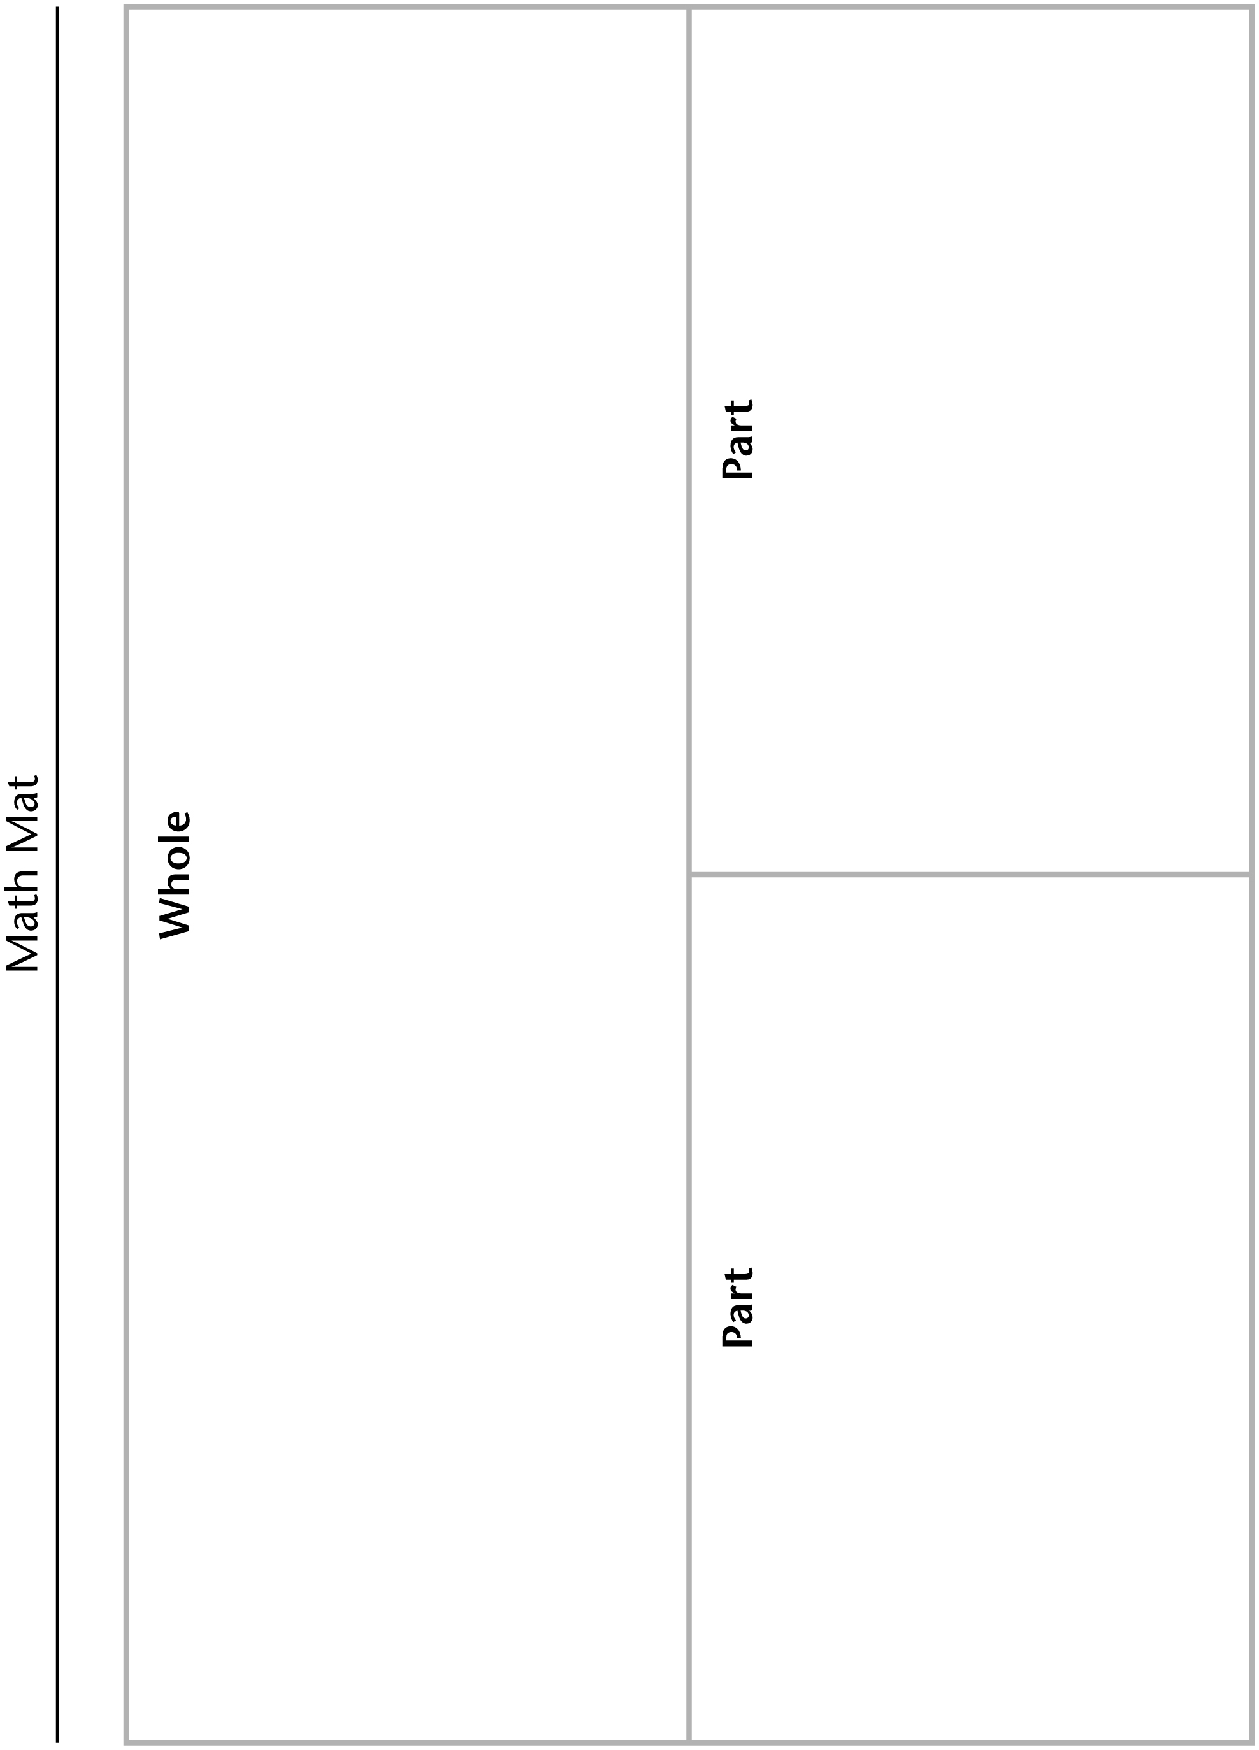

True or False Cards Line Master 4

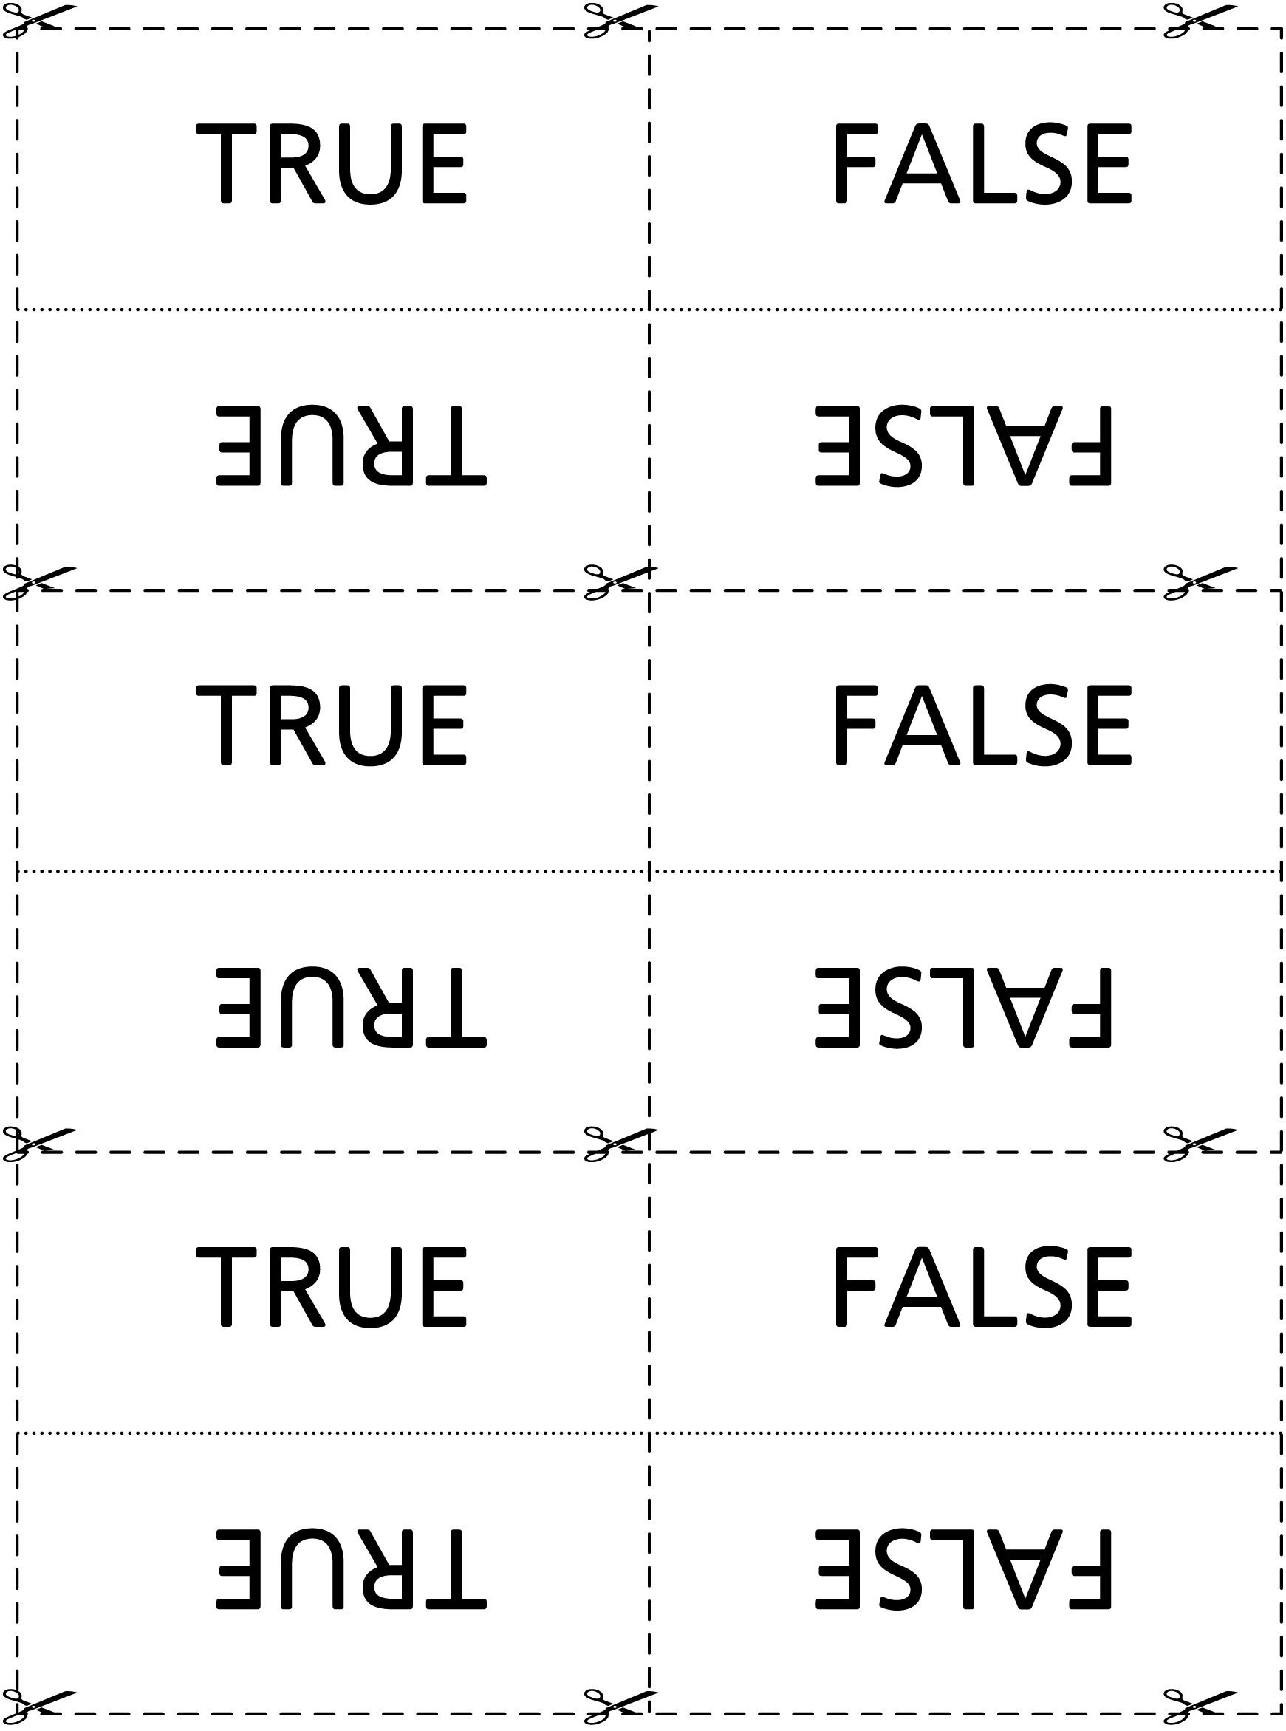

Problem Strips Line Master 5

 – – – – – – – – – – – – – – – – – – – – – – – – – – – – – – – – – – – – – – – – – –
Sun had 15 pieces of gum. Her sister gave
her some more. Now she has 22 pieces of gum.
How many pieces did her sister give her?
 – – – – – – – – – – – – – – – – – – – – – – – – – – – – – – – – – – – – – – – – – –
Anil had some books. He went to the
library and got 5 more books. Now he has
14 books altogether.
How many books did he have to start with?
 – – – – – – – – – – – – – – – – – – – – – – – – – – – – – – – – – – – – – – – – – –
There were 55 fish in the big tank.
The pet shop owner moved some of them.
Now there are only 40 fish in the big tank.
How many fish did the shop owner move?
– – – – – – – – – – – – – – – – – – – – – – – – – – – – – – – – – – – – – – – – – –
Ms. MacDonald had some pencils.
She gave 10 of them away. Now she has 18 left.
How many pencils did Ms. MacDonald have
to begin with?
– – – – – – – – – – – – – – – – – – – – – – – – – – – – – – – – – – – – – – – – – –

Number Cards Line Master 6–1

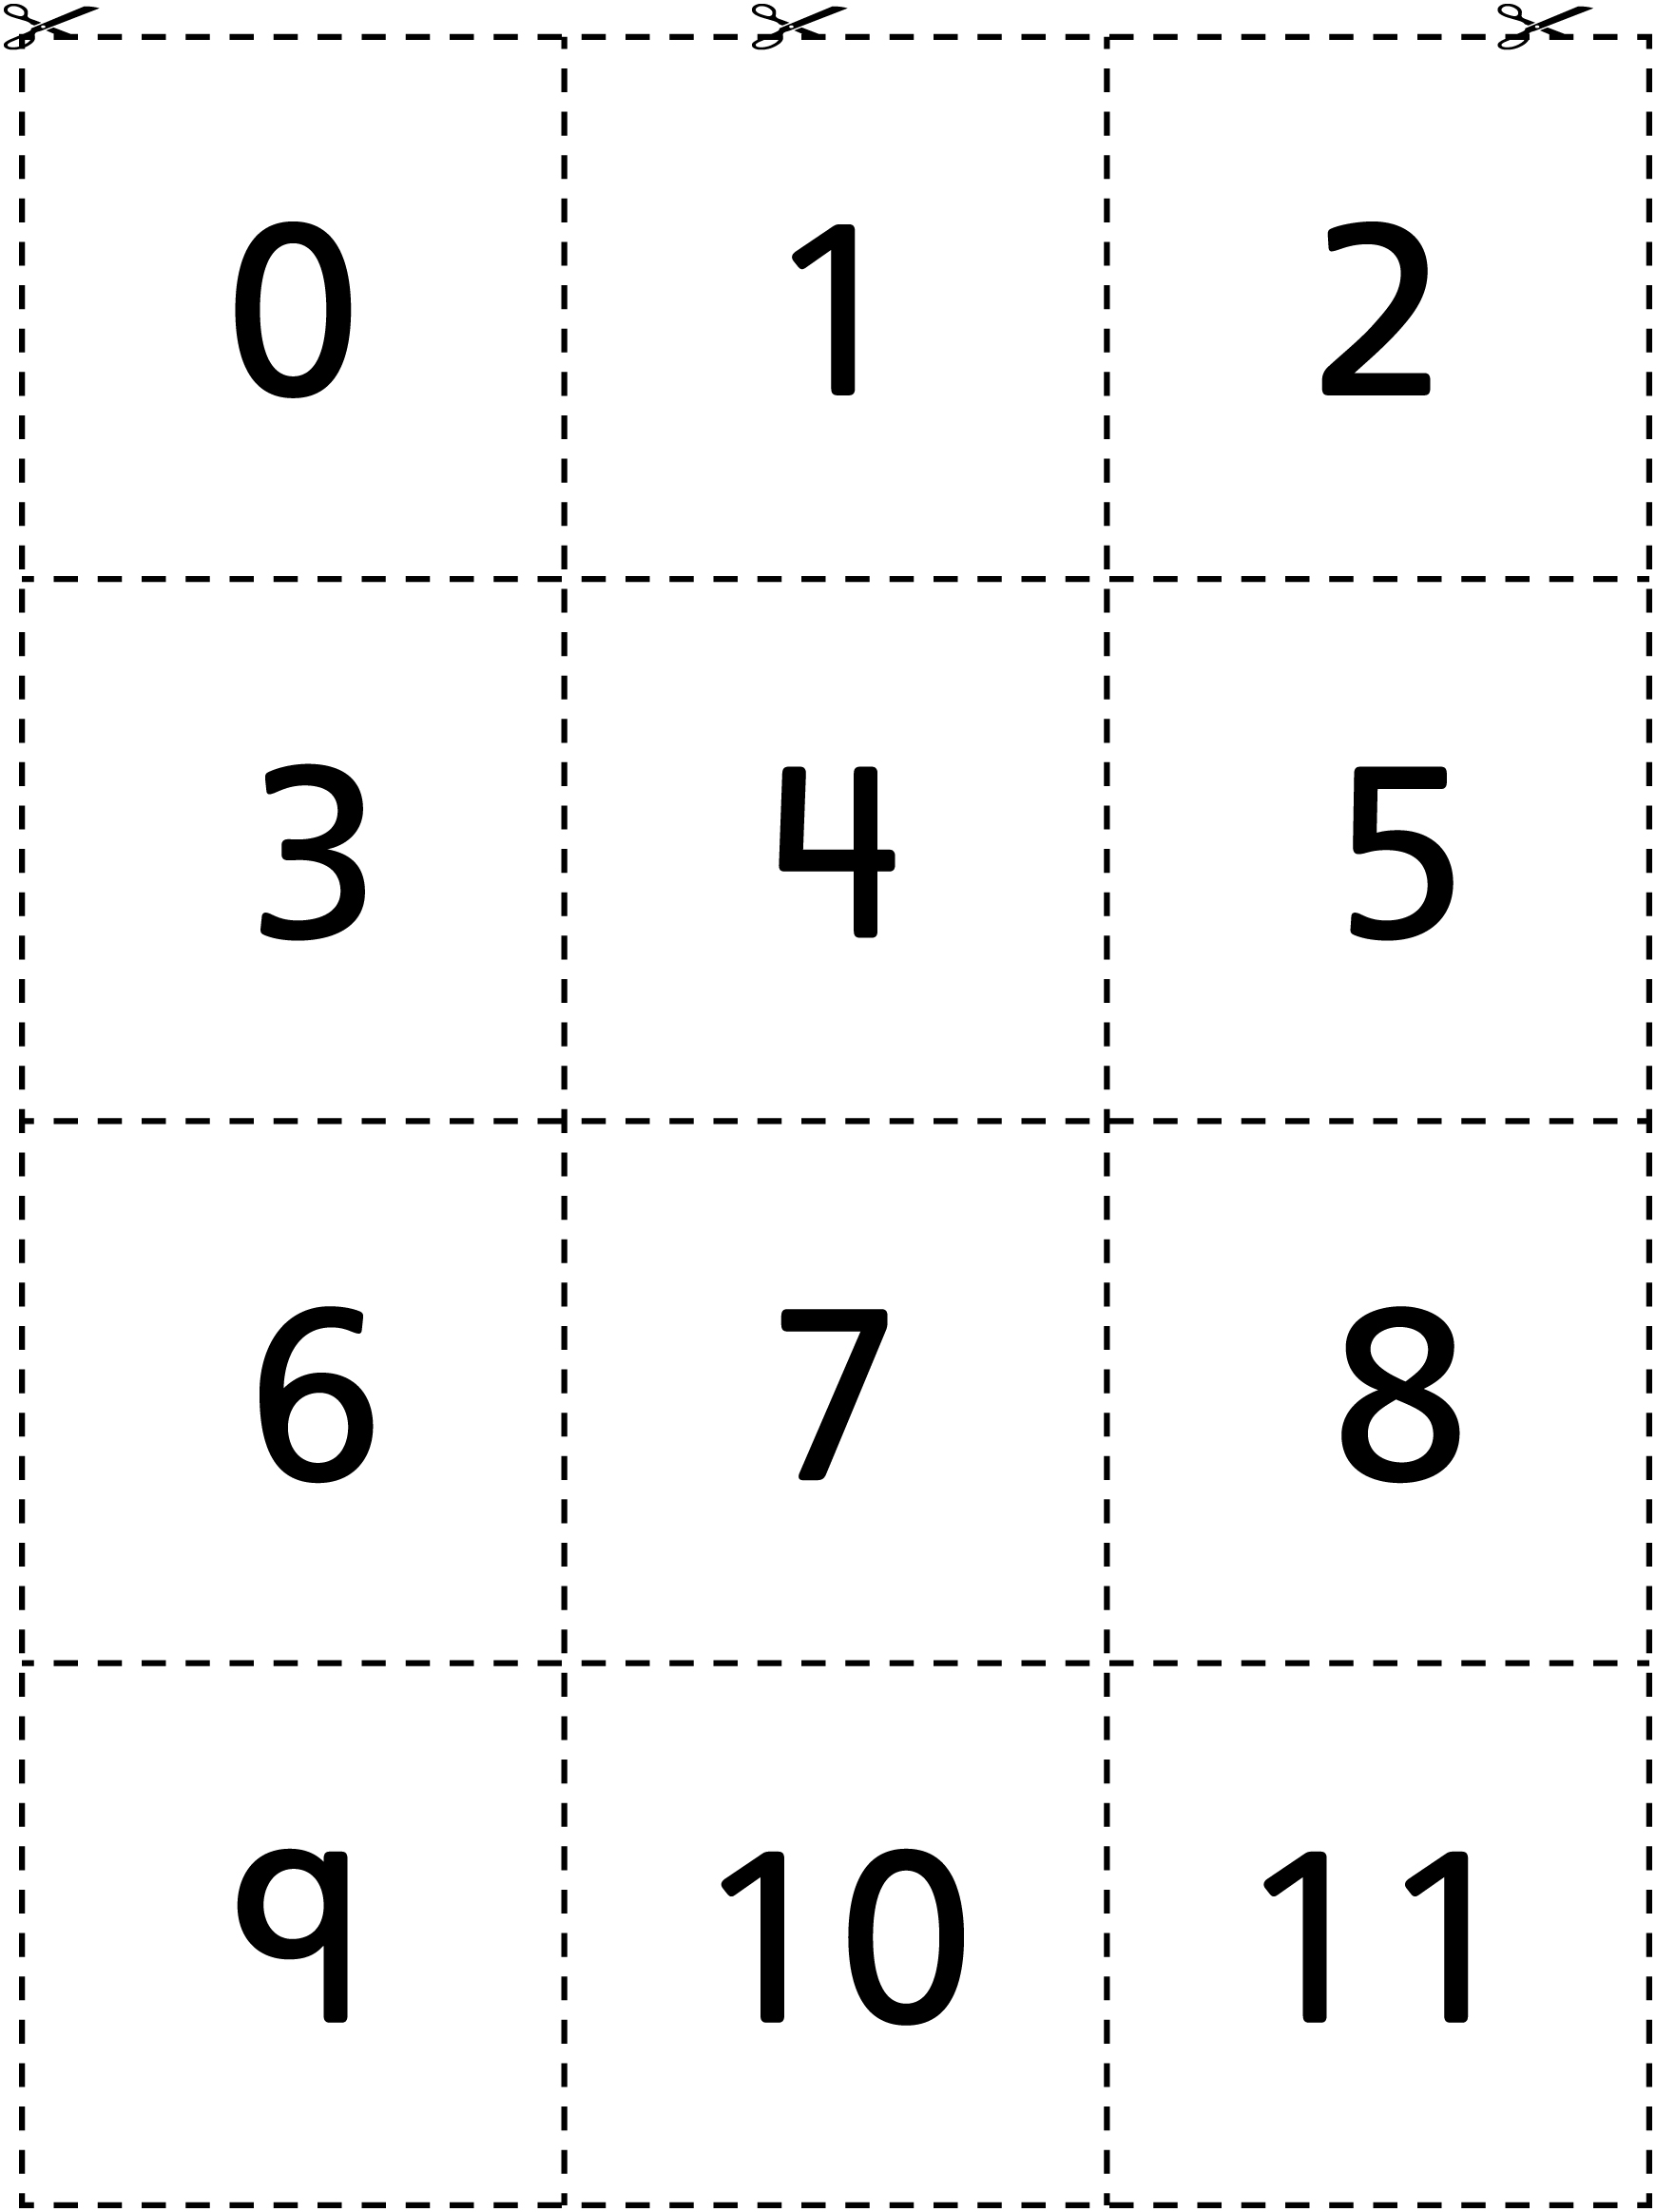

Number Cards Line Master 6–2

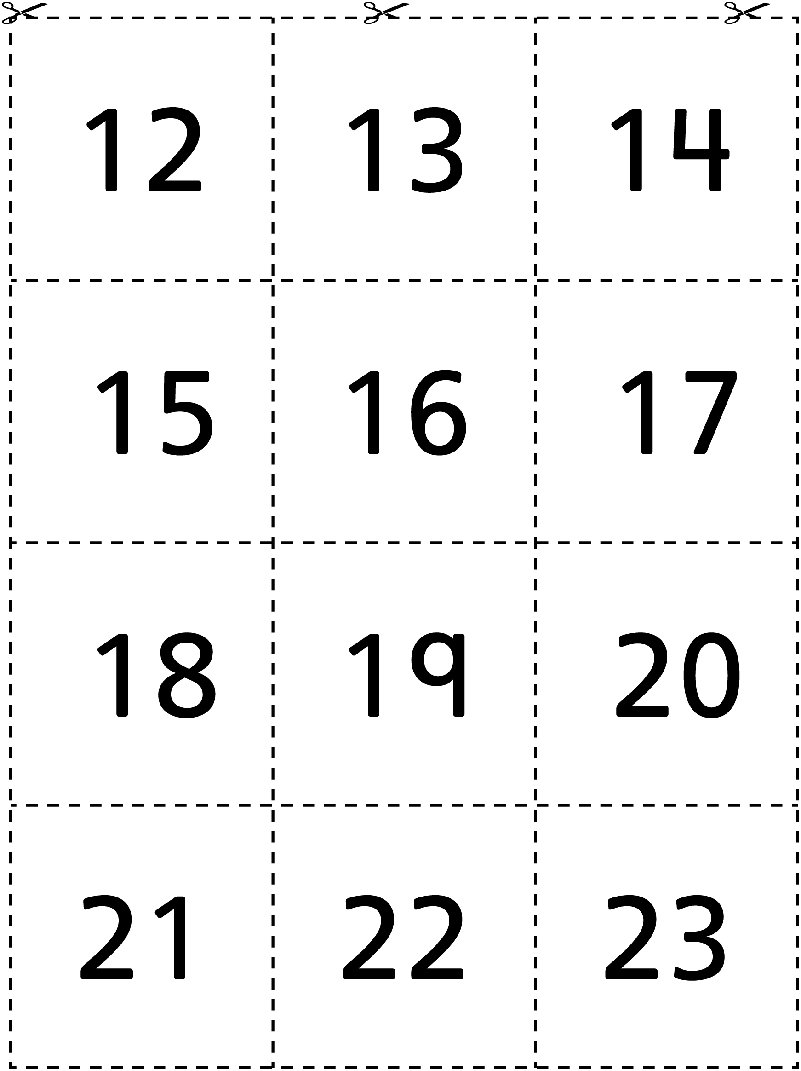

Number Cards Line Master 6–3

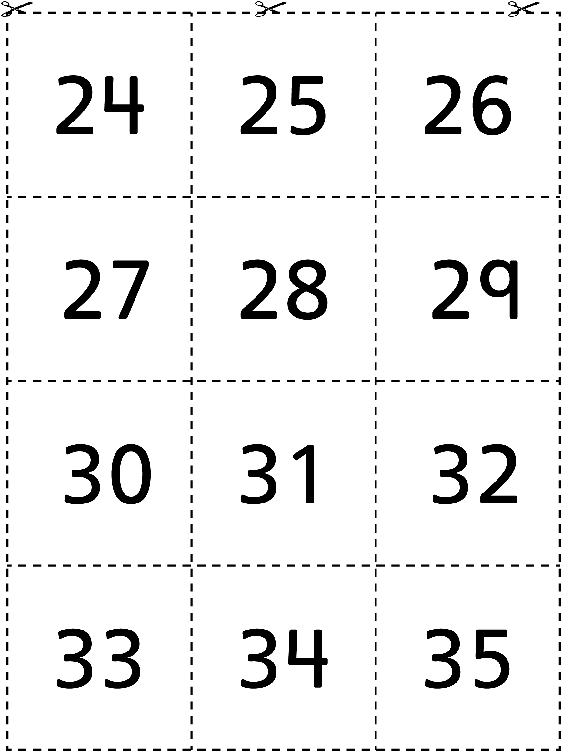

Number Cards Line Master 6–4

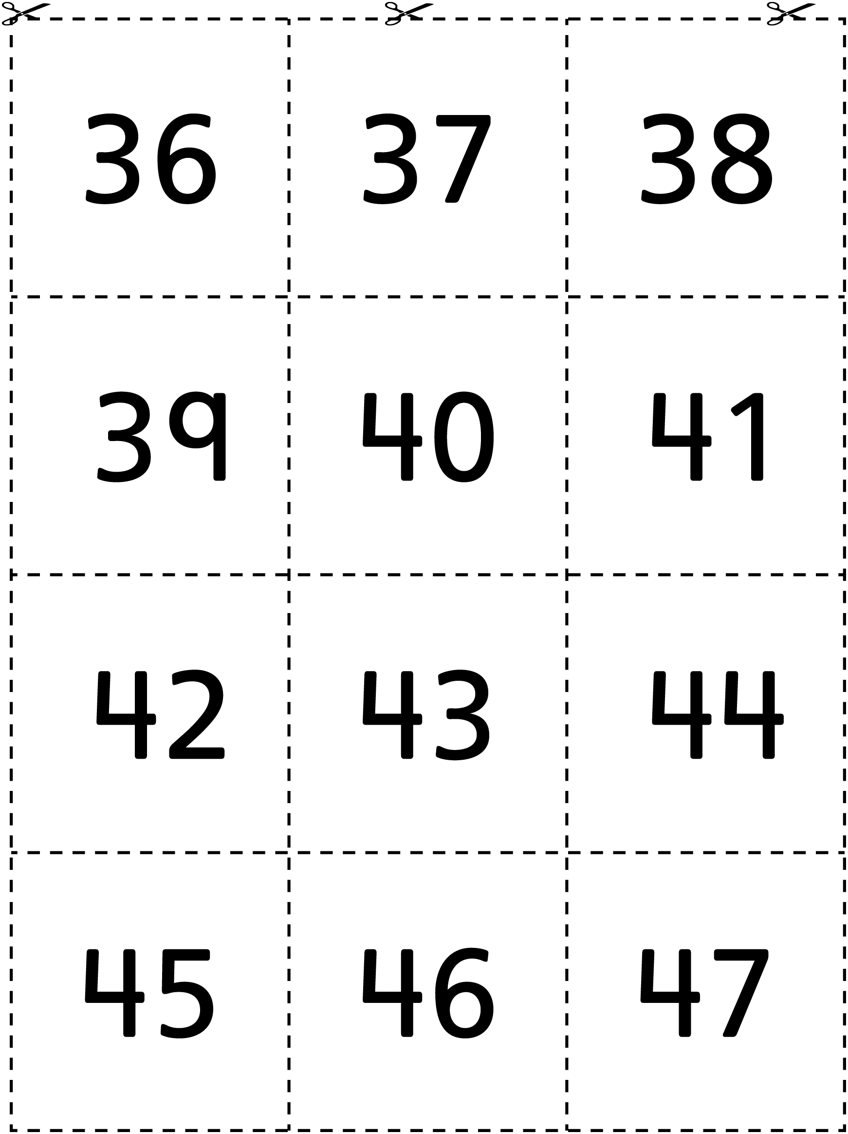

Number Cards Line Master 6–5

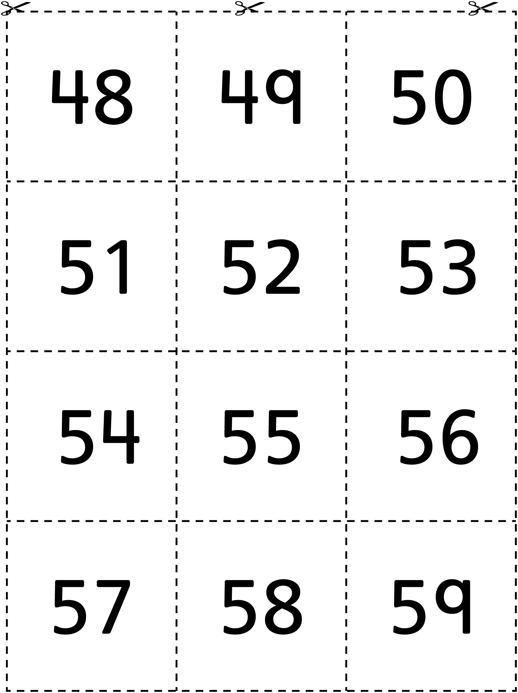

Number Cards Line Master 6–6

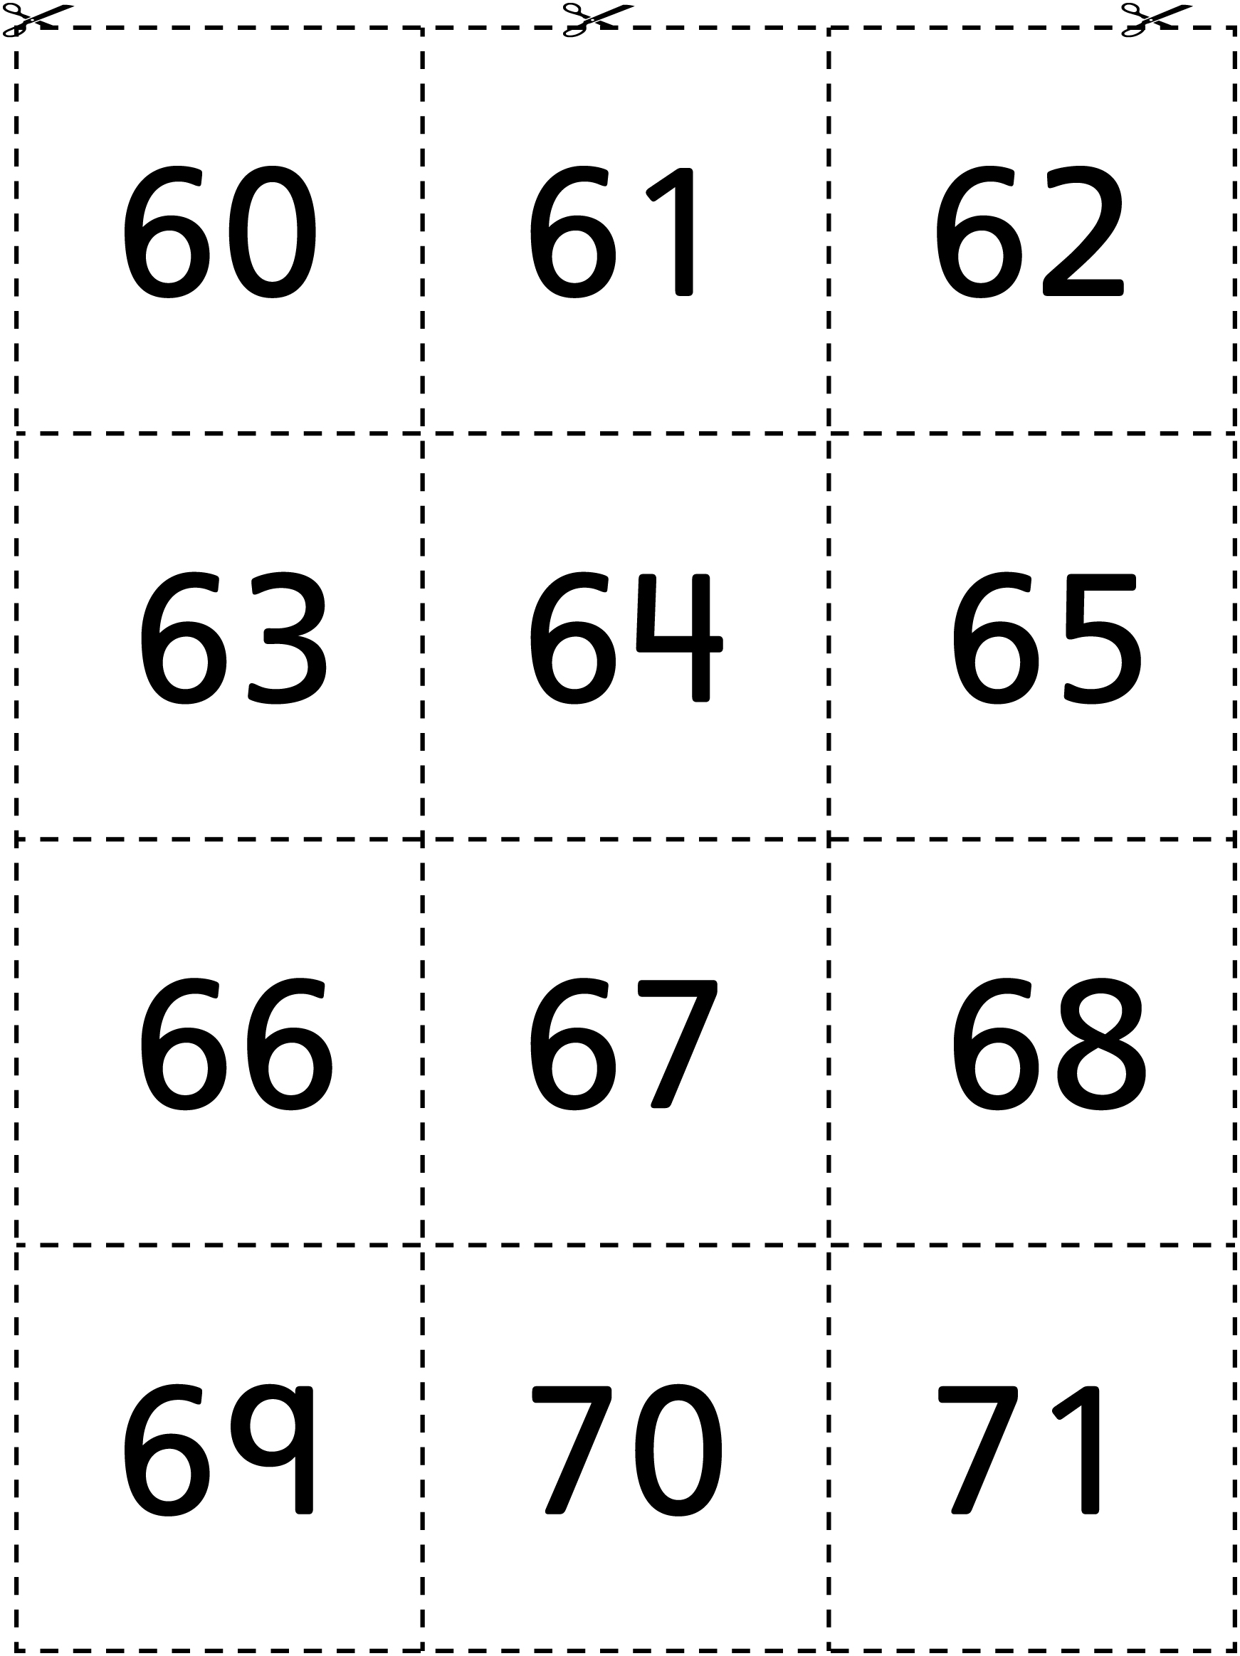

Number Cards Line Master 6–7

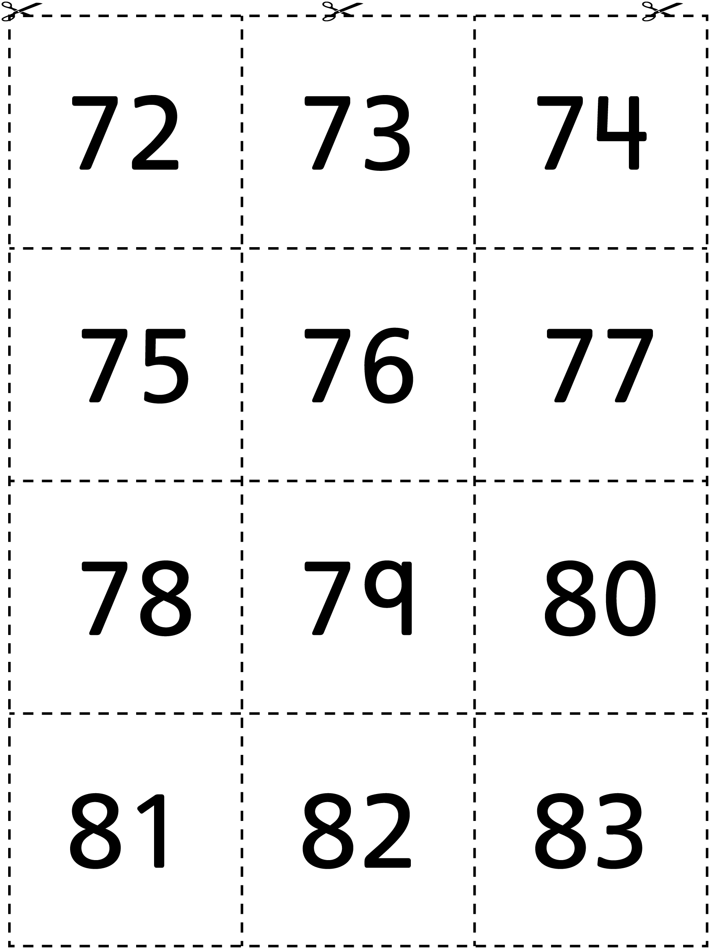

Number Cards Line Master 6–8

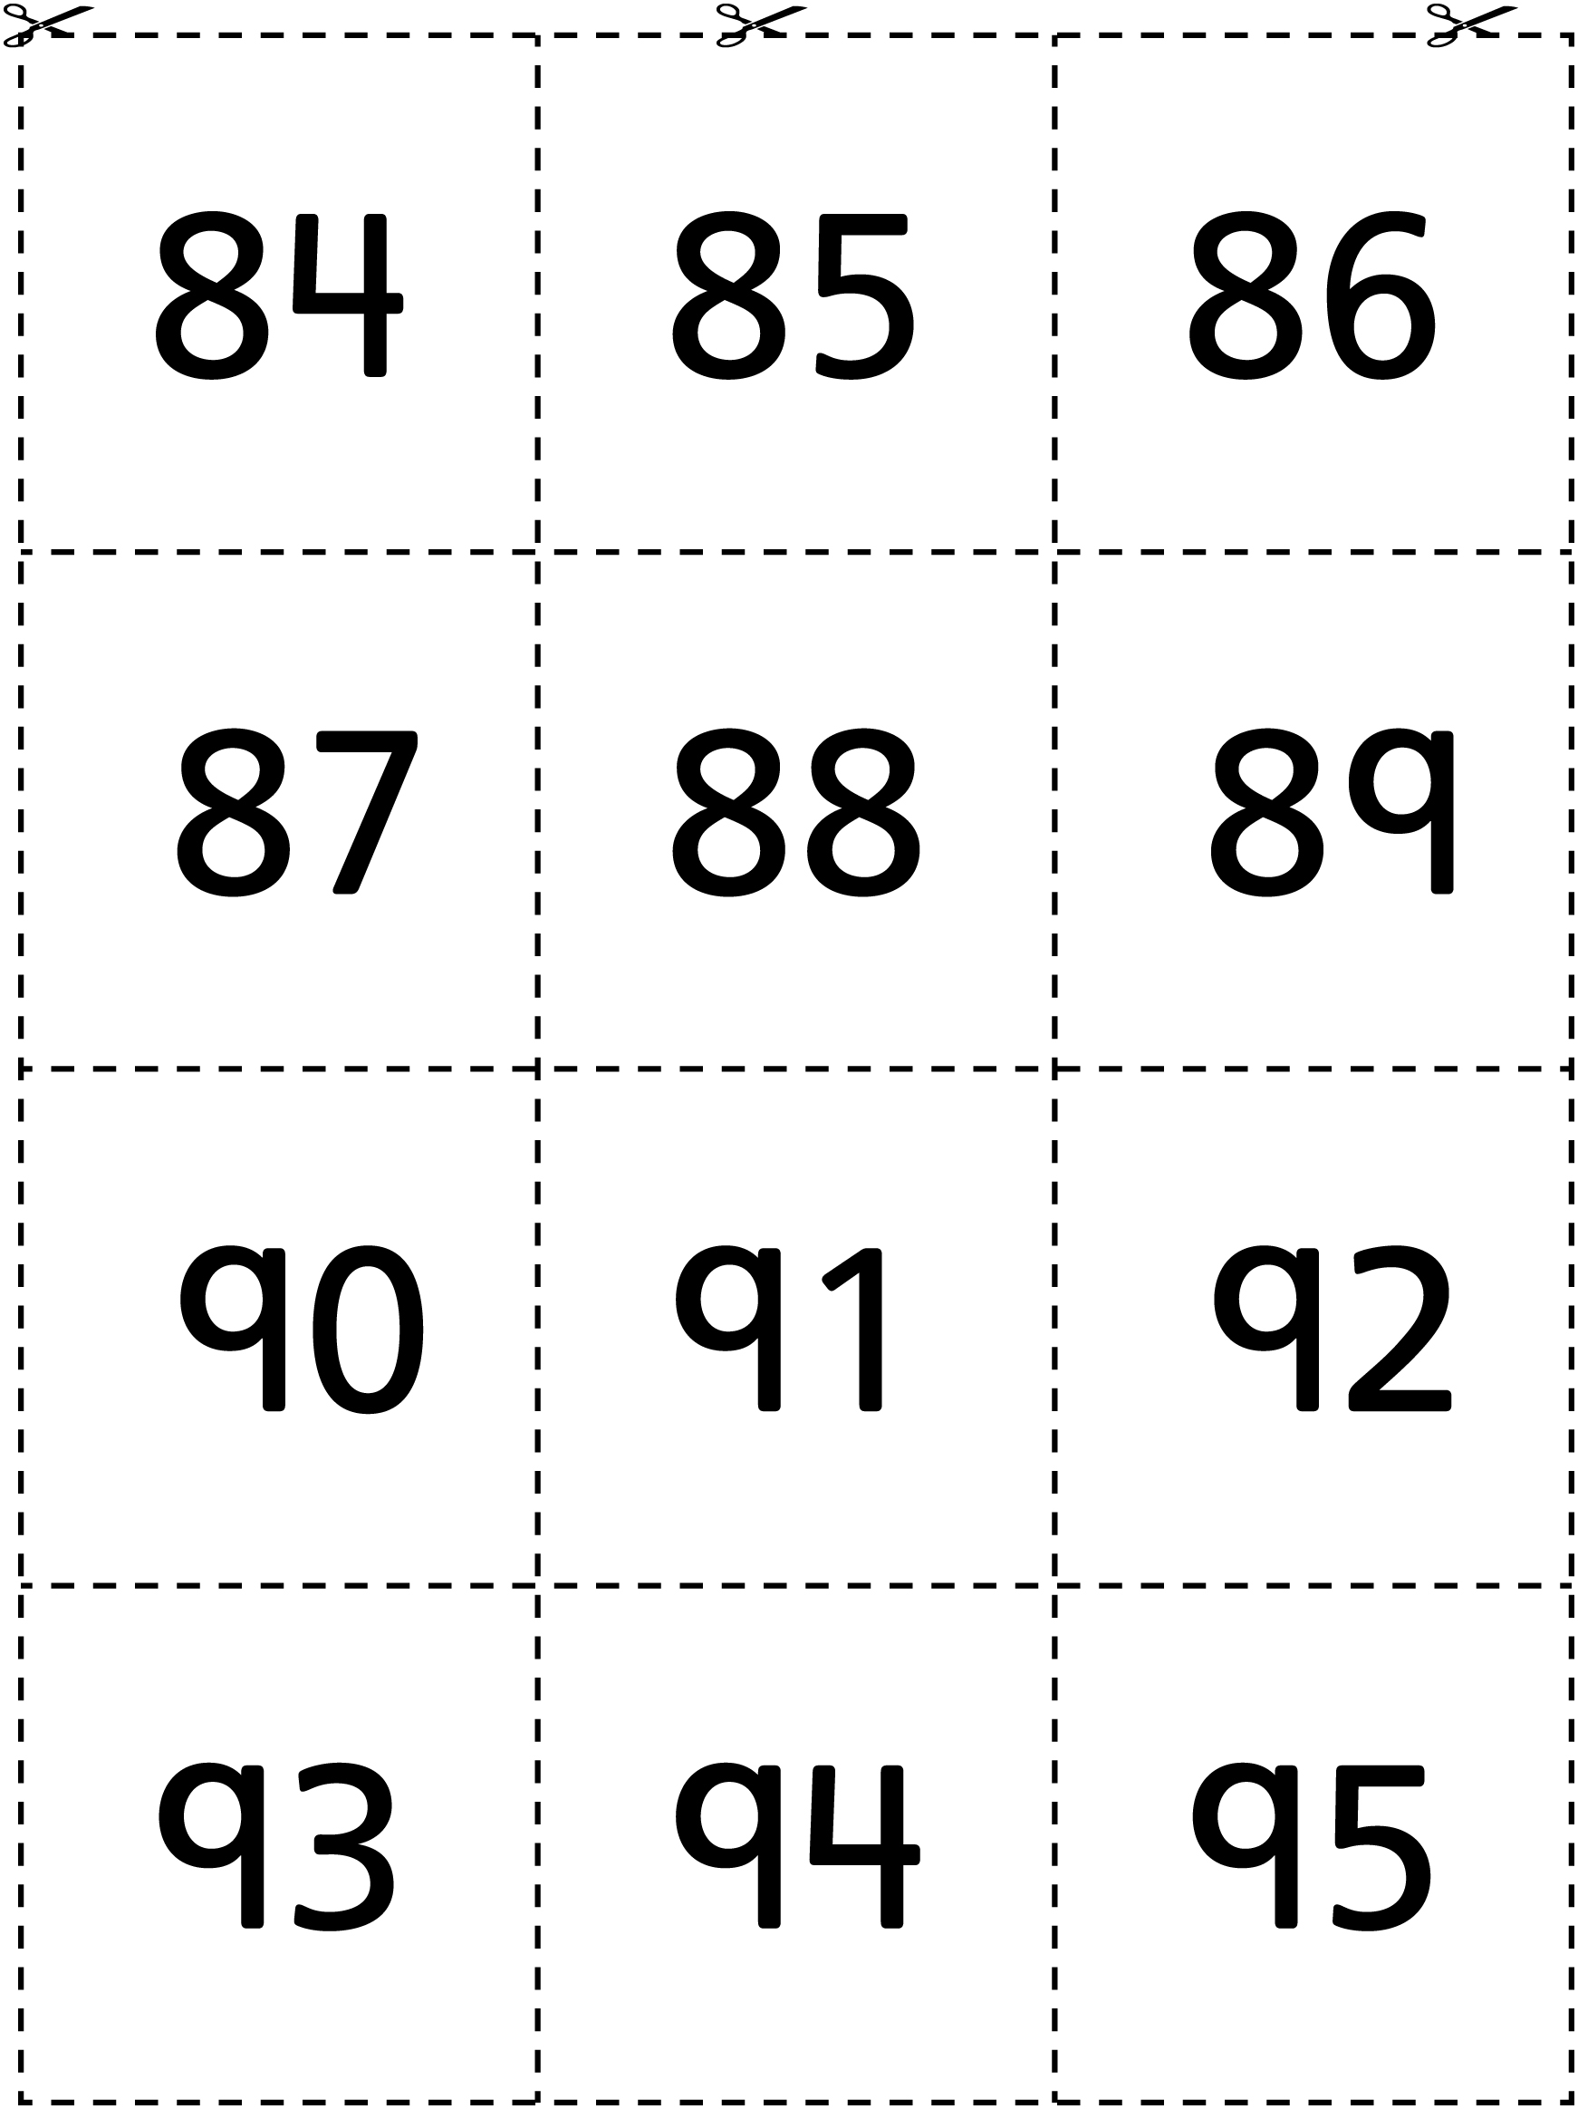

Number Cards Line Master 6–9

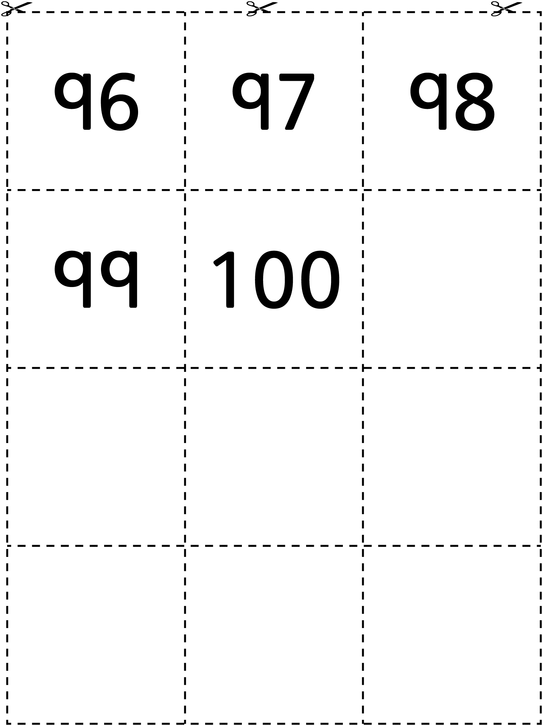

Equation Cards Line Master 7

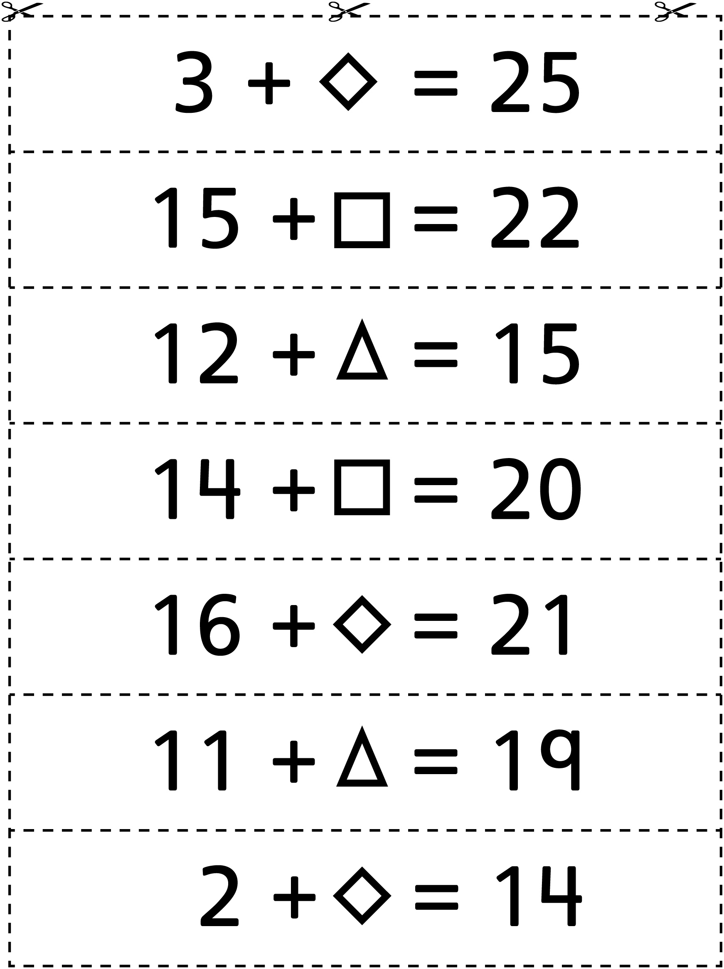

Planting Seeds Line Master 8
Name: _____________________________

Total Seeds | Seeds Above Ground | Seeds Below Ground (Planted)

Equation Match Line Master 9–1

Word Problems
Min has 15 cherries. She eats some and then she has 6 cherries. How many cherries did she eat? | Samuel has 6 hockey cards, but he would like to have 15 hockey cards. How many more hockey cards does  he need?
Adnan has 15 markers, but 6 of them no longer work. How many markers does he have that work? | Some cookies are on a plate. There are 6 cookies in a jar and 15 cookies altogether. How many cookies are there on the plate?

Equation Match Line Master 9–2

Equation Cards

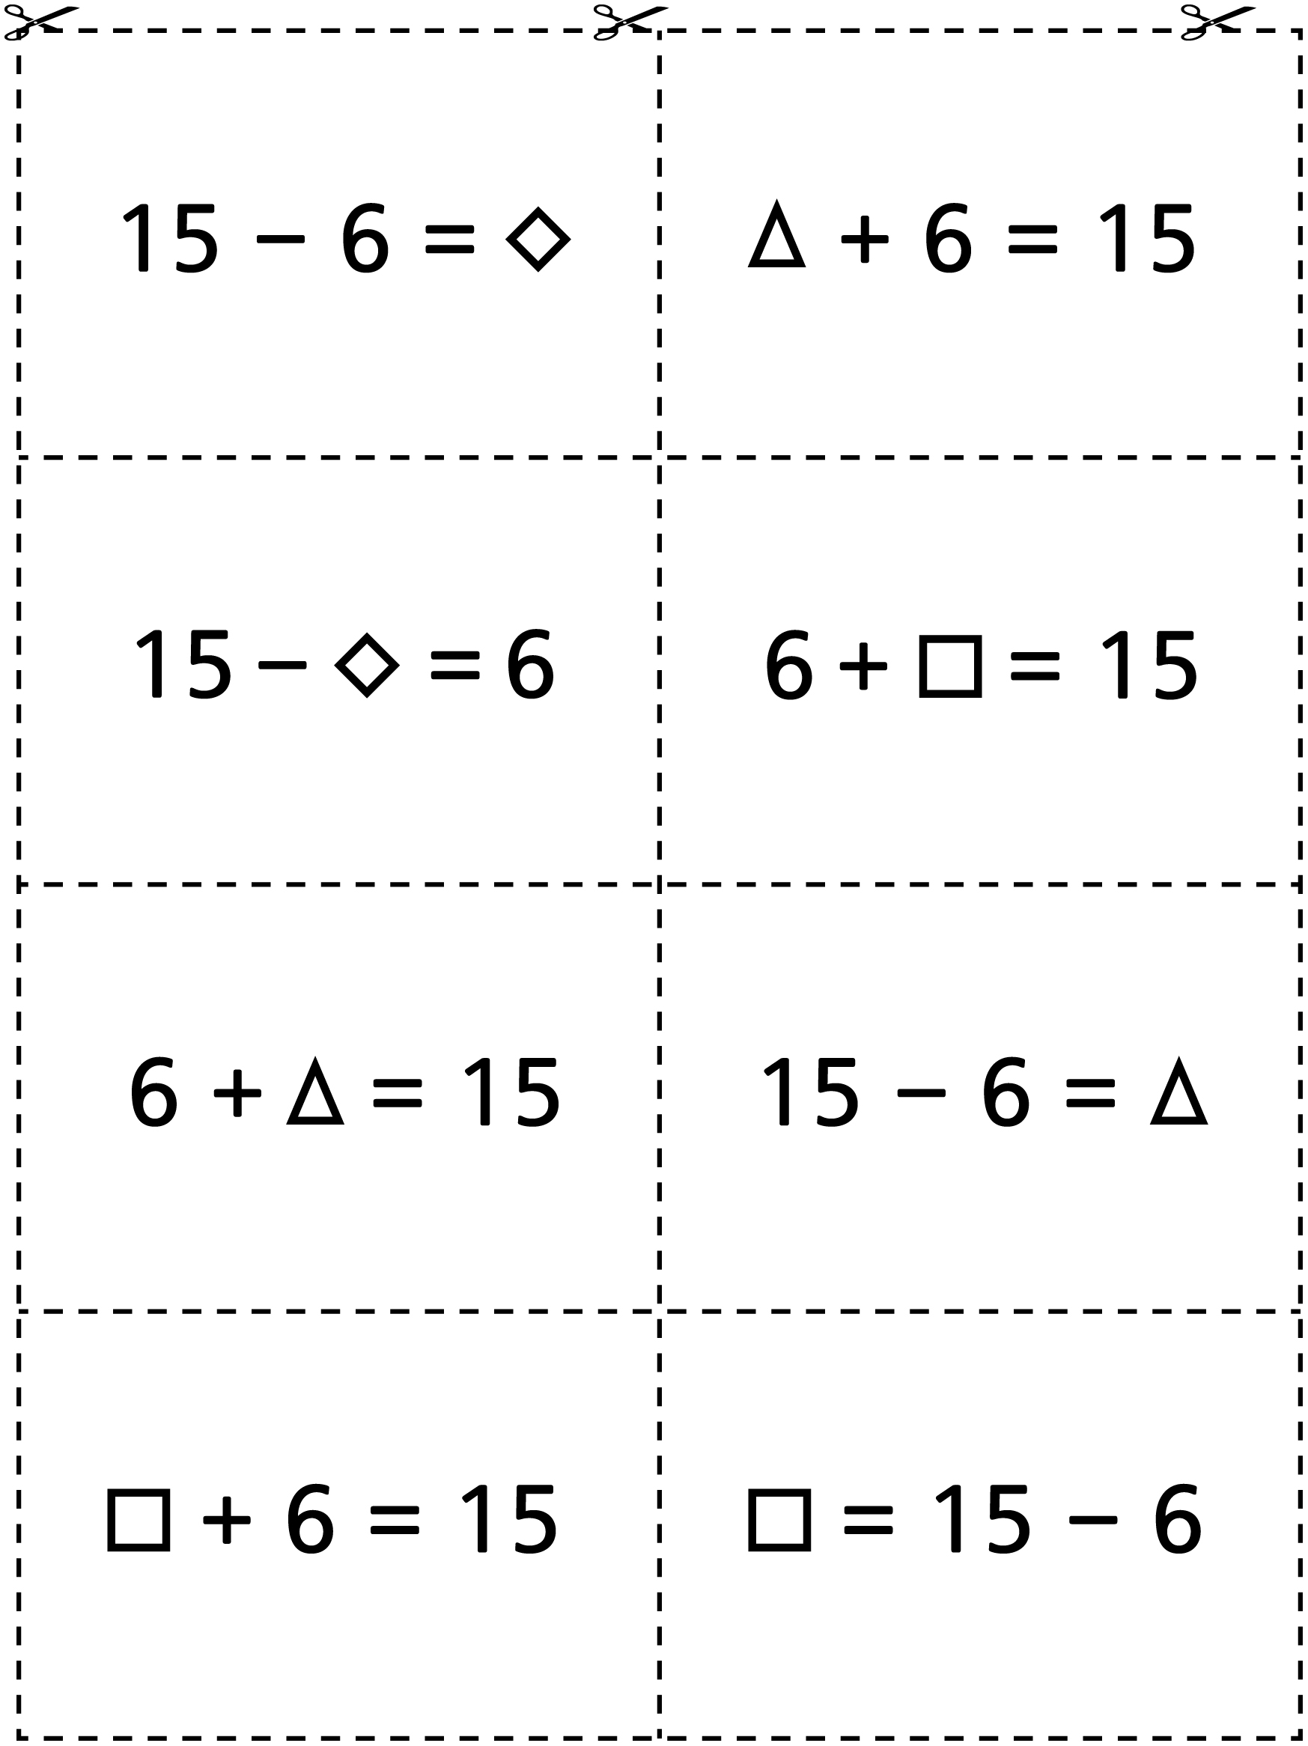

Balance It! Line Master 10

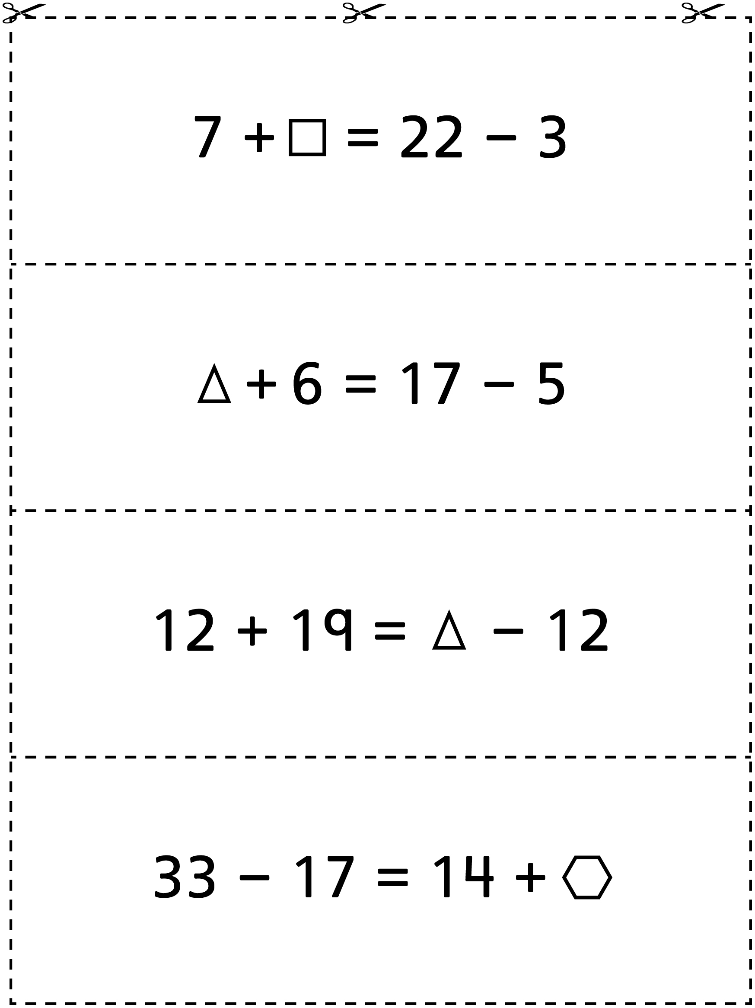

Writing Prompts Line Master 11–1

– – – – – – – – – – – – – – – – – – – – – – – – – – – – – – – – – – – – – – – – – –
Ms. Mills put this equation on the board:
21 − 8 = ∆
Sanjay said the answer was 12. Martin said the answer was 13. Is it possible that both boys’ answers are correct?
Why or why not?
– – – – – – – – – – – – – – – – – – – – – – – – – – – – – – – – – – – – – – – – – –
Solve this equation.
17 + 10 = □ + 4
Use drawings, numbers, and words to explain the strategies you used to figure it out.
– – – – – – – – – – – – – – – – – – – – – – – – – – – – – – – – – – – – – – – – – –
Aputik solved the equation 13 = 7 + ∆. She said that the answer was 20. Is she correct? Explain your answer using models, drawings, and/or words.
– – – – – – – – – – – – – – – – – – – – – – – – – – – – – – – – – – – – – – – – – –

Writing Prompts Line Master 11–2

– – – – – – – – – – – – – – – – – – – – – – – – – – – – – – – – – – – – – – – – – –
Write a story problem for this equation:
∆ + 18 = 25
– – – – – – – – – – – – – – – – – – – – – – – – – – – – – – – – – – – – – – – – – –
What is your favourite strategy for solving an addition equation? Can you always use it? Use words and numbers to explain.
– – – – – – – – – – – – – – – – – – – – – – – – – – – – – – – – – – – – – – – – – –
What is your favourite strategy for solving a subtraction equation? Can you always use it? Use words and numbers to explain.
– – – – – – – – – – – – – – – – – – – – – – – – – – – – – – – – – – – – – – – – – –
Write a story problem for this equation:
35 − ∆ = 11
– – – – – – – – – – – – – – – – – – – – – – – – – – – – – – – – – – – – – – – – – –

True/False Equation Sort Line Master 12

16 + 18 = 18 + 16 | 9 + 1 = 6 + 5 | 21 + 10 = 21 − 10
1 + 13 = 13 − 1 | 21 + 0 = 12 + 0 | 80 − 20 = 30 + 30
16 + 26 = 8 + 34 | 50 + 50 = 100 − 0 | 13 + 9 = 15 + 7

