Chance Line Master 1
(Assessment Master)
Name: _____________________________

Explore the Likelihood of Different Outcomes | Not observed | Sometimes | Consistently
Makes predictions (based on the question, context, or data presented)
Predicts the likelihood of an outcome (in simple probability experiments)
Lists possible outcomes
Collects data from trials of the same experiment
Compares data from trials of the same experiment
Investigate the Fairness of Games
Formulates questions that can be addressed through multiple trials of simple experiments
Explains why a game is fair or unfair
Uses simple experiments to test the likelihood of an event and assess and adjust as needed
Strengths:

Next Steps:

Connecting Home and School Line Master 2–1

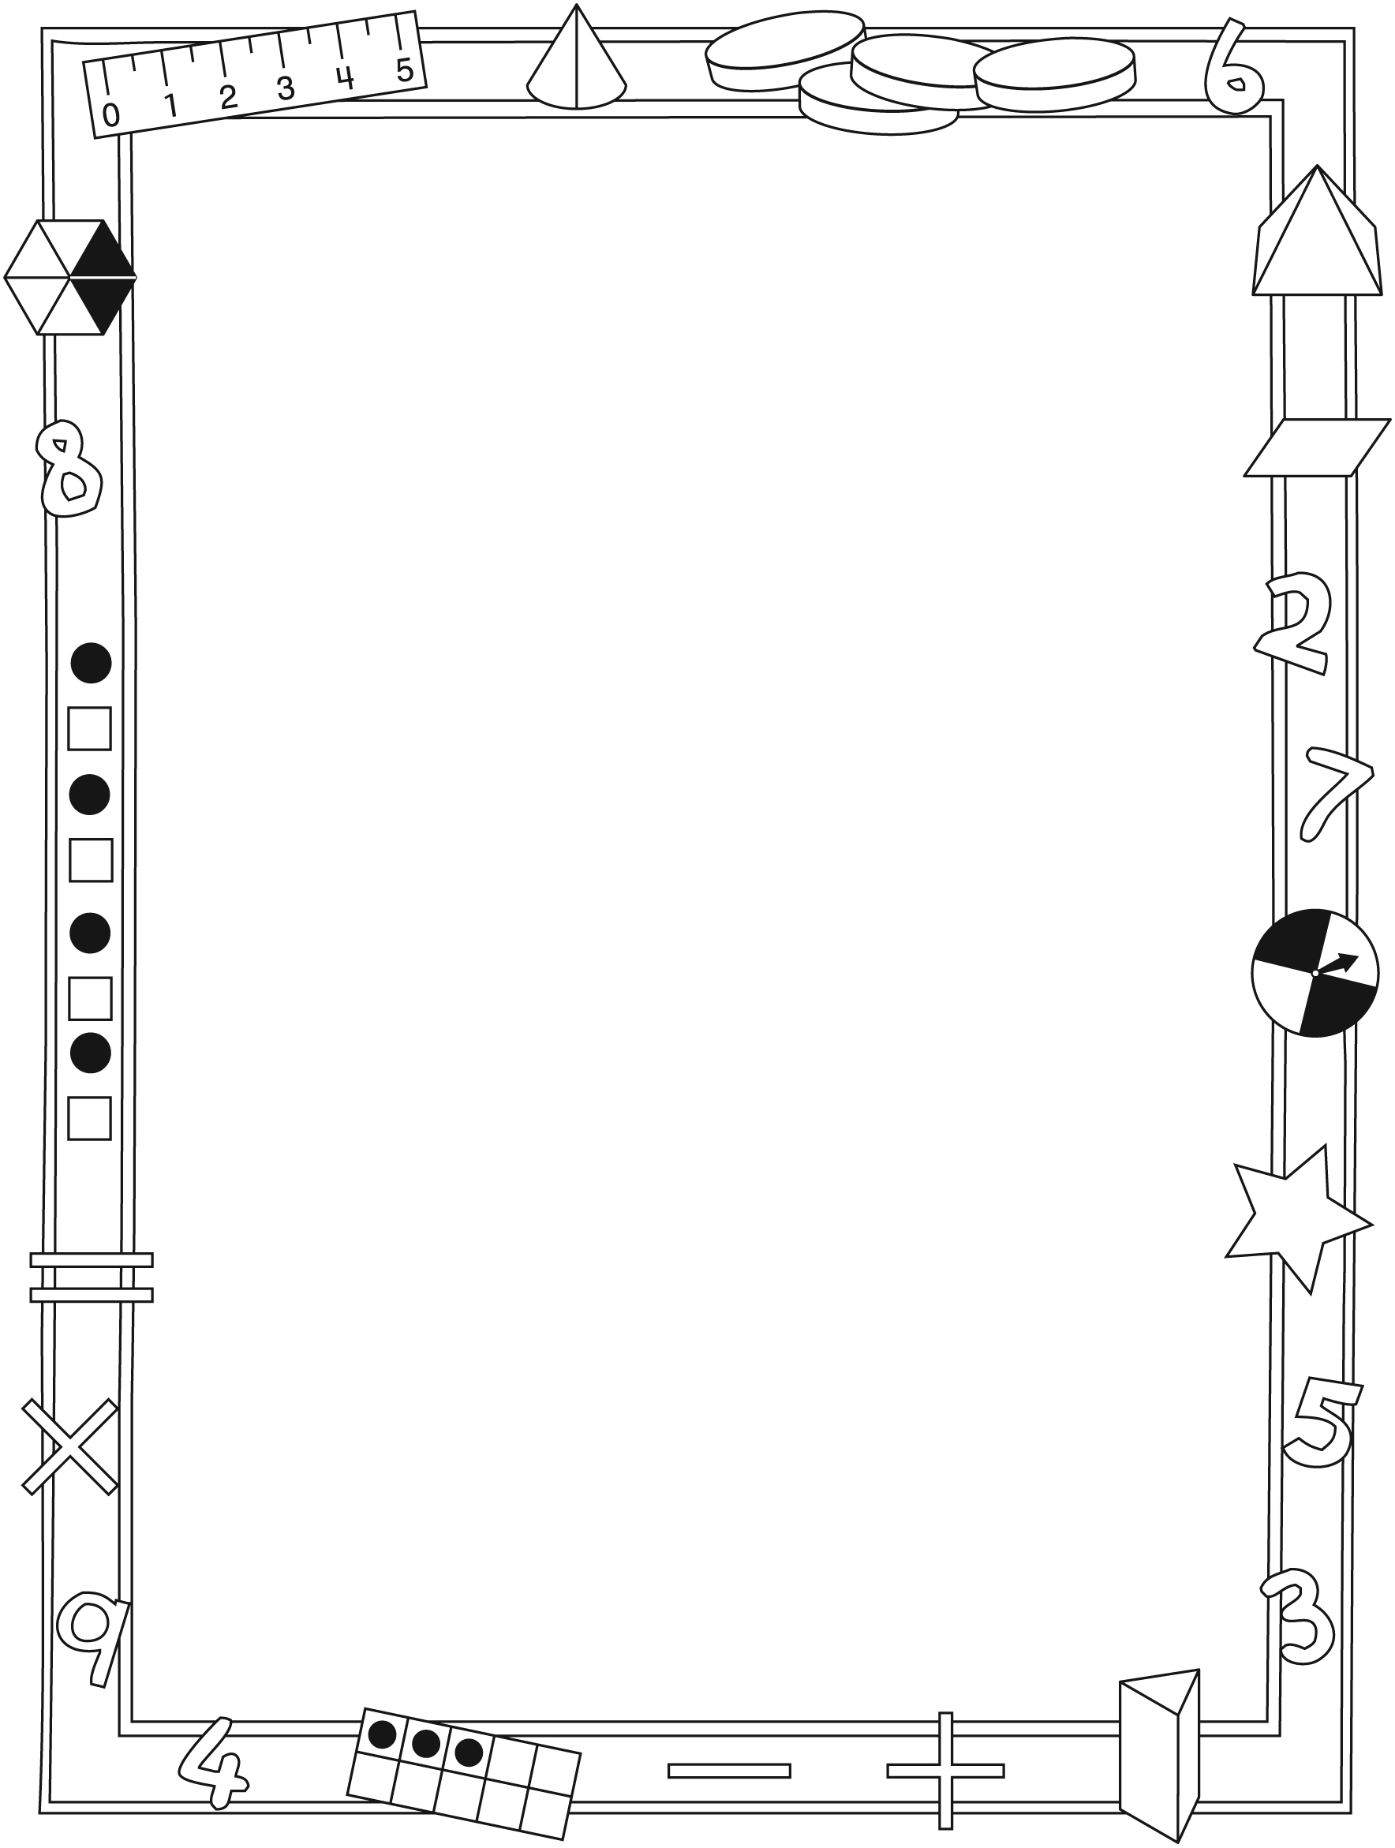

NOTE TO THE TEACHER

You may wish to send families a Chance letter outlining a familiar activity or two they can do at home with their children.

Create a letter using this template and select one or two activities from the suggestions on the next page. Simply delete these instructions and cut and paste the activities you have selected, adapting them to fit your needs.

Connecting Home and School Line Master 2–2

Dear Family:

We have been working on Chance, which engages children in conversations, investigations, and activities that help to develop their understanding of the big math idea that “Collecting and displaying data can help us predict and interpret situations.” Particular focus is placed on exploring the likelihood of different outcomes, and investigating the fairness of games. Try this activity at home with your child.
– – – – – – – – – – – – – – – – – – – – – – – – – – – – – – – – – – – – – – – – – –
Reading the Story: As you read the story, enjoy talking about the various ways choices are made, and what you learn from the experiments. After you read, you might try some of the experiments yourself, by flipping a coin or drawing small objects from a bag. Have fun reading and re-reading the story and changing the outcomes for Cam as the story progresses.
– – – – – – – – – – – – – – – – – – – – – – – – – – – – – – – – – – – – – – – – – –
Sum to 7! Sum to 11! With your child, play the game from page 18 of Chance. Take turns rolling 2 number cubes and finding the sum. Every time the sum is 11, the first player gets a point. Every time the sum is 7, the second player gets a point. The first player to get 10 points wins. Explore whether this is a fair game.
– – – – – – – – – – – – – – – – – – – – – – – – – – – – – – – – – – – – – – – – – –
Making Choices at Home: With your child, flip a coin to choose between two appropriate options at home (e.g., What should we do first: make the bed or get dressed? Should we eat vegetables first or drink milk first?). Talk about the likelihood of things happening.
– – – – – – – – – – – – – – – – – – – – – – – – – – – – – – – – – – – – – – – – – –
Sincerely,

___________________________

Chance Math Mat Line Master 3

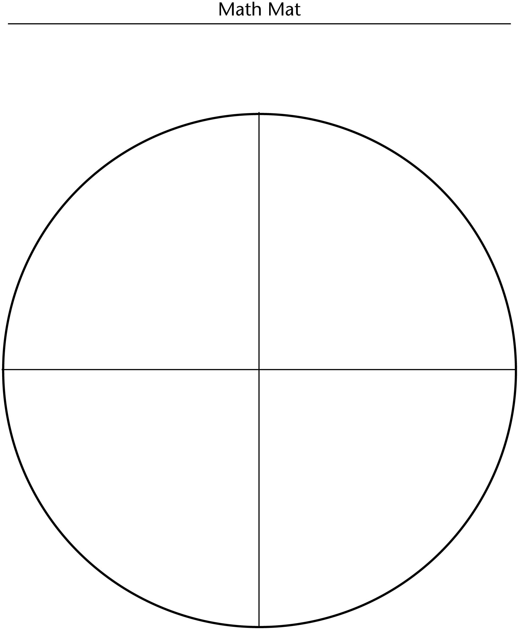

Spinner Winner Line Master 4
Name: _____________________________

Turn | I predict the spinner will land on… | The spinner landed on… | Check if your prediction matched what the spinner landed on.
1
2
3
4
5
6
7
8
9
10
Total Number of
Correct Predictions

2-Part Spinner Line Master 5

Hair Care Double Dare Line Master 6
Name: _____________________________

Check the colour(s) that you pick in each turn. Add to find the total number you picked of each at the end of 10 turns.

Turn | Red | Blue | Yellow | Green
1
2
3
4
5
6
7
8
9
10
Total of Each Colour

Odd or Even Line Master 7
Name: _____________________________

Turn | Number | Is the number odd or even? Circle your answer. | Make a check if you get a point.
1 |  | Odd Even
2 |  | Odd Even
3 |  | Odd Even
4 |  | Odd Even
5 |  | Odd Even
6 |  | Odd Even
7 |  | Odd Even
8 |  | Odd Even
9 |  | Odd Even
10 |  | Odd Even
Total Number
of Points

Use It or Lose It Line Master 8
Name: _____________________________

Take turns picking a tile from the bag. Record your score each time.

Yellow: 10 points
Green: 5 points
Blue: 2 points
Red: Change all the points from all the turns you took so far to 0.

Turn | Colour chosen | Points this turn
1
2
3
4
5
6
7
8
9
10
Total Number
of Points

Graphing Grid Line Master 9

Chance Problems Line Master 10–1

– – – – – – – – – – – – – – – – – – – – – – – – – – – – – – – – – – – – – – – – – –
Sam has 2 trays of toy cars. On one tray, there are 4 red cars and
6 yellow cars. On the other tray, there is 1 red car, 1 blue car, 2 green cars, and 6 yellow cars. Sam plans to close his eyes and pick a car.

1. If Sam wants a yellow car, which tray gives him the best chance? Use colour tiles in place of the cars on trays. Try the experiment
to see.

2. Now make 2 spinners to match the colours on the trays. Use the spinners to see what happens. Did it match what happened with the colour tiles? Why do you think so?

– – – – – – – – – – – – – – – – – – – – – – – – – – – – – – – – – – – – – – – – – –
1. a) Make a fair game that uses 1 red tile, 5 blue tiles, 3 yellow tiles,
2 green tiles, and a spinner or a number cube.

b) Explain how you know it is a fair game.

– – – – – – – – – – – – – – – – – – – – – – – – – – – – – – – – – – – – – – – – – –

Chance Problems Line Master 10–2

– – – – – – – – – – – – – – – – – – – – – – – – – – – – – – – – – – – – – – – – – –
Hadley likes apples best. There are three bags of fruit. She is going to reach into a bag and take out the first piece of fruit she touches.
• One bag has 4 apples, 6 pears, and 5 mangoes.
• One bag has 5 apples, 9 pears, and 1 mango.
• One bag has 6 apples, 7 pears, and 3 mangoes.

1. a) In which bag is Hadley more likely to touch an apple first? How do you know? Is it certain?

b) Create an experiment to test your thinking.
What did you find out? How many times did you have to reach in before you got an apple?

2. In which bag is Hadley more likely to touch a mango first?

3. In which bag is Hadley more likely to touch a pear first?

– – – – – – – – – – – – – – – – – – – – – – – – – – – – – – – – – – – – – – – – – –

10-Part Spinner Line Master 11

